Total Maximum Daily Load (TMDL) Implementation Plan for the
Huron River Watershed MS4s in Washtenaw County
Updated February 5, 2021

The Michigan Department of Environment, Great Lakes, and Energy (ELGE), under the National Pollutant Discharge Elimination System (NPDES) Storm Water Discharge Permit application, requires a plan or other documentation outlining how each Municipal Separate Stormwater Sewer System (MS4) will "make progress toward achieving the pollutant load reduction requirement" in each TMDL listed in each applicant's application notice. The purpose of this document is to provide the collective watershed plan for addressing relevant TMDLs in the Huron River Watershed in Washtenaw County by MS4s for the purpose of stormwater permit compliance through a complete permit cycle. This document addresses the permit application sections VII.86 through VII.88.

I. TMDL and MS4 Coverage

This TMDL plan is submitted on behalf of the following Phase I and II MS4s within the Huron River Watershed, for each of the below-listed TMDLs:

A. Excessive nutrients (phosphorus) and algae in Ford Lake and Belleville Lake

City of Ann Arbor
Ann Arbor Public Schools
Barton Hills Village
City of Dexter
Eastern Michigan University
Pittsfield Charter Township
City of Ypsilanti
Ypsilanti Charter Township
Washtenaw County Water Resources Commissioner
Washtenaw County Road Commission
University of Michigan
VA Ann Arbor Healthcare System

B. Excessive bacteria (E. coli) in the Huron River and tributaries downstream of Argo Dam to Geddes Dam

City of Ann Arbor
Ann Arbor Public Schools
Pittsfield Charter Township
Washtenaw County Water Resources Commissioner
Washtenaw County Road Commission
University of Michigan
VA Ann Arbor Healthcare System

C. Excessive bacteria (E. coli) in Honey Creek

City of Ann Arbor
Ann Arbor Public Schools
Washtenaw County Water Resources Commissioner
Washtenaw County Road Commission

D. Aquatic biota impairment in Malletts Creek

City of Ann Arbor
Ann Arbor Public Schools
Pittsfield Charter Township
Washtenaw County Water Resources Commissioner
Washtenaw County Road Commission
University of Michigan

E. Aquatic biota impairment in Swift Run

City of Ann Arbor
Ann Arbor Public Schools
Pittsfield Charter Township
Ypsilanti Charter Township
Washtenaw County Water Resources Commissioner
Washtenaw County Road Commission

II. Prioritizing and Implementation BMPs

The MS4s in the Middle Huron River Watershed have put forth substantial effort and resources to reduce the sources of impairments related to the TMDLs listed in the previous section. These partner organizations, along with non-MS4 entities have developed a number of general and specific plans to address watershed impairments. These plans direct the current and future project and program priorities. The suite of projects and programs already put in place contributed to significant impairment reduction, as evidenced by data collected through on-going monitoring (see Appendix A for details).

To comply with NPDES stormwater permit requirements, the above-listed MS4s submit that the suite of Best Management Practices (BMPs) contained in the attached table represents each MS4’s project priorities that will be implemented during the permit cycle to collectively make progress toward achieving each of the TMDL pollutant load reduction targets. The attached table of BMPs identifies the targeted TMDL pollutants (i.e. phosphorus, sediments, or bacteria where relevant) and the priority of the BMP. In many cases, no additional prioritization is needed, as the activity is a general (G) stormwater treatment BMPs and will be applied across the MS4 and watershed, and not specific to a particular drainage or impairment. For those BMPs that are area or pollutant specific, data from the monitoring program will be used to help establish priorities for implementation. In these cases, BMPs are classified as high (H), medium (M) or low (L) priority for each TMDL. The high priority BMPs will first be implemented in creeksheds or drainage areas that are determined (through monitoring) to be greater sources of the TMDL pollutant or impairment. Conversely, medium and low priority BMPs will be implemented in these TMDL-pollutant source areas after high priority BMPs are implemented.

III. Monitoring Plan

A summary of past monitoring results and conclusions related to TMDLs in the watershed is included in Appendix A. The summaries provided are based primarily on data collected through HRWC's Chemistry and Flow Monitoring Program, which has been funded in part by MS4s. Currently the MS4s and other watershed partners plan to continue to support this program to seasonally monitor Middle Huron River tributaries for TMDL pollutants. However, for the purposes of NPDES stormwater permit compliance, the MS4s commit to the following monitoring plan.

- MS4s will support the collection of water quality samples from sites that are located at or near major tributary mouths. Figure 1 shows a map of long-term monitoring sites at the time of publication. A current map of monitoring sites is located at https://www.hrwc.org/chemistryandflow/.

- Samples will be collected at least twice during the permit cycle, not including the data included from previous monitoring. Sampling years will be permit year 2 and year 5. At least one sampling event will take place at each of the nine sites. An effort will be made to sample water quality parameters during a representative (i.e. >0.25” and <1.5”) wet weather event.

- Samples will be collected following procedures identified in HRWC's Chemistry and Flow Monitoring Program QAPP (see Appendix B). Samples will be analyzed by the Ann Arbor Water Treatment Plant Laboratory or other certified lab for the following concentrations: Total Phosphorus (TP), Total Suspended Solids (TSS), and E. coli.

- Stream flow estimates will be obtained from existing stations during the dates and times water quality samples are collected.

- The pollutant concentrations and stream flow estimates will be used to update pollutant loading models and estimate pollutant load reductions. These results will be summarized in a brief report to be shared with the public via HRWC and/or MS4 websites at least once during the permit cycle, but currently is done annually.

- Depending on the results from long-term monitoring sites, additional short-term investigative sites may be selected upstream. These sites will be sampled within an hour of sampling at the downstream site so that results can be compared and better define pollutant source locations.

- Based on a review of year 2 and year 5 data and summary reports, BMP implementation will be reviewed and BMPs may be updated or revised to ensure progress toward achieving TMDL pollutant load reductions.

In addition to this stormwater sampling plan, HRWC currently collects macroinvertebrates three times a year at sites throughout the Huron River Watershed. A number of these sites (see Figure 2) are in Malletts Creek and Swift Run watersheds, which are impaired for low biota diversity. This monitoring is not required, and MS4s do not commit to continue such sampling, but HRWC plans to continue doing so on behalf of all MS4s.

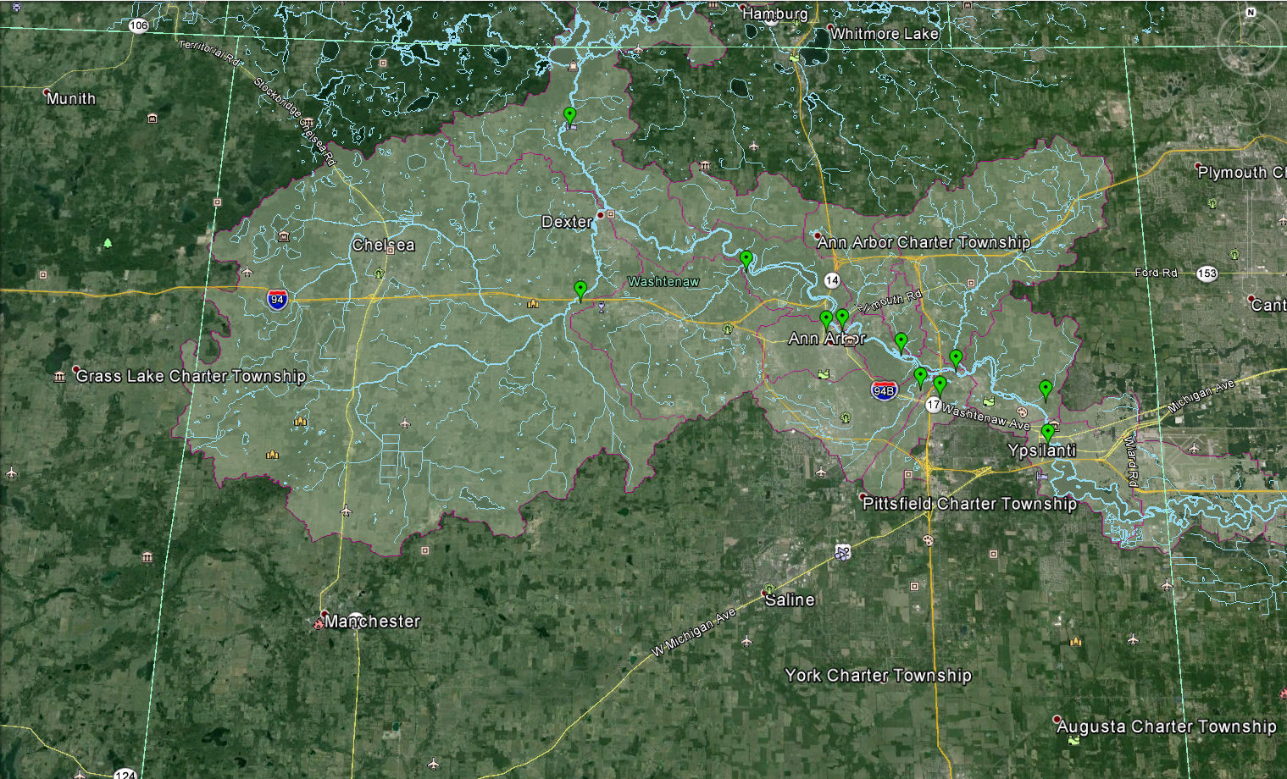
Figure 1. Long-term water quality monitoring stations in the Middle Huron River watershed.
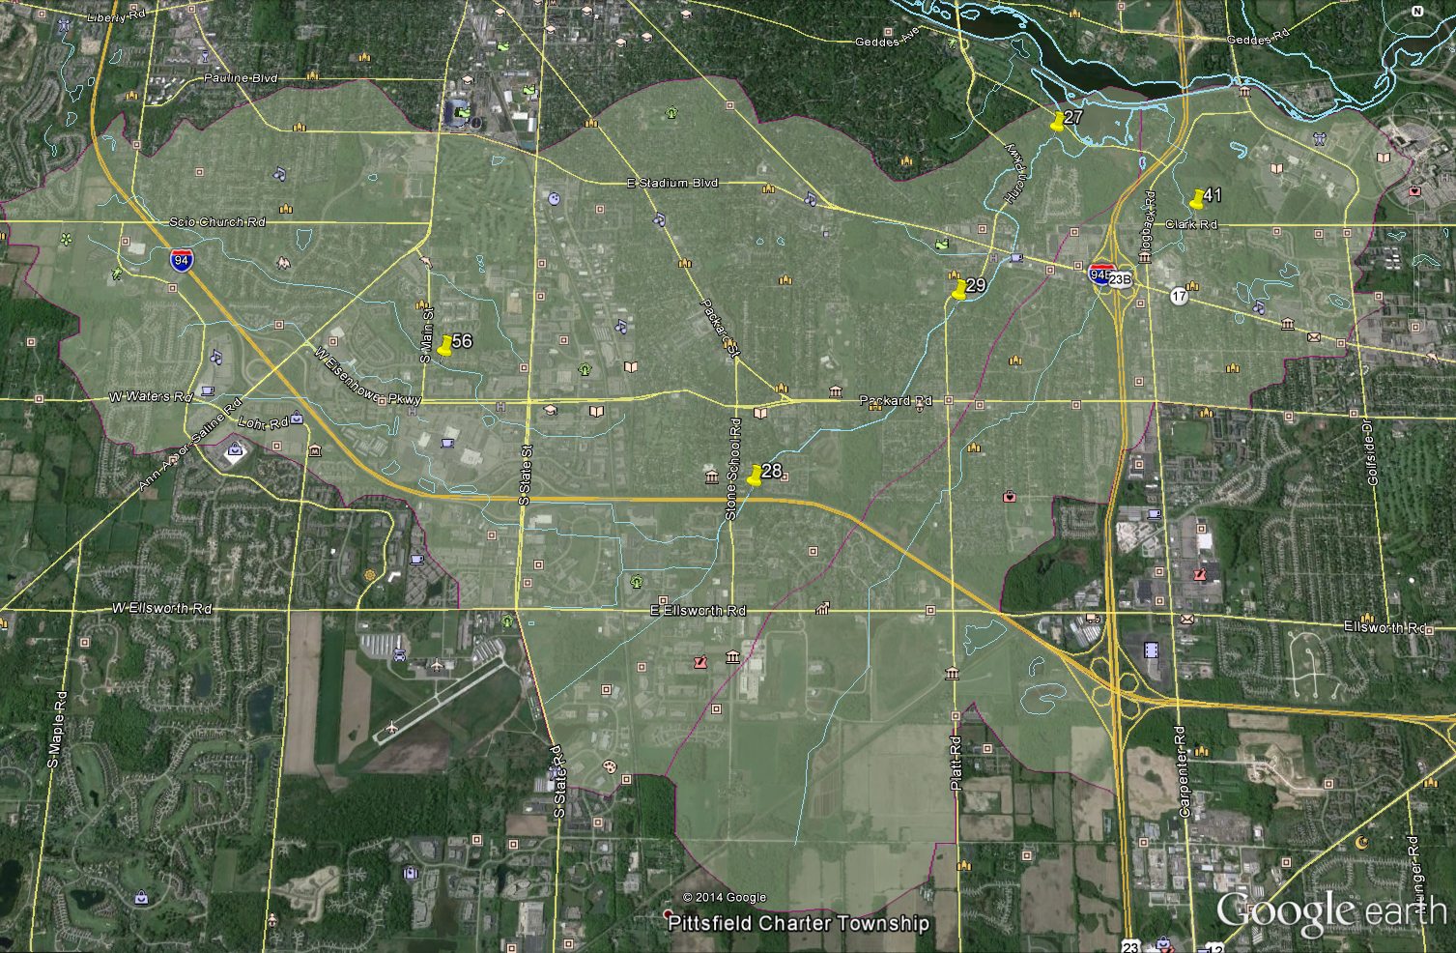
Figure 2. Current HRWC macroinvertebrate sampling locations in Malletts Creek and Swift Run watersheds.

