2.4. Creekshed Current Conditions

In order to gain a perspective on the past and present general water quality conditions in the Watershed, efforts were made to compile and summarize relevant and readily available existing water quality data. This effort included but was not limited to acquisition of studies conducted by state researchers, as well as requests to Advisory Committee members and researchers in the area.

Numerous studies and datasets of relevance were obtained in this process; however, spatial and temporal data may be somewhat limited in certain areas, especially for areas of the Watershed drained by minor tributaries. Due to these limitations, the following narrative should be considered a snapshot of water quality in the Watershed rather than a comprehensive review.

The Watershed was split into two major sections for this summary: the upstream Huron River and direct drainage as it flows through Superior Township and the City of Ypsilanti, and Ford and Belleville Lake and their direct drainage.

2.4.1 Huron River and direct drainage tributaries

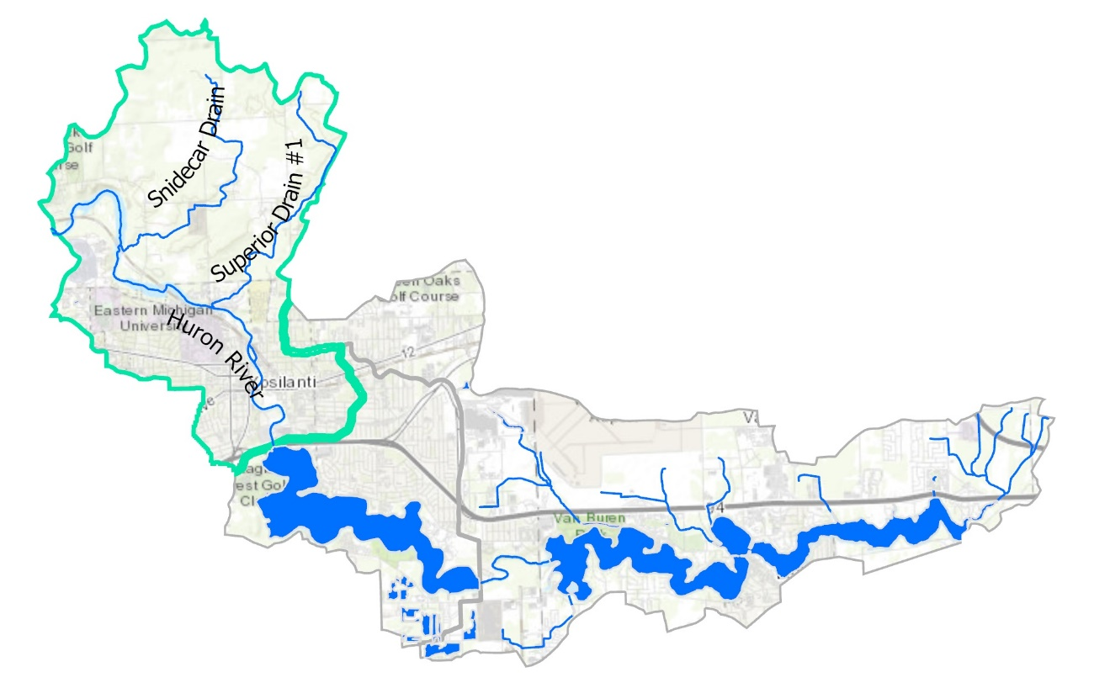

2.4.1.1 Creekshed Natural Areas

The watershed’s forests, wetlands, and grasslands soak up rainwater and runoff, filter pollutants from runoff, and provide wildlife habitat and beautiful places for us all to enjoy.

About 10 percent of this subwatershed remains as intact natural areas. About a quarter of these areas are protected from development. (including LeFurge Woods Preserve). Without designated protection, the rest of the natural areas in this area face an uncertain future. It will be important to keep these lands natural, so they can continue to help keep the Huron healthy.

Fish and insect communities are less diverse when impervious surface exceeds 8-12% of the total watershed area., 6% (1.7 square miles) of this area is impervious. However, the river is impacted by the 9% impervious surfaces upstream of the Watershed as well, which are not considered in this number.

2.4.1.2 Hydrology

The hydrology of the Huron River through this section of the Watershed is discussed and evaluated in section 2.1.4, including for a station at Forest Avenue within the Watershed. The hydrology in the small direct drainages to the river has not been measured nor evaluated. Given the size of their drainage areas, direct drainage streams will have little impact on the overall river flow, but they do generate a greater amount of flow per area than tributaries upstream. Further, as discussed in the Morphology section below, the flow dynamics in these streams cause significant erosion and may contribute a significant sediment load to the river.

2.4.1.3 Morphology

Recent conditions:
HRWC evaluated stream morphology for Snidecar and Superior Creeks (drains), two smaller direct drainages to the Huron River, along with three reaches of the river itself (Appendix C). The terrain along the Huron River in this section of the watershed is quite diverse. While the land use near the river is quite developed and urban, the direct riparian corridor has very good riparian cover with a well-connected floodplain. Bank slopes along this section of the river can be high in some places, but are comparatively gentle for most of the reach surveyed. Riverbanks show moderate erosion rates. The Huron River itself has a unit erosion rate of 0.071 tons/year per linear foot of river assessed, which is less than half the average rate of 0.153 tons/yr/ft across all of the assessed reaches of the Watershed (Table 2.7). None of the river reaches had erosion rates in the highest priority category.

The tributary stream reaches, on the other hand, are rated to be quite susceptible to erosion. While there were a few sections with good riparian cover and intact banks, on average, both small, direct-drainage streams and the two named tributaries showed high erosion rates. Combined, the direct drainages had an average unit erosion rate of 0.283 tons/yr/ft, and the two tributaries had erosion rates about half that, but still considered high when compared to other watersheds. These drainages cut through rolling hill terrain in the riparian valley, with agricultural areas upland. Upstream sections appear to have been channelized over the years. Overall, the 2.5 miles of Huron River generates an estimated total of 940 tons/year in eroded soil, while the 11.3 combined miles of tributaries and direct drainages erode a combined estimate of 8,659 tons/year. These erosion rates and amounts are significantly higher than upstream watersheds and the eroded sediment is likely contributing to lake nutrient impairments.

Table 2.7. General erosion rates for the assessed streams of 2 primary Creeksheds, the main Huron branch, and the smaller direct-to-Huron drainages.
Measurement | Huron River | Direct-to- Huron Drainages | Snidecar Creek | Superior Creek
Length Assessed (mi) | 1.59 | 1.07 | 0.18 | 2.82
Total Reach Length (mi) | 2.52 | 2.85 | 3.95 | 4.47
Erosion Rate (tons/yr/ft) | 0.071 | 0.283 | 0.053 | 0.140
Tons per year | 940 | 4,263 | 1,099 | 3,297

2.4.1.4 Stream Habitat

At a minimum of every five years and occasionally more frequently, HRWC conducts a habitat assessment at one monitoring site in this subwatershed, the Huron River at East Cross Street in Ypsilanti (Riverside Park/Frog Island Park area). The assessment is composed of qualitative observations (riparian width, erosion sites, meandering, woody debris, counts of riffles/pools/runs, desktop observations through aerial photography and GIS) combined with quantitative measurements of stream substrate (substrate size analysis across ten cross section transects).
This location was last monitored for habitat on August 9, 2021. The average width of river here is 133 feet and had an average depth of 3 feet on this date. However, this depth is known to regularly change with weather and flow conditions. A similar study in 2014 had an average depth of 0.8 feet and during higher flows the river will be above the heads of anyone attempting to take the depth. The river has a rocky substrate here, with 12% boulder, 43% cobble, 26% rock, 13% gravel, and just a very small amount of sand and muck along the quieter edges or in the gaps between larger rocks.

Along the whole stretch of the Huron River in this Watershed, the river has a moderately deep natural riparian zone on both banks, (thirty to several hundred feet, depending on exact location). One exception to this is an area of mowed grass at Riverside Park in Ypsilanti.

2.4.1.5 Phosphorus

HRWC’s Chemistry and Flow Monitoring Program has monitored the Huron River at East Cross Street in Ypsilanti (MH11) twice monthly from April through September since 2014. Over the entire sampling period between 2014 and 2022, total phosphorus (TP) concentrations in the Huron River at East Cross Street have seen a statistically significant decline (n=100, p=0.02). Average TP concentrations have declined from 0.07 mg/l in 2014 to 0.05 mg/l in 2021 and 0.06 mg/l in 2022. Average and median TP concentrations at MH11, both 0.06 mg/l (s=0.02), are still above the Total Maximum Daily Load (TMDL) target for Ford and Belleville Lake of 0.03 mg/l. Only 7 percent of monitored TP values from 2014 to 2022 are at or below the 0.03 mg/l TMDL target.

From 2003 to 2013, HRWC also monitored TP at Superior Drain #1 at West Clark Road (MH10) in Superior Township. HRWC and volunteer teams collected samples at MH10 twice monthly during the growing season (April through September). During that period, TP concentrations averaged 0.09 mg/l (n=80, s=0.3) with a median of 0.07 mg/l. TP values at Superior Drain ranged from 0.02 mg/l to 0.31 mg/l. No significant trends in TP were observed during that period, however, HRWC TP sampling indicates Superior Drain is a likely source of phosphorus loading into the Section 3 Middle Huron Watershed. Nonetheless, additional more recent monitoring could confirm if current TP concentrations remain high at Superior Drain.

HRWC collected two monitoring seasons (April through September) of TP data from Snidecar Drain at Superior Road (SD01) in 2016 and 2017. TP concentrations at Snidecar Drain saw an average of 0.20 mg/l (n=22, s=0.2) and a median of 0.11 mg/l. Values ranged from 0.04 mg/l to 0.67 mg/l, all above the TMDL target of 0.03 mg/l. Snidecar

2.4.1.6 Suspended Solids

From 2014 to present, HRWC’s Chemistry and Flow Monitoring Program has collected total suspended solids (TSS) data from the Huron River at East Cross Street during the growing season. TSS data at MH11 reveals low sedimentation throughout this stretch of the Huron River. Across 99 samples collected during the monitoring period, 98 percent were below 25 mg/l, which indicates low sediment loading in this area across all conditions and water levels. During the nine-year sampling period, TSS values for the Huron River at East Cross Street ranged from 0 to 41 mg/l and averaged 8 mg/l (s=6). TSS at MH11 illustrates no observable, statistically significant trend.

HRWC’s Chemistry and Flow Monitoring Program monitored TSS at Superior Drain #1 from 2003 to 2013. Of the 81 measured TSS values, 84 percent of values were below 25 mg/l. However, TSS values at Superior Drain reached over 100 mg/l on two occasions, likely during or after high precipitation events. One TSS sample in 2011 during high flow conditions reached over 700 mg/l, which may indicate high sedimentation potential from Superior Drain following extreme weather events. Overall, TSS at Superior Drain averaged 26 mg/l (s=83) and had a median of 10 mg/l.

In 2016 and 2017, HRWC collected biweekly TSS data at Snidecar Drain (SD01) from April through September. The limited data show some sedimentation across conditions and seasons at Snidecar Drain. TSS data at SD01 averaged 69 mg/l (s=92) with a median of 26 mg/l. Just over half of the measured TSS values (52%) were above 25 mg/l and a quarter (24%) were over 100 mg/l. Across the two-year sampling period, TSS at Snidecar Drain peaked at 294 mg/l, revealing some sediment loading during high flow conditions.

2.4.1.7 Nitrate and Nitrite

From 2014 through the present, HRWC has monitored nitrate and nitrate twice monthly where the Huron River crosses East Cross Street in Ypsilanti (MH11). Nitrate and nitrite concentrations at MH11 remain below the EPA’s Maximum Contaminant Levels (MCL), with a range of 0.0 to 0.07 mg/l for nitrite (n=94) and 0.5 to 2.8 mg/l for nitrate (n=100) from 2014 to 2022. During the monitoring period, nitrite averaged 0.01 mg/l (s=0.01) and nitrate averaged 1.2 mg/l (s=0.4). Over the eight years of monitoring, no trend has been observed for either nitrate or nitrite.

The two tributaries to the Huron River in this area –Snidecar and Superior drains – both have nitrate and nitrite ranges below EPA’s MCLs for these parameters. Both Snidecar and Superior drains have average nitrate concentrations of 0.3 mg/l and average nitrite concentrations of 0.01 mg/l. At both sites, there are no observable trends in nitrate and nitrite concentrations over the respective monitoring periods.

2.4.1.8 Conductivity

HRWC’s long-term monitoring site on the Huron River at East Cross Street in Ypsilanti (MH11) has been monitored for conductivity since 2014 using handheld water quality sondes from YSI. Of the 104 conductivity measurements, 50 (49%) exceed the 800 µS threshold used by HRWC. However, the average and median conductivity values for MH11 fell just below that threshold at 771 µS (s=157) and 791 µS, respectively. Overall, conductivity values during the eight-year monitoring period range from 412 µS to 1570 µS, which was the only reading to reach beyond 1000 µS. Given MH11 is within the urbanized areas of Ypsilanti and downstream of Ann Arbor, it is likely that pollutant sources from urban areas are leading to elevated conductivity levels at MH11 and within the Section 3 Huron River Watershed. During the monitoring period, there has been no observable trend in conductivity values at the MH11 site.

During HRWC’s ten-year monitoring period at Superior Drain from 2003 to 2013, stream conductivity remained consistently low. Conductivity values ranged from 310 µS to 990 µS, with an average of 611 µS (s=125). Only 2 readings (4%) were over 800 µS.

Conductivity measurements were taken at Snidecar Drain in 2016, 2017, and 2020. Among the three years of monitoring (n=28), conductivity at Snidecar Drain ranged from 257 µS to 1263 µS. Conductivity values are slightly elevated with 40 percent of readings above the 800 µS threshold. However, both mean and median conductivity values at Snidecar Drain are slightly below that threshold at 753 µS (s=218) and 772 µS, respectively.

2.4.1.9 pH

HRWC’s Chemistry and Flow Monitoring Program has monitored pH where the Huron River crosses East Cross Street in Ypsilanti (MH11) since 2014. During the monitoring period, pH values fall within the prescribed range under the Michigan Water Quality Standards for surface waters. From 2014 to 2022, pH values ranged from 7.4 to 8.5, with an average of 8.2 (s=0.2). Tributaries into this section of the Huron River, including Snidecar and Superior drains, also have pH values within a normal range for surface water with respective average values of 8.2 (s=0.1) and 7.6 (s=0.3).

2.4.1.10 Temperature

Temperature data has been collected by HRWC’s Chemistry and Flow Monitoring Program along the Huron River near Riverside Park and East Cross Street in Ypsilanti (MH11) since 2014. The monitoring season runs April through the end of September. The average water temperature of the Huron River at MH11 is 69.6 degrees Fahrenheit (s=10.2) as measured between 2014 to 2022. During that period, temperatures ranged from 41.5 to 83.3 degrees Fahrenheit. Due to seasonal variability, there is no observable trend in temperature at MH11.

HRWC also connected temperature data using handheld YSI multimeters at Superior and Snidecar drains over more limited monitoring periods. Data collected at Superior Drain from 2003 to 2013 show an average water temperature of 60.1 degrees Fahrenheit (s=6.1) across 69 measurements. Temperature values reached a maximum of 71.6 degrees Fahrenheit and a minimum of 43.3 degrees Fahrenheit at Superior Drain and are within expected seasonal values for surface water temperatures.

At Snidecar Drain, temperature measurements were collected from April through September in 2016 and 2017 and briefly in July and August of 2020. Across 28 measurements from Snidecar Drain, temperature values averaged 64.6 degrees Fahrenheit (s=6.8) with a median of 66.4 degrees Fahrenheit. The range of temperature values at Snidecar Drain is slightly narrower than at MH11 and Superior Drain with values ranging from 46.6 degrees Fahrenheit to 73.2 degrees Fahrenheit.

2.4.1.11 Dissolved Oxygen

In-stream dissolved oxygen (DO) measurements for the Huron River at East Cross Street (MH11) are collected every other week from April through September by HRWC’s Chemistry and Flow Monitoring Program. From 2014 to 2022, DO at MH11 (n=100) met and exceeded Michigan’s DO standard of 5 mg/l across 98 percent of measurements. DO values at MH11 ranged from a minimum of 3.67 mg/l in 2015 to 14.17 mg/l in 2019. Across the eight-year monitoring period, DO values at MH11 averaged 9.28 mg/l (s=1.84) with a median of 8.81 mg/l, which are high enough DO values to sustain life and contribute to healthy aquatic conditions along with Huron River.

At Superior Drain, HRWC collected DO measurements across the growing season from 2003 to 2006 and again in 2008 and 2009. Across the monitoring record (n=35), DO averaged 7.82 mg/l (s=1.25) and ranged from 5.5 mg/l to 11.41 mg/l. Given all collected measurements are above 5 mg/l, dissolved oxygen at Superior Drain appears to be within healthy ranges for surface water and to sustain aquatic life. However, HRWC could collect more recent data to ensure DO levels at Superior Drain remain high across the growing season.

HRWC also has a few years of DO data at Snidecar Drain at Superior Road. In 2016, 2017 and 2020, HRWC collected 28 DO measurements at Snidecar Drain averaging 6.99 mg/l (s=2.66). 25 percent of measured DO values at Snidecar Drain fell below the 5 mg/l DO standard, indicating issues with stream oxygenation during the dry summer months. DO values fell as low as 2.37 mg/l in July 2020 and reached up to 11.17 mg/l in May 2017.

2.4.1.12 Bacteria

Note: when discussing E. coli bacteria concentrations, two different analytical methods are used and report in different, but equivalent units. One method uses CFU = coliform forming units and the other uses MPN = most probable number. Generically, they can be referred to as counts.

HRWC’s Chemistry and Flow Monitoring Program has monitored E. coli counts within the Section 3 Huron River since 2014. From 2014 to 2020, biweekly single grab samples were collected from the Huron River at East Cross Street (MH11) during the growing season. In 2021 and 2022, triplicate samples were collected at MH11 biweekly from April through September.

Single grab samples at MH11 from 2014 to 2020 had average and median E. coli counts below both the state partial body contact and full body contact standards at 183 counts per 100 ml (s=305) and 90 counts per 100 ml, respectively. During the seven-year sampling period (n=74), 13 percent of samples were above the full body contact, single-event standard of 300 E. coli per 100 ml and 4 percent of samples were above the partial body contact standard of 1000 E. coli per 100 ml.

During the triplicate sampling in 2021 and 2022, HRWC saw E. coli results consistent with its previous single grab samples. Across 24 sampling events, HRWC saw only 1 geomean in April 2022 (427 cfu/100 ml) over the full body contact standard of 300 E. coli per 100 ml. Triplicate samples were consistently below that standard across all seasons, with an average value of 91 cfu/100 ml and a median value of 70 cfu/100 ml. Overall, HRWC’s E. coli monitoring data indicates water quality compatible with recreational activities such as paddling and swimming during dry weather conditions in the main branch of the Huron River within the Section 3 Middle Huron Watershed. However, following rain storms for up to 48 hours, contact should be avoided as E. coli levels during these periods may be elevated above state health standards.

HRWC also collected single E. coli grab samples at Superior Drain from 2006 to 2013. Across eight years of sampling (n=64), HRWC saw consistently high E. coli counts at Superior Drain. 66 percent of samples were at or above the full body contact standard and 23 percent of samples were above the partial body contact standard. E. coli sample counts averaged 959 cfu/100 ml (s=1795), with a maximum value of 12,400 cfu/100 ml and a median value of 405 cfu/100 ml, both above the full body contact standard.

HRWC monitored for E. coli at Snidecar Drain in 2016, 2017, and 2020. From 2016 to 2017, HRWC collected biweekly single grab samples for E. coli during the growing season. This two-years of E. coli monitoring (n=21) at Snidecar Drain revealed that nearly half of all samples (48%) were at or above the full body contact standard of 300 E. coli per 100 ml. E. coli counts during the two-year period averaged 696 cfu/100 ml (s=844) and reached a maximum of 2603 cfu/100 ml.

In 2020, HRWC conducted a targeted EGLE-funded E. coli study at select sites across the Huron River watershed, including Snidecar Drain. Triplicate samples during that five-week sample period indicated continued high E. coli counts at Snidecar Drain. Weekly geomeans ranged from 286 cfu/100 ml to 4,139 cfu/100 ml. The 30-day geomean at Snidecar Drain was 1,099 cfu/100 ml, which is above both the full and partial body contact standards. The 2020 study also included a microbial source tracking (MST) assessment of Snidecar Drain for human, bovine, and canine markers. Results indicated non-detects for the bovine marker and Bacteroides thetaiotaomicron (B. theta) human-associated marker. However, samples detected the presence of the HF183 human marker and the canine marker, revealing potential sewage and pet waste sources within the Snidecar Drain creekshed.

2.4.1.13 Macroinvertebrates

As a proxy to overall stream health, HRWC records the macroinvertebrate diversity of insect families, the number of insects of the orders Ephemeroptera (mayflies), Plecoptera (stoneflies), and Trichoptera (caddisflies) (EPT families), and calculates a metric score based on Hilsenhoff’s Index of Biotic Integrity. Typically, the higher the diversity of insects, the more diverse the habitat types and the better the water quality, and the lower the value of the Hilsenhoff IBI score. Since natural variation in weather, flow, and volunteer experience will give different results, HRWC always considers a three-year sample average to produce a more robust summary of results, rather than using individual samples.

HRWC monitors the Huron River at the East Cross Street intersection. From 2020-2022, the location is considered to have a barely less than average macroinvertebrate population as compared to the other 62 sites HRWC monitors. 10 aquatic insect families were found on average (compared to 11.2 across the whole Huron Watershed) and 4 of those were EPT families (compared to 4.5 average EPT families across the whole Huron Watershed). The Hilsenhoff IBI rates the site as Good, averaging 5.3 on a scale of 0 (Pristine) to 10 (Highly Degraded). Long term trends (1997-2023) indicate that the macroinvertebrate population here is not significantly changing.

HRWC also looks for highly pollution sensitive stonefly families in January, before the insects emerge as adults. Stoneflies were found at this location in 2021 and not in 2023. Historically, they have been found in 9 out of 17 samples (1997-2023).

Overall, the macroinvertebrates indicate that the habitat and water quality conditions at this location are suitable for aquatic life. It is not impaired, but neither is it exceptionally healthy or noteworthy.

2.4.1.14 Fish

The Huron River throughout most of the Watershed is considered a popular warmwater recreational fishery for shore anglers. Plentiful parks along the riparian corridor allow for free and easy access.

A 2.7 hour MDNR electroshocking sample in the Huron at M-12 and upstream for 1200 feet in 2001 resulted in 4,242 fish comprised of 26 species. The report states:
“The catch by numbers was dominated by greenside darter (35% of the total catch) which, along with spotfin shiner (19%), logperch (14%), northern hog sucker (14%), and smallmouth bass (8%) made up over 90% of the total catch.”

The river was reported as lacking cover and deeper water to shelter larger individuals.

From 2014-2017, as a response to MDNR’s report on the lack of fish habitat through this section, HRWC conducted a habitat improvement project where larger trees were felled with a trunk notch, anchored along the riverbank, and angled downstream to create habitat diversity and faster flow in smaller areas so finer sediment could be washed away to reveal gravel and deeper areas. Additionally, a rock vane was put in Riverside Park by the park’s gazebo to constrict water flow, and several boulders were placed along the edge of the rock vane. This created deeper holes (3-5 feet deep depending on flow conditions) and a diversity in stream substrate (boulders instead of gravel and sand). HRWC conducted fish monitoring, both pre- and post-project in 2014 and 2017. Notable changes include increased numbers of smallmouth bass, northern hogsucker, walleye, and golden redhorse. The rock vane and deeper holes in particular were found to provide habitat for many of these larger fish.

2.4.2 Ford Lake, Belleville Lake, and Tributaries

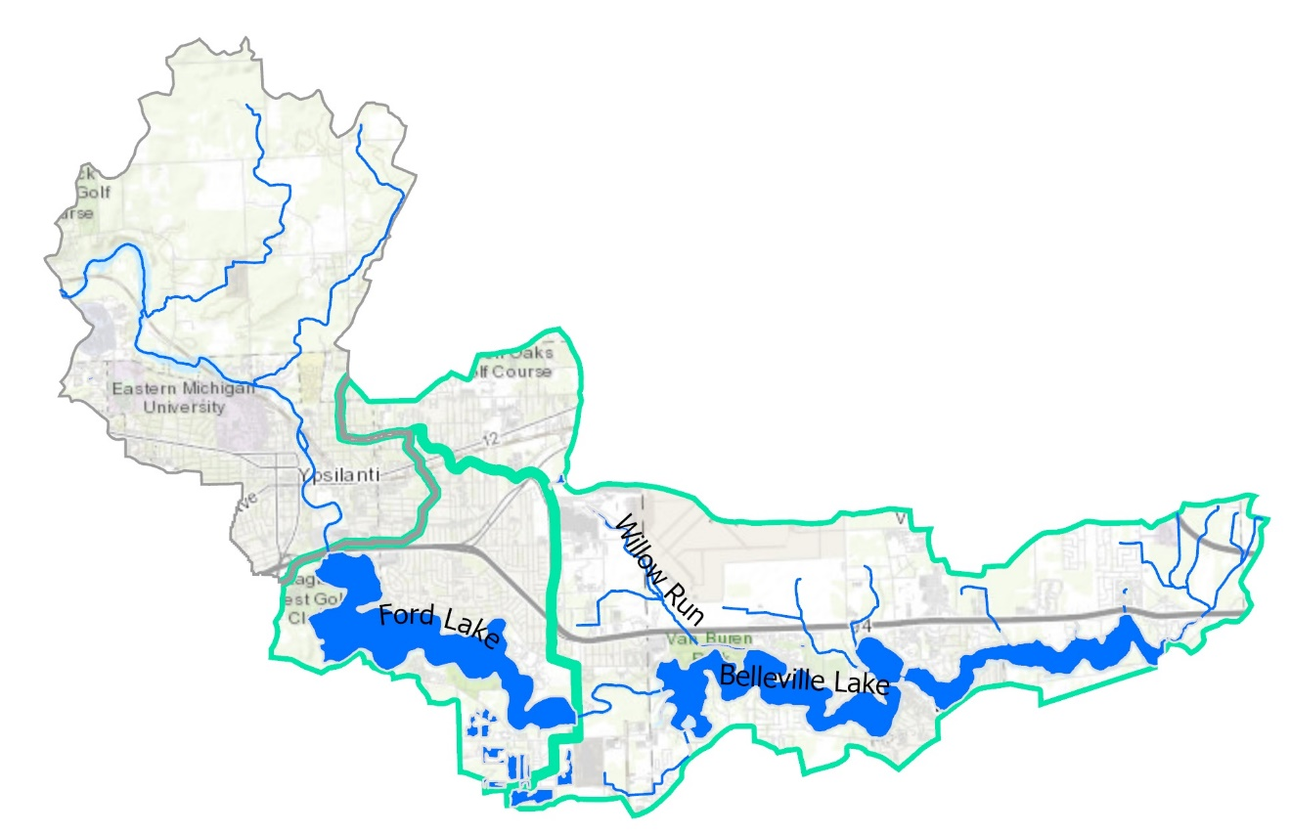

2.4.2.1 Watershed Natural Areas

The Ford Lake subwatershed is highly developed and challenged by high amounts of impervious surface cover. Approximately 35% of the sub-watershed is classified as developed and 30% of the area is water; together, forests, wetlands and grassland areas make up approximately 22% of land cover in the sub-watershed (Figure 2.5).

The Belleville Lake drainage is the most developed subwatershed in the Section 3 Middle Huron Watershed and is also challenged by the degree of impervious surface cover in this area. Approximately 45% of the Belleville Lake sub-watershed is classified as developed and 13% of the area is water; remaining natural areas comprise approximately 26% of land cover (Figure 2.5).

HRWC’s bioreserve map identifies three natural areas in the Ford Lake subwatershed and three natural areas in the Bellville Lake subwatershed that are rated as medium ecological value area (Figure 2.7). Parcels within these natural areas should be prioritized for protection to minimize further development and maintain ecosystem services in this urbanized system.

2.4.2.2 Hydrology

Both Ford and Belleville Lake are human-made impoundments on the Huron River. Ford Lake was created by the Ford Lake Dam (sometimes called the Rawsonville Dam), one of nine dams in the Section 3 Middle Huron River Watershed (Figure 2.8). The Ford Lake Dam was constructed in the 1930’s to provide hydroelectric power to Henry Ford’s Motor Plant in Ypsilanti, Michigan. In 1969, Ypsilanti Township took over ownership and operation of the dam and 1,000 acres of land around the dam and Ford Lake. The dam continues to generate hydroelectric power today. The Ford Lake impoundment is approximately 975 acres (surface area), with a maximum depth of 30 feet. There are no direct tributary drainages to the Ford Lake subwatershed.

Downstream of Ford Lake, Belleville Lake is a 1,200-acre impoundment on the Huron River created in 1926 with the construction of the French Landing Dam by Detroit Edison, also for electric power generation. In 1972, Van Buren township acquired the dam and subsequently restored its power generation capacity. Unlike Ford Lake impoundment, there are several small direct drainage tributaries on the north and eastern side of Belleville Lake, including Willow Run.

2.4.3.3 Shoreline Habitat

Shoreline armoring reduces littoral habitat and can increase wave energy on lakes, leading to excess erosion of the lake bottom and disturbing native macrophytes and emergent vegetation. Submerged logs along the shoreline are important for animal habitat (fish, birds, reptiles, amphibians) as well as reducing the power of erosive wave action.

The Michigan Department of Natural Resources (MDNR) conducted a shoreline habitat survey of Ford Lake in 2006. Staff drove boats around the lake and counted the number of small and large docks, dwellings, submerged trees, and calculated the percent of the armored shoreline on the 9.3 miles of shoreline. The survey found 168 docks, 116 dwellings, 244 logs over 6 inches in diameter were counted in the water (1 tree per 200 feet of shoreline), and a little over 30% of the shoreline was determined to be armored in some fashion.

The numbers of dwellings, docks and amount of shoreline armored on Ford Lake were on the low side for a heavily developed lake in southeast Michigan.

The MDNR conducted a similar shoreline habitat survey of Belleville Lake in 2012 and reported that 55% of the 10.8 miles of shoreline in the lake’s western basin were armored, with 266 houses, 268 docks, and 269 submerged trees (1 tree per 212 feet of shoreline). 88% of the 7.8 miles of shoreline on the eastern basin was armored with 286 houses, 218 docks, and 80 submerged trees (one tree per 512 feet of shoreline).

Research indicates that development of more than about 25% of a lake's shoreline has detrimental effects on a fish community through nearshore habitat degradation associated with the development and a reduction in woody material recruitment into the water. Both of the basins on Belleville Lake have 2-3 times this recommended maximum development level while Ford Lake is right about at the 25% mark. Development is lower on Ford Lake likely because of the steep banks around much of it.

The amount of submerged, nearshore woody material is considered very low in Ford Lake and the western basin of Belleville Lake and even lower to almost nonexistent in the more highly developed Belleville Lake eastern basin.

Neither the Ford Lake or Belleville Lake survey involved counts, analysis, or mapping of erosive shoreline areas. HRWC has received several anecdotal reports of erosion on the south shores of Ford and Belleville lakes, and those slopes are said to be quite steep in sections, but there is no known study, mapping, or available photographs of these points. A study of this nature is in high need.

HRWC’s methodology to assess stream banks (BANCs, see next section) is not appropriate to use on lakeshore banks, however, but other available methods are, such as the Score the Shore method from the Cooperative Lakes Monitoring Program.

2.4.3.4 Stream Morphology and Habitat

Recent conditions:
HRWC did not identify any tributary streams to Ford Lake that could be evaluated for stream morphology.

One tributary (Willow Run) and several direct drainages to Belleville Lake were identified and evaluated however using the BANCs methodology (Appendix C). Reaches in this section of the Watershed were often difficult to access as some were fenced off due to proximity to the Willow Run Airport or other infrastructure or industrial facilities. There are no river reaches in this section of the watershed, with the exception of the connecting channel between the lakes. That channel was deemed too deep to wade.

There is one named tributary, Willow Run, in the Watershed. Only some parts of this tributary were accessible. Reaches in the tributary vary from channelized farm drains in the headwaters north of US-12, to highly altered and armored channels along the airport (aerial observation only). Further downstream, the channel has good riparian vegetation, but the banks appear to be eroding rapidly due to altered hydrology upstream.

Willow Run has a unit erosion rate of 0.150 tons/year per linear foot of river assessed, which is slightly less than the average rate of 0.153 tons/yr/ft across all of the assessed reaches of the Watershed (Table 2.8). Of the five Willow Run reaches assessed, three reaches had erosion rates in the highest priority category, with one each in the moderate and low priority categories.

Direct drainage reaches, on the other hand, all but one (the only reach south of the lakes) appear to be quite susceptible to erosion. These drainages travel through either densely populated residential areas or current or previous farm fields. Streams in these older residential areas seem to largely have been altered and moved to make room for development. Soil in the farm areas is comprised of a higher amount of sand than in upriver areas, making banks more susceptible to erosion. Combined, the direct drainages had an average unit erosion rate of 0.174 tons/yr/ft.

Overall, the 4.9 miles of Willow Run generates an estimated total of 3,857 tons/year in eroded soil, while the 6.9 combined miles of direct drainages erode a combined estimate of 6,376 tons/year. These erosion rates and amounts are also significantly higher than upstream watersheds and the eroded sediment is likely contributing to lake nutrient impairments.
Table 2.8. General erosion rates for the assessed streams of 1 primary Creekshed and the smaller direct-to-Huron drainages.
Measurement | Direct-to- Huron Drainages | Willow Run
Length Assessed (mi) | 3.07 | 1.94
Total Reach Length (mi) | 6.94 | 4.86
Erosion Rate (tons/yr/ft) | 0.174 | 0.150
Tons per year | 6,376 | 3,857

2.4.2.5 Phosphorus

Current Monitoring

The Michigan Department of Environment, Great Lakes, and Energy (EGLE) conducts biannual monitoring of phosphorus in Ford Lake and Belleville Lake between April and September to track progress towards meeting TMDL goals established for Ford and Bellville Lakes in 1995. A Water Resources Division Staff Report released by EGLE in 2019 details the most recent results of biannual monitoring in 2014, 2016, and 2018. During this time, EGLE monitored four sites on Ford Lake and four sites on Bellville Lake. Surface grab samples were collected for total phosphorus and ortho phosphate at all sites; at certain sites, samples were also collected in the middle of the water column and near the bottom of the lake.

EGLE reports that overall, TP concentrations in Ford and Belleville Lakes have not changed significantly since monitoring was initiated in 1994, despite reductions in TP concentrations in the Huron River upstream of the impoundments. Sampling results indicate that total phosphorus ranged widely in Ford Lake both within annual seasons and across the entirety of the sampling period from 30 µg/L in June of 2016 to 87 µg/L in August of 2018, however summer phosphorus concentrations were generally higher than spring concentrations across the sampling period (2014 – 2018). In 2016 and 2018, additional sampling was conducted by EGLE staff to monitor harmful algal blooms on Ford Lake, indicated by the presence of microcystin.

Like Ford Lake, phosphorus concentrations in Belleville Lake were consistently higher in the summer months compared to the spring. In 2018, average TP concentrations in Belleville Lake were higher in spring vs. the summer monitoring period. However, EGLE reports that this increase in spring TP corresponded to releases of effluent from the YUCA Wastewater Treatment Plant between September 2017 and January 2018. Overall, average TP concentrations collected in Belleville Lake across the sampling period were higher than target goals established for the TMDL (30 µg/L) nearly 90% of the time (15 of 17 sampling dates).

EGLE concluded in their 2019 report that it was likely that internal phosphorus loading is occurring in both Ford and Bellville Lakes and is contributing to continued eutrophic conditions in the impoundments despite reductions in TP inputs from the Huron River since the implementation of the TMDL. Higher concentrations of TP in the summer months compared to the spring in both lakes further support this conclusion: In Ford Lake, EGLE’s monitoring indicates that the impoundment experiences anoxic conditions in the hypolimnion during periods throughout the monitoring season (April – September), which can “trigger” a release of phosphorus from benthic sediments and lead to an increase in phosphorus in the system (internal loading). Anoxia is more likely to occur in the summer months when water temperatures are higher.

Willow Run, a direct drainage into Belleville Lake, was monitored by HRWC for total phosphorus in 2016 and again in 2022. From April through September, biweekly grab samples were collected from Willow Run at Van Buren Park in Van Buren Township. Across 24 samples, total phosphorus (TP) concentrations averaged 0.06 mg/l (s=0.1) with a median of 0.04 mg/l, which is slightly above the 0.03 mg/l Total Maximum Daily Load (TMDL) target for Belleville Lake. Overall, a little over one third of samples (38%) had TP concentrations at or below the TMDL target for Belleville Lake. During the 2016 and 2022 sampling efforts, Willow Run TP concentrations mostly ranged from 0.02 mg/l to 0.10 mg/l, however, one sample from September 2016 reached 0.55 mg/l.

Historic Data

In December of 1993, a 12-month phosphorus loading analysis was initiated by the Michigan Department of Environmental Quality to investigate the water quality of the Middle Huron. The analysis showed that Ford and Belleville lakes were impaired as they failed to meet water quality standards due to phosphorus enrichment, which contributed to nuisance algae blooms. Based on water quality sampling and accepted mathematical models, a phosphorus TMDL of 50 µg/L at Michigan Avenue and 30 µg/L in Belleville Lake was established for the months of April to September (Appendix D). According to MDEQ, the TMDL should assure the attainment of water quality standards for Belleville Lake, and significantly reduce problems in Ford Lake, in addition to meeting the requirements of Water Quality Standard R 323.1060(2) which states “nutrients shall be limited to the extent necessary to prevent stimulation of growths of aquatic rooted, attached, suspended, and floating plants, fungi, or bacteria which are or may become injurious to the designated uses of the waters of the state.”

Dr. John Lehman with the University of Michigan conducted a study on the nutrient dynamics and algae growth in Ford and Belleville Lakes and the Huron River upstream. As part of this study, Dr. Lehman and his team sampled twelve sites along the Huron River and sites in Barton Pond and the two lakes. Sampling of these sites occurred between June 2003 and October 2005 once or twice weekly in the summer months, weekly in spring and fall, and biweekly in winter months. Parameters measured at the river sites included several forms of phosphorus and nitrogen, dissolved organic matter, specific conductance and pH. The main conclusion of Dr. Lehman’s study is that internal phosphorus cycling is a major source of phosphorus in Ford and Belleville Lake.

Specific results of Dr. Lehman’s mass balance study included the following:
- From June 2003 to December 2004, 33427 kilograms (KG) of total phosphorus (TP) entered Ford Lake. During the same time period, Ann Arbor Waste Water Treatment Plant (AAWWTP) reports discharging 12427 KG TP to the Huron River (37%).
- Of the 12427 KG P that AAWWTP discharged to the Huron River, only 8854 KG (71%) emerged from Superior Pond. This represents 26% of the load to Ford Lake.
- More TP entered Ford Lake during May 2004 as a result of the 22 May flood than had been discharged by AAWWTP in the previous year.
- From June 2003 to March 2005, 4279 KG of dissolved P (DP) was discharged from Barton Pond into the Huron River above Ann Arbor. During the same time, 12205 KG DP was present below Geddes Pond and upstream of the AAWWTP outfall. This represents an increase of 7926 KG added within Ann Arbor above its WWTP.
- Also from June 2003 to March 2005, 22804 KG DP exited Superior Dam, an increase of 10599 KG from upstream of the WWTP (N.B. This is less than the reported discharge by AAWWTP owing to retention within Superior Pond).
- 23002 KG DP entered Ford Lake, an increase of 198 KG from Superior Rd to Spring St.
- For Particulate P (PP; DP + PP = TP), 16771 KG discharged from Barton Pond; 12043 KG discharged from Geddes Pond. This is a net loss of 4728 KG PP removed by Argo and Geddes Ponds. The balance between PP retention and DP release resulted in the net addition of 3198 KG P to the River within Ann Arbor.
- From June 2003 to March 2005, 16190 KG discharged from Superior Dam. This is an increase of 4147 KG compared to upstream of the AAWWTP. The N/P ratio of this added particulate matter is too low for it to be biological matter. It is almost surely eroded soil. 18349 KG PP entered Ford Lake. This is an increase of 2159 KG. The N/P ratio of this particulate matter is too low for it to be biological matter. It is soil, too.
- 41351 KG TP entered Ford Lake and 32445 KG exited. This was a removal of 8906 KG or a retention of 21.5%. The proportioning between dissolved and particulates was such that 19.3% of DP and 24.3% of PP were retained.

2.4.2.6 Bacteria

Belleville Lake is monitored for E. coli bacteria by the Wayne County Health Department in accordance with the Michigan Department of Environment, Great Lakes, and Energy’s (EGLE) Surface Water Quality Monitoring Program. The Water Quality Standard (WQS) for E. coli as defined under the Natural Resources and Environmental Protection Act requires that “all waters of the state protected for total body contact recreation shall not contain more than 130 E. coli per 100 milliliters (mL), as a 30-day geometric mean…At no time shall the waters of the state protected for total body contact recreation contain more than a maximum of 300 E. coli per 100 ml.”

Van Buren Township Park on Belleville Lake has been monitored consistently for E. coli since 2005. Between 2005 and 2018, the public park beach has been closed due to high bacteria levels 13 times, for a total of 111 days. According to current data available by EGLE’s BeachGuard database, the most recent closure on September 5th, 2018 lasted 26 days, the longest closure since July of 2008. On September 4th, E. coli counts at Van Buren Township Park Beach were 481 E. coli per 100mL of water, exceeding the maximum state WQS of 300 E. coli / 100mL.

HRWC’s Chemistry and Flow Monitoring Program monitored Willow Run, a tributary to Belleville Lake, for E. coli during the 2016 and 2022 growing seasons. Samples collected at Willow Run for E. coli were single grab samples. HRWC’s collected around 12 samples each season, for a total of 23 E. coli samples. E. coli counts at Willow Run averaged 378 counts per 100 ml (s=537) with a median of 229 counts per 100 ml. E. coli samples ranged from 17 counts per 100 ml to 2420 counts per 100 ml. Overall, 65 percent of E. coli samples at Willow Run were below the full body contact standard of 300 counts per 100 ml and 91 percent of samples were below the partial body contact standard of 1000 counts per 100 ml. As a result, E. coli counts at Willow Run appear to be low, however, additional state-approved triplicate sampling could be conducted to validate the single grab sample results.

There are no known bacterial studies on Ford Lake. There are no public swimming beaches on Ford Lake.

2.4.2.7 Macroinvertebrates

As a proxy to overall stream health, HRWC records the macroinvertebrate diversity of insect families, the number of insects of the orders Ephemeroptera (mayflies), Plecoptera (stoneflies), and Trichoptera (caddisflies) (EPT families), and calculates a metric score based on Hilsenhoff’s Index of Biotic Integrity. Typically, the higher the diversity of insects, the more diverse the habitat types and the better the water quality, and the lower the value of the Hilsenhoff IBI score. Since natural variation in weather, flow, and volunteer experience will give different results, HRWC always considers a three-year sample average to produce a more robust summary of results, rather than using individual samples.

HRWC procedures require wadable water and thus there are no macroinvertebrate studies on Ford or Belleville Lake.

In 2010 and 2011, HRWC sampled for macroinvertebrates three times in Willow Run, but then stopped monitoring at this location because the site was too difficult for volunteers to regularly access. Based on three samples only, the location is considered to have a considerably less than average macroinvertebrate populations as compared to the other 62 sites HRWC monitors. 6.3 aquatic insect families were found on average (compared to 11.2 across the whole Huron Watershed) and 2 of those were EPT families (mayfly family Baetidae and caddisfly Hydropyschidae; compared to 4.5 average EPT families across the whole Huron Watershed). The Hilsenhoff IBI rates the site as Very Good, averaging 4.4 on a scale of 0 (Pristine) to 10 (Highly Degraded). The discrepancy between family diversity and IBI score may indicate water that is of good quality to support life but has a lack of different habitat types that would support a broader diversity of insect families.

2.4.2.8 Fish

Current Monitoring

A Do Not Eat Fish Advisory for all fish species was established for Ford Lake and the greater Huron River in 2018 due to PFOS contamination (a form of PFAS, Per- and Polyfluorinated Substances). A 2021 study by the Ecology Center, Friends of the Rouge and HRWC tested fish organs and filets for PFAS. Panfish samples from Ford Lake showed up to 125 parts per billion in organ tissue, among the highest levels detected in the study. Estimated contaminate levels observed in Ford Lake filets remain lower than state advisory levels of 300 parts per billion but are well above what recent research indicates is safe for human consumption. PFAS remains an emerging containment and research on safe levels of PFAS for human contact and consumption is ongoing. As recently as 2022, the US Environmental Protection Agency (EPA) released new health advisory levels for four PFAS chemicals that indicate that PFAS is toxic to humans at extremely low levels, and the agency proposed drinking water standards for six compounds in March 2023. These new rules, if accepted as proposed, will have profound, cascading implications for PFAS exposure considerations in multiple sectors of ecosystem management.

Historic Data

The Michigan Department of Natural Resources (MDNR) reports that Ford and Belleville Lake Fishery has been intensively managed since the 1970’s. Several species were stocked following chemical treatment in 1973 to eliminate all fish in Ford Lake, including “tiger muskellunge, walleye, smallmouth and largemouth bass, hybrid sunfish, channel catfish, bluegills, and black crappie.”

The MDNR conducted a study on the fish population of Ford Lake in 1998 to gauge the levels of white perch inhabiting the lake, fearing they may become nuisance.”
Besides the white perch, Ford Lake had not seen any gains or losses in fish species during the previous twenty-two years. Fish species found through electrofishing were “carp, gar, log perch, pumpkinseed sunfish, bluegill, yellow perch, green sunfish, largemouth bass, smallmouth bass and walleye.” White perch were not found at high enough levels to classify them as “nuisance.”

Creel surveys conducted by the MDNR from 2000-2006 indicated that Bellville and Ford Lakes had the highest and second-highest levels of per-acre fishing pressure of all lakes surveyed. In Ford Lake, surveys also indicated that there was an “extremely high percentage of large predators.” These predators were likely putting pressure on panfish species and contributing to lower numbers of large panfish in 2006 compared to previous surveys. The 2006 survey also indicated that, following stocking in the 1970’s and 1980’s, walleye appear to have established a self-sustaining population in Ford Lake.

The MDNR conducted a fisheries survey of Belleville Lake in 2012. Survey results provided further evidence to the hypothesis that there had been an increase in the percentage of predator species in Belleville Lake over time, which had contributed to declines in quality of the panfish fishery, namely bluegill. The MDNR reported that Belleville Lake hosts a “very popular walleye fishery” and successful populations of small and largemouth bass. Overall, channel catfish were found to make up the greatest percentage of predator biomass in Belleville Lake.

2.4.2.9 Exotic Invasive Aquatic Plants

The Midwest Invasive Species Information Network (MISIN) mapping tool compiles known invasive species locations and abundances from numerous projects including that of EGLE and the MDNR, Cooperative Invasive Species Management Areas (CISMAs), and the Cooperative Lakes Monitoring Program (CLMP).

Plant monitoring efforts on Ford and Belleville have been sparse. According to MISIN, EGLE Aquatic Invasive species staff recorded Eurasian Watermilfoil as “Dense” in two locations on the northern end of the Ford Lake on 6/5/2014.

EGLE Aquatic Invasive species staff recorded Eurasian Watermilfoil as “Patchy” and Curly Leafed Pondweed as “Sparse” in central Belleville Lake on 6/5/2014.

There are no other recorded entries for Ford Lake or Belleville Lake, though it seems probable, given high boating traffic and direct connection to the Huron River, that the lakes have larger invasive species issues than what the data suggests.

2.4.2.10 Additional Water Quality Parameters on Ford and Belleville Lakes

EGLE conducts biannual monitoring of phosphorus in Ford Lake and Belleville Lakes between April – September to track progress towards meeting TMDL goals. Additional water quality metrics are collected during monitoring, including total suspended solids (TSS), nitrite/nitrate, conductivity, pH, temperature, transparency, chlorophyll-a, and dissolved oxygen. Data collected on Ford and Belleville Lake at four monitoring sites during the 2014-2018 monitoring period is reported in EGLE’s 2019 Water Resources Division Staff Report. HRWC interpreted the data presented in EGLE’s 2019 report to include highlights for each water quality parameter detailed below. Data from other sources may be included in these breakdowns as well, with references given as appropriate.

TSS

Over the monitoring period, TSS concentrations ranged from a low of 1 mg/L to a high of 41 mg/L in Ford Lake (n=165), and a low of 1 mg/L to a high of 31 mg/L in Belleville Lake (n=161). Average concentrations were 7.5 and 8.9 mg/L in Ford and Belleville Lakes, respectively. TSS concentrations were highest in both Ford and Belleville Lakes in the month of September, when average concentrations were approximately 10.36 mg/L in Ford Lake and 13.2 mg/L in Belleville Lake, and median concentrations were 11.0 mg/L and 12.5 mg/L, respectively.

Nitrate and Nitrite

Nitrate concentrations ranged from a minimum of 0.01 mg/L to 2.3 mg/L in Ford Lake (n=156) and 0.01 mg/L to 0.7 mg/L in Belleville Lake (n=144), with an average of 0.50 and 0.31 mg/L, respectively. Over the monitoring period, the highest average concentrations of nitrate in both Ford and Belleville Lakes were observed in the month of April, when average and median concentrations were approximately 0.70 mg/L in Ford Lake, and 0.63 mg/L in Belleville Lake. On average, concentrations were lowest in both lakes in August.

Nitrite concentrations ranged from 0.004 mg/L to 0.34 mg/L in Ford Lake (n=161) and 0.002 mg/L to 0.055 mg/L in Belleville Lake (n=141), and an average of 0.02 ug/L in both lakes. In general, average nitrite concentrations in both lakes were lowest in April (0.01 mg/L) and increased throughout the summer months.

Conductivity

Specific conductivity data was collected along a depth profile using a Yellow Springs Instrument (YSI) and is reported in uS/cm. Values reported are averages of the depth profile data, across all sites on Ford or Belleville Lake. Throughout the monitoring period, specific conductivity was highest in Ford Lake in July at 828.4 uS/cm and lowest in May at 740.9 uS/cm. Median values were 823 uS/cm and 674 uS/cm, respectively. Average conductivity was also highest in July in Belleville Lake at 809.4 uS/cm (median=810 uS/cm); on average, the lowest conductivity in Belleville Lake was observed in June (726.1 uS/cm, median of 721 uS/cm).

pH

Like conductivity, pH (SU) data was collected along a depth profile using a YSI. Values are reported as averages across the depth profile data, across all sites on Ford or Belleville Lake. Throughout the monitoring period, average monthly pH varied little in either lake. On average, pH ranged from a low of 8.12 in May to a high of 8.26 in April in Ford Lake; in Belleville Lake, average values were lowest in June at 8.09 and highest in April at 8.29.

Temperature Profiles/Dissolved Oxygen

HRWC developed temperature/dissolved oxygen profiles from the data made available in EGLE’s 2019 Water Resources Division Staff Report. Values were averaged across the monitoring period (2014, 2016, 2018) by month (April – September) for the deepest EGLE monitoring sites in Ford Lake (F4) and the deepest site in Belleville Lake (B4). The monitoring shows that Ford Lake becomes anoxic during periods throughout the monitoring season, with anoxia occurring most frequently in July and August and largely recovering in September. Belleville Lake goes anoxic sooner in the summer, getting close to 0 mg/L in dissolved oxygen in May and June, achieving full anoxia in July, and then recovering in September.

Figure 2.17. Ford Lake Temperature and Dissolved Oxygen Depth Profiles: Average values from 2014,2016, 2018.
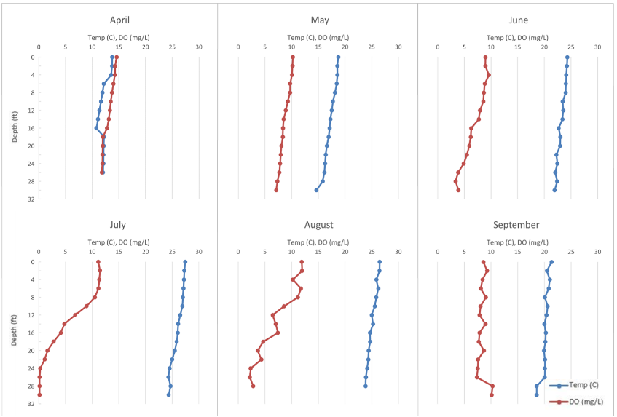

Figure 2.18. Belleville Lake Temperature and Dissolved Oxygen Depth Profiles: Average values from 2014,2016, 2018.
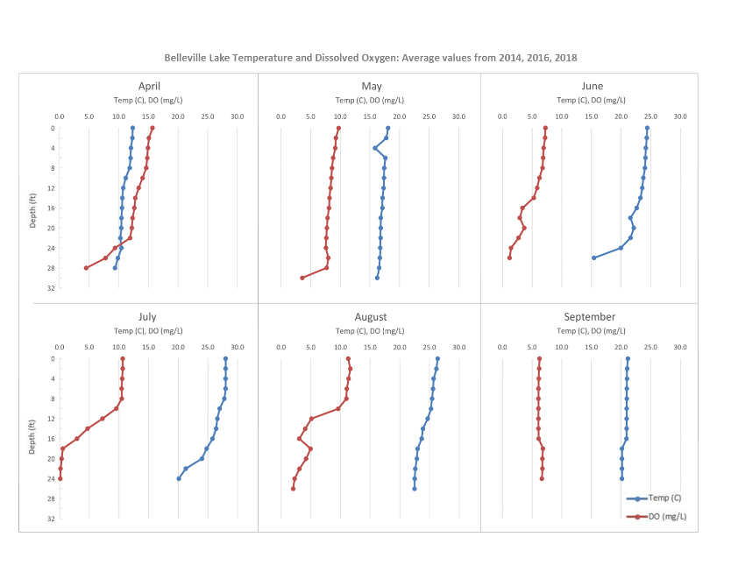

Ypsilanti Township maintains a water monitoring system on Ford Lake and reports dissolved oxygen and temperature at varying depths. Data and contact information are available at https://ytown.org/hydro-dam-station.

Secchi Disk Transparency

Secchi depths are measured by EGLE as part of biannual water quality monitoring conducted on Ford and Belleville Lakes following implementation of the 1995 phosphorus TMDL. In EGLE’s 2019 Water Resources Division Staff Report detailing data from the 2014, 2016, and 2018 monitoring season, EGLE reports no noticeable trends in average Secchi disk measurements across the monitoring period for either lake.

Trained volunteers measured Secchi depth on Ford Lake through the Michigan Clean Water Corp’s Cooperative Lakes Monitoring Program (CLMP) from May through September 2016. The average Secchi depth reported was 7.2 feet, compared to a historic average of 4.8 feet (May – September 1976 – 1981), also measured through the CLMP.

Chlorophyll-a

Chlorophyll-a was measured by EGLE using a bottle sampler that captured water across the photic zone for a depth integrated analysis followed by lab analysis. In Ford Lake, Chlorophyll-a concentrations ranged from 2.7 to 79 µg/L between 2014-2018, across all sampling sites, with an average concentration of 15.46 ug/L. In Belleville Lake, concentrations ranged from 3.5 to 44.0 ug/L with an average of 16.92 ug/L. Average Chlorophyll-a concentrations were highest in both lakes in the month of August, 25.17 ug/L in Ford Lake and 24.23 ug/L in Belleville, with median values of 16 ug/L and 24.0 ug/L, respectively. Average concentrations were lowest in Ford Lake in April, at 8.41 ug/L with a median value of 8.27 ug/L. Average concentrations were lowest in Belleville Lake in May, at 11.74 ug/L with a median value of 12.0 ug/L.

Trophic Status

In the 2014-2018 EGLE study, EGLE calculated Overall Carlson’s Trophic Status Index (TSI) for one site in Ford Lake, F-4, located downstream of the Ford Lake impoundment, and for one site in Belleville Lake, B-4, over the monitoring period from 2014-2018; TSI scores indicate that both Ford and Belleville Lake are eutrophic systems.

2.4.2.10 Additional Water Quality Monitoring on Willow Run

Willow Run is a tributary that flows into Belleville Lake. The creek had been used as a dumping ground for manufacturing since 1941 with most of the hazardous waste poured into the Willow Run Sludge Lagoon, Tyler Pond and Edison Pond. In 1994, a collaboration between multiple shareholders in federal, state and local government; business; and academia came together to create a plan to clean-up the Willow Run Creek Site to avert designation as a US EPA “Superfund” site for hazardous waste. The site was remedied over the course of four years by treating and confining the dried, hazardous sediments to a landfill site according to MDEQ requirements. Willow Creek is scheduled for further work in the near future as the Washtenaw County Water Resources Commissioner intends to remove Tyler and Beyer dams and restore the channel and floodplain (see section 2.1.3.1, Dams and Impoundments).

Willow Run was monitored at Van Buren Park biweekly in 2016 and 2022 by HRWC’s Chemistry and Flow Monitoring Program for a wide range of water quality parameters, listed below.

TSS
During the 2016 and 2022 sampling season, HRWC saw TSS concentrations at Willow Run range from 8 mg/l to 337 mg/l. On average, TSS values were around 26 mg/l (s=29) with a median value of 8 mg/l. 22 out of 23 collected samples were below the target TSS concentration of 80 mg/l, indicating low sedimentation during baseflow conditions. However, one TSS sample at 337 mg/l reveals potential high sediment runoff into Belleville Lake during precipitation or high flow events.

Nitrate and Nitrate
Nitrate concentrations across all 24 samples from Willow Run were below the EPA’s Maximum Contaminant Level (MCL) of 10 mg/l. Nitrate at Willow Run averaged 0.9 mg/l (s=0.3) and ranged from 0.0 mg/l to 1.4 mg/l. Nitrite concentrations from Willow Run in 2016 and 2022 were also below EPA’s MCL of 1 mg/l. 24 nitrite samples averaged 0.01 mg/l (s=0.01) with a median of 0.01 mg/l. Values ranged from 0.0 mg/l to 0.02 mg/l, indicating low nitrate concentrations at Willow Run.

Conductivity
HRWC used handheld YSI multimeters to test conductivity (n=23). On average, conductivity values at Willow Run exceeded the 800 µS threshold used by HRWC. 80 percent of conductivity measurements from Willow Run were above the 800 µS threshold and, as a result, values averaged 942 µS (s=176). Over the two monitoring seasons, conductivity values ranged from 574 µS in April 2022 to 1123 µS in July 2016. The consistently high conductivity values at Willow Run indicate possible pollutant loading into Belleville Lake, potentially from Willow Run Airport or the nearby I-94 highway.

pH
HRWC used handheld YSI multimeters to test pH. pH values at Willow Run averaged 8.2 (s=0.1) and ranged from 8.02 to 8.44, which is within the prescribed range under the Michigan Water Quality Standards for surface waters.

Temperature
Willow Run’s water temperature was monitored using a YSI multimeter. HRWC collected 23 temperature measurements that averaged 65.5 degrees Fahrenheit (s=9.1). Surface water temperature at Willow Run across the two monitored seasons ranged from 44.2 degrees Fahrenheit in early April 2016 to 79.5 degrees Fahrenheit in late July 2016.

Dissolved Oxygen
Within Willow Run dissolved oxygen levels appear to be within healthy ranges to support aquatic life. Across all 23 measurements collected by HRWC’s Chemistry and Flow Monitoring Program in 2016 and 2022, DO remained above 5 mg/l. DO values averaged 10.0 mg/l (s=1.6) and ranged from 7.1 mg/l in late July 2016 to 13.2 mg/l in early April 2022.

Arnold, C.L. and C.J. Gibbons, 1996. Impervious surface coverage: the emergence of a key environmental indicator. Journal of the American Planning Association 62(2), pp. 243-258.
Schueler, T., 1994. The Importance of Imperviousness. Watershed Protection Techniques 1(3): 100-111.
Hilsenhoff, William. 1987. "An Improved Biotic Index of Organic Stream Pollution". The Great Lakes Entomologist. 20 (1).
Michigan Department of Natural Resources. 2004. Fish Collection System. Water Survey: Huron River 8/15/2001.
Ypsilanti Charter Township Hydro Dam Station, https://ytown.org/hydro-dam-station. Accessed May 2023.
Van Buren Charter Township, Belleville Lake, https://www.vanburen-mi.org/departments/municipal_services/belleville_lake_.php. Accessed April 2023.
Braunscheidel, J. J., Michigan Department of Natural Resources. Ford Lake, Washtenaw County, Fisheries Survey. May 15-19,2006 and June 14, 2006.
Braunscheidel, J. J., Michigan Department of Natural Resources: Status of the Fishery Resource Report. May, 2012. Belleville Lake, Huron River Watershed.
O'Neal, R.P., and G.J. Soulliere. 2006. Conservation guidelines for Michigan lakes and associated natural resources. Michigan Department of Natural Resources, Fisheries Special Report 38, Ann Arbor.
Michigan Clean Water Corps. Score the Shore: Lakeshore Habitat Assessment procedures. https://micorps.net/lake-monitoring/clmp-documents/. Accessed August 2023.
Michigan Department of Environment, Great Lakes, and Energy Water Resources Division. November, 2019. Staff Report, Nutrient Chemistry Survey of Ford and Belleville Lakes, Washtenaw and Wayne Counties, April – September 2014, 2016, 2018.
Lehman, John. 2005. “Mass Balance Study of the Middle Huron River 2003-2004: Highlights of Key Findings to Date Relevant to Middle Huron Partners.” http://www.umich.edu/~hrstudy/, April 25, 2005.
Michigan Department of Environment, Great Lakes, and Energy Water Resources Division. July 2019. Staff Report, Michigan Beach Monitoring Year 2018 Annual Report.
Michigan Department of Enivronment, Great Lakes, and Energy Beach Guard Database. https://www.egle.state.mi.us/beach/BeachDetail.aspx?BeachID=291. Accessed April 2023.
Ecology Center Healthy Stuff Lab, Friends of the Rouge, Huron River Watershed Council, 2023. Community-Based Study on PFAS in Fish, testing fish in the Huron River and Rouge River watersheds of Southeast Michigan. https://www.ecocenter.org/our-work/community-based-science/fishing-pfas-rouge-and-huron-rivers. Accessed August 2023.
Barbo, N., Stoiber, T., Naidenko, O.V., Andrews, D.Q. Locally caught freshwater fish across the United States are likely a significant source of exposure to PFOS and other perfluorinated compounds. Environmental Research, Volume 220, 2023, 115165, ISSN 0013-9351, https://doi.org/10.1016/j.envres.2022.115165.
United States Environmental Protection Agency. https://www.epa.gov/sdwa/and-polyfluoroalkyl-substances-pfas. Accessed 6/15/23.
Braunscheidel, J. J., Michigan Department of Natural Resources. Ford Lake, Washtenaw County, Fisheries Survey. May 15-19,2006 and June 14, 2006.
MDNR: Fish Collection System. July, 1998. Water Survey: Ford Lake.
MDNR: Fish Collection System. Summer, 2006. Angler Creel Survey: Ford Lake, Washtenaw County
Braunscheidel, J. J., Michigan Department of Natural Resources: Status of the Fishery Resource Report. May, 2012. Belleville Lake, Huron River Watershed.
Midwest Invasive Species Information Network (MISIN). https://www.misin.msu.edu/browse/. Accessed April, 2023.
Michigan Department of Environment, Great Lakes, and Energy Water Resources Division. November, 2019. Staff Report, Nutrient Chemistry Survey of Ford and Belleville Lakes, Washtenaw and Wayne Counties, April – September 2014, 2016, 2018.
Michigan Clean Water Corps Data Exchange. https://micorps.net/about-data-exchange/. Accessed April 2023.
The Willow Run Creek Site Remediation Project. “Success Through Partnership.”

