2.2 Communities and Current Land Use

2.2.1. Political Structure

The drainage area to the Watershed is 36 square miles (23,039 acres), representing approximately 4% of the total Huron River Watershed. All or portions of 7 municipalities (not counting Federal or State or County) are situated in the Watershed: the Cities of Belleville and Ypsilanti, and the townships of Ann Arbor, Romulus, Superior, Van Buren, Ypsilanti. The Watershed lies both in Washtenaw County (66% of the Watershed) and Wayne County (34%).
See Table 1.1 for the full breakdown.

Political jurisdictions regarding the Huron River and its tributaries, riparian zones, and land are controlled by federal and state laws, county and local ordinances, and town by-laws. Regulatory and enforcement responsibility for water quantity and quality regulation often lies with the EPA and EGLE. Major activities regulated by the state, through EGLE, are the alteration/loss of wetlands, pollutant discharges (NPDES permits), control of stormwater, and dredging/filling of surface waters.

The State of Michigan maintains that:
“’Surface waters of the state’ means all of the following, but does not include drainage ways and ponds used solely for wastewater conveyance, treatment, or control:
(i) The Great Lakes and their connecting waters.
(ii) All inland lakes.
(iii) Rivers.
(iv) Streams.
(v) Impoundments.
(vi) Open drains.
(vii) Wetlands.
(viii) Other surface bodies of water within the confines of the state.”
County government assumes responsibility for carrying out certain state policies. In most cases, county governments enforce the state erosion control policy, under the Michigan Soil Erosion and Sedimentation Control Act 347 of 1972 and Part 91 of Act 504 of 2000. Some cities, villages, charter townships, and some general law townships have elected to enforce Part 91 through adoption of a soil erosion and sedimentation control ordinance. These agencies are called Municipal Enforcing Agencies (MEAs). MEAs will review soil erosion and sedimentation control plans, issue permits, and take enforcement actions when necessary to ensure compliance with Part 91 within their jurisdiction. In the Watershed two of the local municipalities are MEAs: City of Belleville, and Ypsilanti Township.

Designated county drains are maintained by the Washtenaw County Office of the Water Resources Commissioner and the Wayne County Drain Commissioner. Figure 2.8 indicates the stream channels that are designated county drains in the Watershed which may be open ditches, streams or underground pipes, retention ponds or swales that convey stormwater. These systems are designed to provide storm water management, drainage, flood prevention, and stream protection for urban and agricultural lands. The Drain Code gives the Water Resource/Drain Commissioners authority for construction or maintenance of designated county drains for flood control and water management. In Wayne County, nearly all of the open streams flow in the Watershed except for Belleville Lake are County Drains. In Washtenaw County, most of the open streams in the Watershed are not considered a drain and the drains instead are underground pipes (especially in Ypsilanti Township).

Drains including roadside ditches, pipes, bridges, and culverts under state highways and county roads that are not designated county drains are maintained by the County Road Commissions.

Figure 2.8. Designated County Drains within the Watershed area (Marked as green and thicker lines).

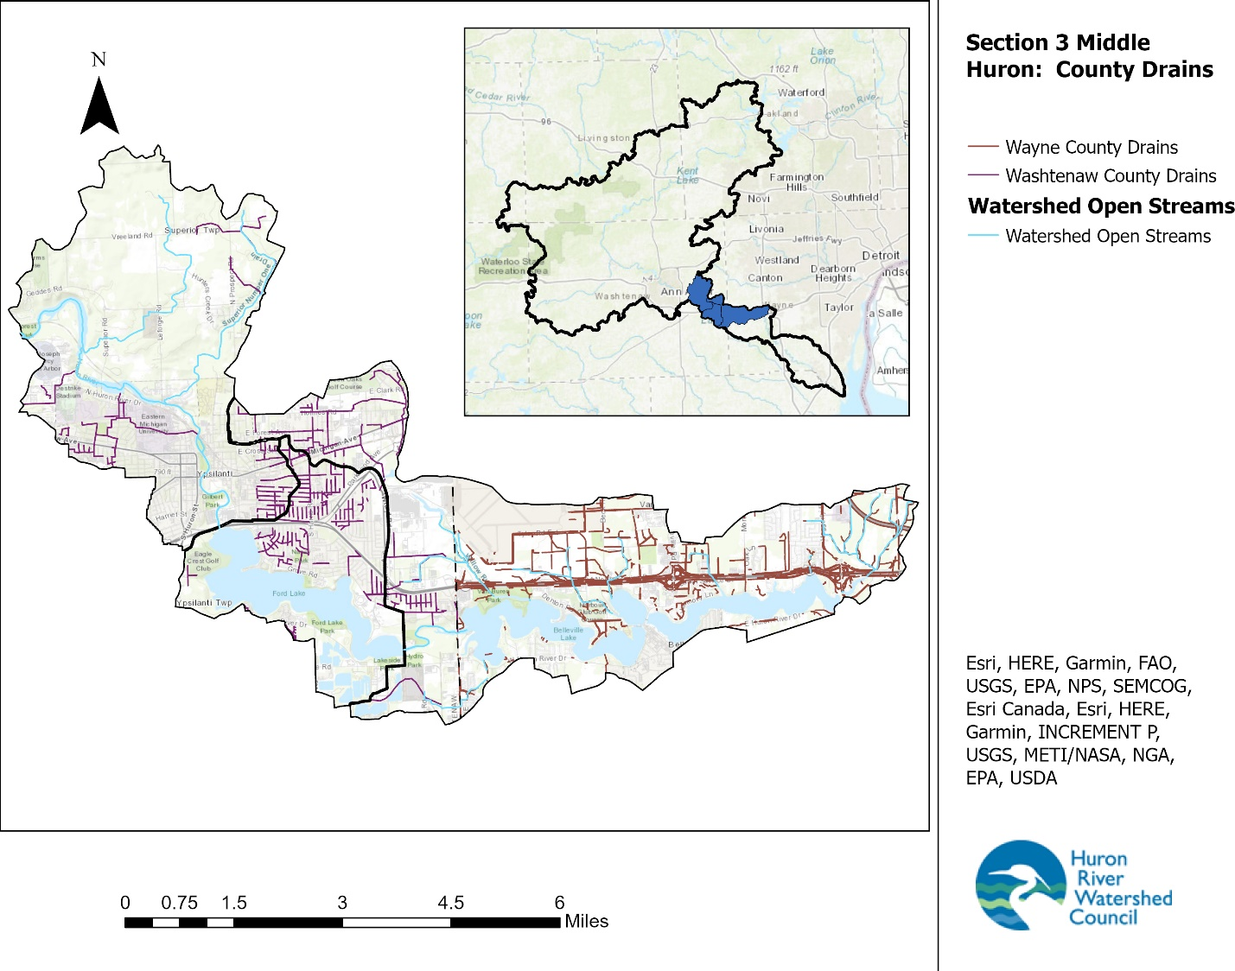

Each local government in the watershed has a zoning code and holds regularly scheduled meetings where rulings are made on policy additions and changes, budgets, land use issues, and other important local business. Working with the guidance of statewide procedures, townships and other local governments have power to formulate land use and development policy, among other important activities.

While state and county governments take an active role in many relevant watershed or water quality regulations and policies, local governments assume much leadership in land and water management by passing and enforcing safeguards. These local ordinances can be more protective than state laws, though state regulations set minimum protections that cannot be violated. Working under numerous established procedures, local governments may enact ordinances to control stormwater runoff and soil erosion and sedimentation; protect sensitive habitats such as woodlands, wetlands and riparian zones; and establish watershed-friendly development standards and lawn care and landscaping practices, among other options. Local governments oversee enforcement of their policies.

2.2.2. Growth Trends

Prior to European settlement, the region around the watershed was home to Chippewa and Potawatomi Native American tribes who had long used the land for farming, hunting, and gathering. Despite an unfavorable report by the U.S. Surveyor-General in 1815 that characterized the soils in the area as being unsuitable for farming, European settlers soon began to recognize the area’s agricultural potential, which subsequently became an important area for livestock and grain in the 19th century. The settlers moved in, forcibly displacing the original inhabitants and massively altering the ecological landscape. This agricultural trend thrived until, in the wake of World War II, growth in southeast Michigan was catalyzed by the baby boom, increased automobile ownership, and establishment of better road systems. As a result, the influence of agriculture began to diminish as land was transferred to urban and suburban uses in a trend that continues today.

Federal decennial census data shows the historical rate of growth in the Watershed area, and then a SEMCOG model predicts future growth (Table 2.4)., From 1990 through 2020, the core communities’ population modestly increased (22%). This increase should be held in context with a comparison to Section 1 of the Middle Huron (Dexter, Chelsea areas) which has seen a 91% change and Section 2 (Ann Arbor) which has seen a 20% change.

The largest contributor to population increase was Ypsilanti Township, whose population increased by approximately 10,000 people, and Van Buren Township (9,000 people). Superior Township increased by the highest percentage with 70% but the absolute numbers are lower (6,000 people). The City of Ypsilanti was the only to area to have a population decrease (about 4,000 people, -17%)
All of the municipalities, including the City of Ypsilanti, are expected to grow by some positive rate in population by 2030 and 2040, but SEMCOG notes that the recession in the circa-2010 timeframe contributed to a slowing growth period and that in general the rate of growth is predicted to be slower from 2020-2040 than it was from 1990-2010.
Changes in total housing also reflect the changing population throughout the Watershed. Building of housing closely reflects population growth.
Table 2.4. 1990-2040 Population Changes for Core Communities in the Watershed
 | 1990 Census | 2000 Census | 2010 Census | 2020 Census | % change 1990-2020 | 2030 SEMCOG forecast | 2040 SEMCOG forecast
City of Belleville | 3,270 | 3,997 | 3,991 | 4,008 | +23% | 3,613 | 3,724
City of Ypsilanti | 24,846 | 22,237 | 19,435 | 20,648 | -17% | 23,412 | 24,290
Superior Township | 8,720 | 10,740 | 13,058 | 14,832 | +70% | 16,285 | 18,689
Van Buren Township | 21,010 | 23,559 | 28,821 | 30,375 | +45% | 33,163 | 35,398
Ypsilanti Township | 45,307 | 49,182 | 53,362 | 55,670 | +23% | 56,198 | 60,371
Total of Cities and Townships | 103,153 | 109,715 | 118,667 | 125,533 | +22% | 132,671 | 142,472
Washtenaw County | 282,937 | 322,770 | 344,791 | 372,258 | +32% | 415,606 | 444,139
Wayne County (excluding Detroit) | 1,083,713 | 1,109,892 | 1,106,788 | 1,154,450 | +7% | 1,107,172 | 1,134,274

2.2.3. Land Use and Development
As the Watershed’s communities develop, the potential increases for negative environmental impacts, including water quality impacts from erosion, sedimentation, and increased inputs of stormwater pollutants. Potential impacts on water quantity also increase as wetlands, woodlands, floodplains and other natural features that regulate water quantity are altered or replaced with impervious surfaces.
Prior to permanent European settlement, oak and hickory forests dominated the upper morainal portion of the Watershed. This dominant landscape was interspersed with patches of wetlands, such as shrub swamps and wet prairie (Figure 2.13).
The downriver portion of the Watershed is quite flat (Section 2.1.2. Geology, Soils, and Groundwater) as it is the ancestral lakebed of Lake Erie during the previous Ice Age. The area immediately around the Huron River was covered in hardwood swamps, with black oak barrens in drier uphill soils. The area also had significant amounts of beech-maple forests where Belleville Lake is today.

Figure 2.9. Watershed’s Ecosystems, circa 1830’s.
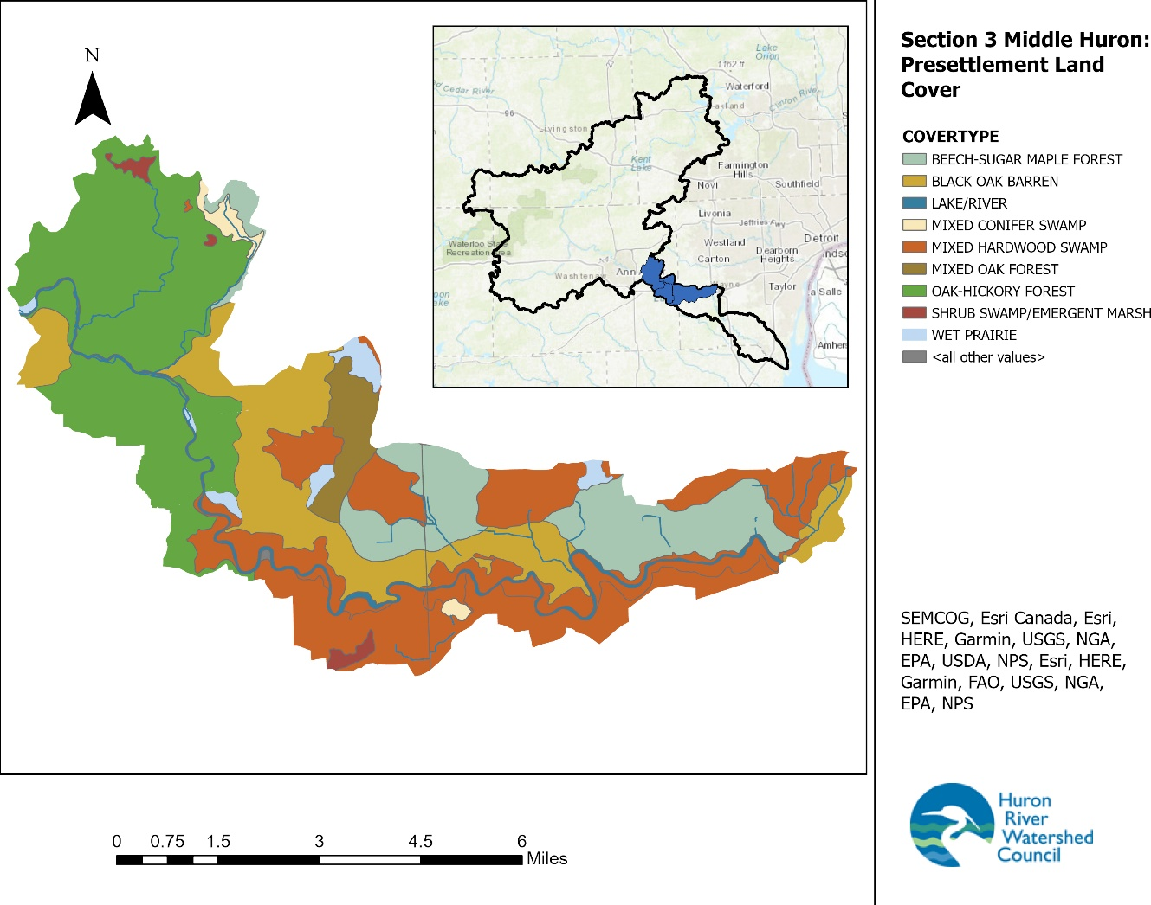
Upon permanent settlement, the land began to be used for human benefit. Initial activities on the land centered on the clearing of grasslands and draining of wetlands for agricultural production and the use of forested areas for wood and wood by-products.
The most recent land use data indicates the significant changes to the landscape that have occurred since settlement. (Figure 2.10). A very simple breakdown is that the Watershed (36 square miles) is 9% agriculture/rural residential, 29% natural lands including wetlands, fields, and forests, 12% open water due to Ford and Belleville Lakes, and 37% urban/developed. 13% are other uses that don’t fit neatly into these categories like cemeteries, utilities, parks, vacant lots, and golf courses (Tables 2.5).
While 29% of the land is still natural, much of that is heavily affected by development impacts, and there is considerable potential for the reduction of water quality through stormwater runoff and agricultural practices. In addition, the vast majority of those natural lands are designated for some kind of residential, agricultural, or commercial land use (based on local government master plans and zoning ordinances), so their status can easily change when development proceeds forward.
The Watershed is a part of the Middle Huron River, and does not exist in isolation. It receives substantial water from upstream, which comes into the Watershed with some water quality problems of its own.
The land area upstream of the Middle Huron Section 1 is almost 500 square miles, is 9% impervious, and made up of landcover and land use with the following breakdown: 24% forest, 19% agriculture, 5% open water, 1% grassland, 18% wetland, and 33% urban and residential. The Chain of Lakes Watershed Management Plan, while getting dated at this point, is still the best source to understand the section of the Huron River immediately upstream of the Middle Huron River.
Section 1 of the Middle Huron is 204 square miles containing 43% natural lands (forest/wetland/grassland), 44% agriculture, and 10% urban and residential.
Section 2 of the Middle Huron is immediately upstream of the Watershed and is 81 square miles containing 17% natural lands (forest/wetland/grassland) 45% agriculture, and 36% urban and residential.
Figure 2.14. Land use and Land cover in 2020.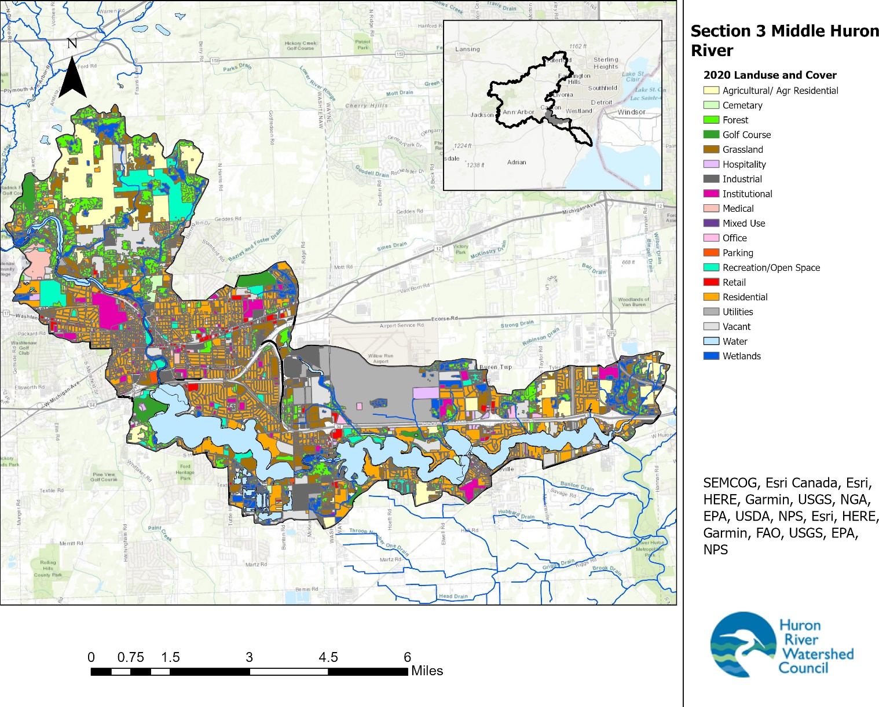

Table 2.5. 2020 Land use and Land cover in the Watershed, broken into the sub-watersheds.

Landuse/ Landcover | Subcategory | Superior Pond/Peninsular Pond/Huron River |  | Ford |  | Belleville |  | The Watershed (all)
 |  | Acres | % of Creekshed | Acres | % of Creekshed | Acres | % of Creekshed | Acres | % of Watershed
Total |  | 8016.5 | 100.0 | 3325.4 | 100.0 | 10329.6 | 100.0 | 21671.6 | 100.0
Agricultural / Rural Residential |  | 1337.0 | 16.7 | 56.1 | 1.7 | 565.4 | 5.5 | 1958.5 | 9.0
Cemetery |  | 59.7 | 0.7 | 8.0 | 0.2 | 17.8 | 0.2 | 85.5 | 0.4
Extractive |  | 0.0 | 0.0 | 0.0 | 0.0 | 0.0 | 0.0 | 0.0 | 0.0
Developed | Total Developed | 2176.8 | 27.2 | 1180.8 | 35.5 | 4653.0 | 45.0 | 8010.6 | 37.0
 | Hospitality | 31.4 | 0.4 | 9.8 | 0.3 | 123.8 | 1.2 | 165.0 | 0.8
 | Industrial | 150.8 | 1.9 | 16.9 | 0.5 | 455.7 | 4.4 | 623.4 | 2.9
 | Institutional | 325.0 | 4.1 | 66.7 | 2.0 | 284.9 | 2.8 | 676.6 | 3.1
 | Medical | 195.0 | 2.4 | 3.9 | 0.1 | 9.9 | 0.1 | 208.8 | 1.0
 | Mixed Use | 8.1 | 0.1 | 2.3 | 0.1 | 14.5 | 0.1 | 24.9 | 0.1
 | Office | 45.5 | 0.6 | 14.1 | 0.4 | 86.7 | 0.8 | 146.3 | 0.7
 | Parking | 40.8 | 0.5 | 7.2 | 0.2 | 5.2 | 0.1 | 53.2 | 0.2
 | Utilities | 30.6 | 0.4 | 18.8 | 0.6 | 1580.1 | 15.3 | 1629.5 | 7.5
 | Retail | 106.2 | 1.3 | 48.8 | 1.5 | 160.6 | 1.6 | 315.6 | 1.5
 | Attached Condo Housing | 4.0 | 0.0 | 9.7 | 0.3 | 23.3 | 0.2 | 37.0 | 0.2
 | Mobile Home | 0.0 | 0.0 | 42.2 | 1.3 | 123.7 | 1.2 | 165.9 | 0.8
 | Multi-family housing | 319.6 | 4.0 | 191.0 | 5.7 | 272.7 | 2.6 | 783.3 | 3.6
 | Single-family Housing | 919.8 | 11.5 | 749.4 | 22.5 | 1511.9 | 14.6 | 3181.1 | 14.7

Table 2.5, continued. 2020 Land use and Land cover in the Watershed, broken into the sub-watersheds.

Landuse/ Landcover | Breakout | Superior/Peninsular/Huron River |  | Ford |  | Belleville |  | The Watershed (all)
 |  | Acres | % of Creekshed | Acres | % of Creekshed | Acres | % of Creekshed | Acres | % of Creekshed
Forest | Total Forest | 1658.5 | 20.7 | 188.1 | 5.7 | 858.2 | 8.3 | 2704.8 | 12.5
 | Beech Maple | 19.3 | 0.2 | 0.1 | 0.0 | 7.2 | 0.1 | 26.6 | 0.1
 | Central Hardwood/Oak | 357.1 | 4.5 | 78.8 | 2.4 | 250.8 | 2.4 | 686.7 | 3.2
 | Dry-Mesic Oak Forest | 58.6 | 0.7 | 0.8 | 0.0 | 6.7 | 0.1 | 66.1 | 0.3
 | Dry Oak Forest | 168.9 | 2.1 | 17.1 | 0.5 | 135.7 | 1.3 | 321.7 | 1.5
 | Maple Basswood | 1054.1 | 13.1 | 91.3 | 2.7 | 456.4 | 4.4 | 1601.8 | 7.4
 | Northern Hardwoods | 0.1 | 0.0 | 0.0 | 0.0 | 0.0 | 0.0 | 0.1 | 0.0
 | Northern Pine-Oak | 0.4 | 0.0 | 0.0 | 0.0 | 1.4 | 0.0 | 1.8 | 0.0
 | Pine | 0.0 | 0.0 | 0.0 | 0.0 | 0.0 | 0.0 | 0.0 | 0.0
Golf Course |  | 95.4 | 1.2 | 116.5 | 3.5 | 150.1 | 1.5 | 362.0 | 1.7
Grassland | Total Grassland | 803.9 | 10.0 | 301.6 | 9.1 | 919.9 | 8.9 | 2025.4 | 9.3
 | Grass and shrub land | 803.0 | 10.0 | 301.6 | 9.1 | 919.7 | 8.9 | 2024.3 | 9.3
 | Pine-Oak Barrens | 0.9 | 0.0 | 0.0 | 0.0 | 0.2 | 0.0 | 1.1 | 0.0
Recreation/ Open Space |  | 633.1 | 7.9 | 102.5 | 3.1 | 184.9 | 1.8 | 920.5 | 4.2
Table 2.5. 2020 Land use and Land cover in the Watershed, broken into the sub-watersheds.

Landuse/ Landcover | Breakout | Superior/Peninsular/Huron River |  | Ford |  | Belleville |  | The Watershed (all)
 |  | Acres | % of Creekshed | Acres | % of Creekshed | Acres | % of Creekshed | Acres | % of Creekshed
Wetlands | Total Wetland | 445.2 | 5.6 | 223.8 | 6.7 | 881.6 | 8.5 | 1550.6 | 7.2
 | Aquatic Bed Wetland | 0.0 | 0.0 | 18.3 | 0.6 | 21.4 | 0.2 | 39.7 | 0.2
 | Emergent Wetland | 0.0 | 0.0 | 43.5 | 1.3 | 9.5 | 0.1 | 53.0 | 0.2
 | Flats | 0.0 | 0.0 | 0.0 | 0.0 | 0.7 | 0.0 | 0.7 | 0.0
 | Floodplain | 202.2 | 2.5 | 7.0 | 0.2 | 181.0 | 1.8 | 390.2 | 1.8
 | Lowland Conifer | 0.0 | 0.0 | 0.0 | 0.0 | 0.0 | 0.0 | 0.0 | 0.0
 | Lowland Hardwoods | 81.2 | 1.0 | 55.9 | 1.7 | 282.4 | 2.7 | 419.5 | 1.9
 | Mixed Wooded Wetland | 2.1 | 0.0 | 0.0 | 0.0 | 8.3 | 0.1 | 10.4 | 0.0
 | Rich Swamp | 96.3 | 1.2 | 59.8 | 1.8 | 63.5 | 0.6 | 219.6 | 1.0
 | Shrub-Herbaceous Wetland | 17.6 | 0.2 | 38.4 | 1.2 | 66.2 | 0.6 | 122.2 | 0.6
 | Shrub/Scrub Wetland | 45.8 | 0.6 | 0.0 | 0.0 | 244.5 | 2.4 | 290.3 | 1.3
 | Swamp | 0.0 | 0.0 | 0.9 | 0.0 | 4.1 | 0.0 | 5.0 | 0.0
Water |  | 173.2 | 2.2 | 1000.4 | 30.1 | 1362.7 | 13.2 | 2536.3 | 11.7
Vacant |  | 633.7 | 7.9 | 147.6 | 4.4 | 736.0 | 7.1 | 1517.3 | 7.0

2.2.4. Point Sources and Permitting
Due to the nutrient TMDLs in Ford and Belleville Lakes, waste load allocations for phosphorus contributions from permitted point sources have been established in all upstream contributing portions of the Huron River watershed. These waste load allocations set goals on the maximum amount of phosphorus that should be discharged into waters flowing to these TMDL areas. These limits are considered when determining the amount of phosphorus that may be discharged by existing National Pollutant Discharge Elimination System (NPDES) permittees. The TMDL may also factor into determining whether additional phosphorus-discharging facilities may be permitted to locate in a TMDL area, and what their discharge limits may be.
There are several point source facilities in the Watershed that hold NPDES permits issued by the State of Michigan, and the discharge points were mapped in Figure 2.15. The number of permitted point sources is not static due to expiring old permits and activation of new permits. More information can be found on any point by using EGLE’s MiWaters tool.

As of July 2023, according to EGLE’s Water Resources Division Permits Section, 12 permits were in issuance that discharge include the Huron River, streams or drains, and impoundments in the Watershed.

Individual Permits are written to reflect site-specific conditions of a single discharger and is unique to that discharger. There were 3 of these in the Watershed as of July 2023.

- MI0060221—Willow Run Airport MS4
- MI0056413—Wayne Disposal Inc, stormwater
- MI0059159—Rock Ridge Estates, (discharge type not listed)
- MI0022217 and NEC187195—Ann Arbor Wastewater Treatment Plant (just upstream of Watershed), wastewater and industrial stormwater

7 of the permits were for NPDES Certificate of Coverage under General Permit (COC). General permits contain effluent limitations protective of most surface waters statewide but are not tailored to a specific permittee.

- MIG081222- Sunoco, petroleum contaminated wastewater
- MIS410025- Marsh Plating Corp, Industrial stormwater
- MIS410057- Ford-Rawsonville Plant, Industrial stormwater
- MIS410138- Cadillac Asphalt LLC, Industrial stormwater
- MIS410590- R & L Carriers, Industrial stormwater
- MIS410711- WTPS Willis Terminal, Industrial stormwater
- MIS420050- Holbrook Auto Parts, Containment stormwater

Figure 2.15. NPDES permits in the Watershed, as of July 2023.
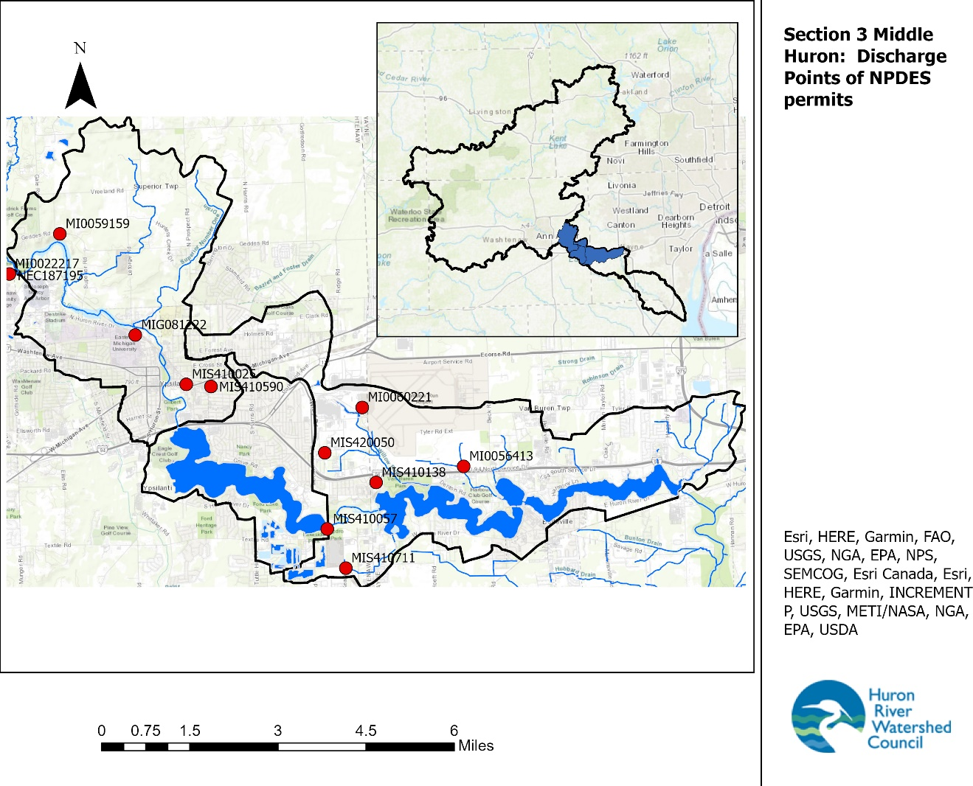

2.2.5. Sanitary Sewer Service Areas and Privately-Owned Septic Systems

Waste discharges can be treated by publicly owned wastewater treatment plants (WWTP) or on-site decentralized wastewater systems (privately-owned septic systems). The entire Watershed is piped to send wastewater to the Ypsilanti Community Utilities Authority (YUCA) WWTP.

Sanitary sewers rely on the connection of pipes from residential, commercial, and industrial sites that ultimately are received at a wastewater treatment plant where treatments are applied before discharge. Privately owned on-site septic systems, or septic tanks, allow wastewater from a single (sometimes multiple) entity to be treated via biological and infiltration processes. Both technologies are effective methods of wastewater treatment if maintained and operated properly; however, impairments do occur.

Improperly functioning sewer systems and privately-owned septic systems can have a profound impact on water quality. By carrying nutrients (phosphorus and nitrogen), bacteria, pharmaceutical agents, and other pollutants to waterbodies with little or no treatment, impaired systems can result in unhealthful conditions to humans (i.e., bacterial contamination) and to aquatic organisms (i.e., low dissolved oxygen from plant growth).

If either system is designed, constructed, or maintained improperly, it can be a significant source of water pollution and a threat to public health. The County Health Departments regulate the design, installation, and repair of privately-owned septic systems.

Sanitary sewer systems can suffer from improper installation and maintenance. For instance, in many older developments sanitary sewer pipes can be inadvertently connected to stormwater drainage systems, causing what is termed an “illicit discharge.” These discharges can have an even greater impact on water quality than impaired septic systems, depending on the type, volume, and frequency of the activity. Both county and local units of government covered by Phase II stormwater permits are required to identify and eliminate illicit discharges in their communities through an Illicit Discharge Elimination Program (IDEP).

2.3 Water Quality Parameters

This section provides a synopsis of water constituents and how they make up and affect the aquatic ecosystems of the Watershed. Many of these parameters are also indicators for gauging water quality. A general discussion of basic limnology (lake behavior) is also presented. While these parameters are important and useful in evaluating overall water quality, data for all of them were not readily available for all creeks in the Watershed. For the data that is available, it has been broken down to the creekshed level and presented in Section 2.4.

2.3.1. Chemical and Physical Parameters

2.3.1.1 Stream Morphology and Substrate

Stream channels provide a diversity of habitats for aquatic life and each serves a different function for the stream ecosystem. Most natural stream channels alternate through a pattern of riffles (small rapids), runs, glides and pools. The specific shape and pattern is controlled by the underlying geology (bedrock, rocks and soils) and hydrology (pattern and size of stream flow). Natural streams can take on a variety of forms along the journey from headwaters to confluences, and these forms are generally dynamic – changing somewhat following each major storm. If the stream has a good connection to its floodplain, it might meander from one channel to another and back again over the years. As this movement occurs, the stream lifts, transports and deposits sediment into its channels or floodplains, creating new aquatic and upland habitat.

As hydrology is altered (e.g. through artificial channelization or upland urbanization and disconnection to groundwater), storm flows increase, and the erosion rates of stream banks and beds increase as well. This can result in homogenization of channel type, habitat destruction, and loss of important sediment and chemical processing functions. Phosphorus can be exported with higher erosion, and stagnant, low oxygen pools can form that promote bacterial growth. Highly altered streams of this type produce biological communities with very low diversity.

Stream bottoms or substrate can be composed of a number of different materials, depending on the geology of the stream bed and surrounding drainage area. This substrate can vary from a predominance of large particles such as gravel, cobble or even bedrock to moderately sized sands to fine organic particles in silt and clay. Silt, which is the fine-grained particulate matter that results from eroded soil, can be deposited in streams over substrate composed of larger particles. Silt in riffles can limit the number of creatures living in a creek because it fills the spaces between surfaces and reduces oxygen in the substrate. Eroded silt also degrades water quality because soil binds pollutants, like phosphorus, which helps to create nuisance algae blooms. Many streambeds in the Huron River system are naturally sand or gravel bottoms. When fine sediments build up too fast, the natural aquatic ecology cannot rapidly adapt and the biotic diversity may be degraded. Erosion is a natural process, but dramatic increases in fine sediment suggest unnaturally high erosion rates upstream. Evaluation of stream banks can help determine the need for bank and channel restoration.

One method HRWC uses to assess stream habitat is through a procedure called “Measuring and Mapping”, which itself is a volunteer friendly version of EGLE’s Procedure 51 Habitat Assessment. In this assessment, volunteers conduct a pebble count/substrate size analysis across ten cross sections of the creek, assessing at a minimum 100 pieces of substrate and then computing overall substrate size percentages (% boulder, cobble, rock, gravel, sand, fines/muck). Volunteers also answer qualitative questions regarding amount and quality of riffles, runs, pools, riparian habitat, woody debris, and so on. HRWC use these answers to calculate a stream habitat score with the same metrics used in the P51 assessment.

In recent years, HRWC began using a method called BANCS (Bank Assessment for Non-point source Consequences of Sediment, Appendix C) to evaluate the stability of representative stream reaches (i.e. segments) throughout the Huron River Watershed. In summary, the rapid evaluation method assesses the erodibility of a stream reach’s banks and the hydraulic forces impacting those banks to estimate erosion rates for each bank. These bank assessments can then be compiled into an overall erosion rate for the stream reach or average rates for all evaluated streams within a creekshed. The erosion estimates should only be used to get a general sense of the scale of erosion relative to other streams in the system (rather than taken as precise estimates of sediment load), as the techniques are designed for a rapid and broad assessment.

Given the size of the Watershed and total length of streams, as well as the ability to access the streams, HRWC needed to assess a sample of reaches rather than attempt a full census. HRWC evaluated the accessibility of all stream reaches in the watershed and scheduled the assessment of all accessible stream reaches. During assessment, some reaches were determined to be impassible at points or impossible to find. Most river reaches were too deep to wade, but several important reaches were accessible. Most accessible reaches were assessed. For this Watershed, teams of HRWC field assessors were able to evaluate 11.8 miles of stream/river to estimate erosion rates for 25.1 miles of stream reaches.

Results for each creekshed are presented in section 2.4, but Figure 2.16 shows the evaluated stream reaches and their erosion rates. Within the Watershed, the majority (59%) of stream reaches have high erosion rates (Table 2.6). Most of the remaining reaches have a moderate erosion rate, with only one reach with a low erosion rate, or stable banks. Reaches with high erosion rates tended to be in the mid-range of drainage area size class, as none of the river sites had high rates. The only low erosion rate stream was a small headwater stream. Huron River reaches had moderate erosion rates, which bring mean and median drainage areas up.

Table 2.6. Summary of BANCs results for the Watershed.

Erosion Rate | # of Reaches | % of Assessed | Assessed Reach Length (mi) | % of Total Length | Mean Drainage Area (mi²) | Median Drainage Area (mi²)
High | 13 | 59% | 13.8 | 55% | 1.36 | 0.82
Moderate | 8 | 36% | 1.4 | 39% | 107.5 | 2.30
Low | 1 | 5% | 9.9 | 6% | 0.35 | 0.35
Total | 22 | 100% | 25.1 | 100%

Figure 2.16 Estimated Unit Erosion Rates (in tons/yr/ft of stream) for Evaluated Stream Reaches. Note: Inaccessible reaches are in blue.
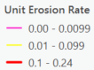
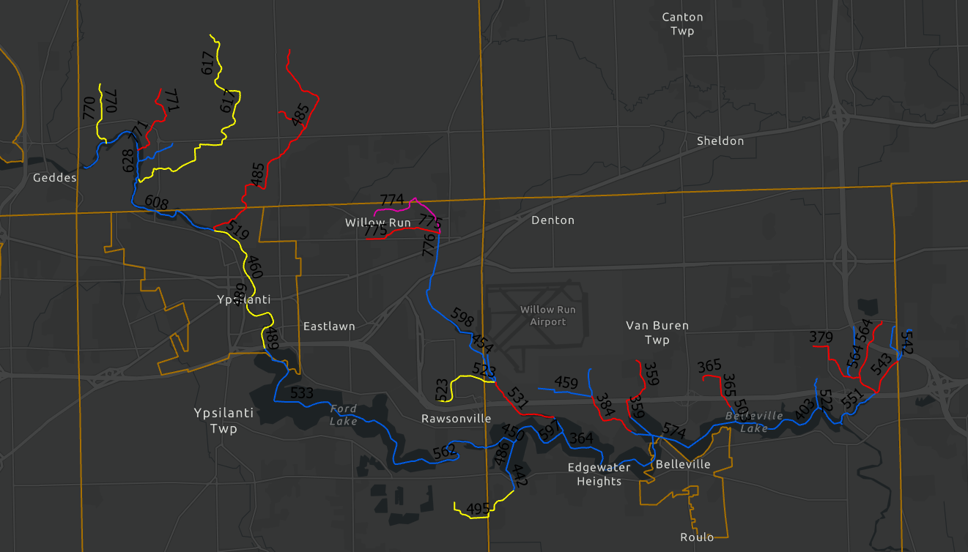
Medium
High
Low

2.3.1.2 Phosphorus

Phosphorus and nitrogen are nutrients essential for the growth of aquatic plants. Phosphorus is needed for plant growth and is required for many metabolic reactions in plants and animals. Generally, phosphorus is the limiting nutrient in freshwater aquatic systems. That is, if all phosphorus is used up, then plant growth will cease no matter how much nitrogen is available. Phosphorus is the main parameter of concern that causes excessive plant and algae growth (eutrophication) in lakes and impoundments. The extent to which this process has occurred is reflected in a lake's trophic classification: oligotrophic (nutrient-poor or low plant productivity), mesotrophic (moderate nutrient levels and moderate plant productivity), eutrophic (nutrient-rich, high plant productivity) and hypereutrophic (excessive plant productivity and excessive nutrients). Eutrophic and hypereutrophic conditions are characterized by depletion of dissolved oxygen in the water. Low levels of dissolved oxygen adversely affect aquatic animal populations and can cause fish kills. High nutrient concentrations interfere with recreation and aesthetic enjoyment of waterbodies by causing reduced water clarity, unpleasant swimming conditions, foul odors, blooms of toxic and nontoxic organisms, and interference with boating.

Phosphorus enters surface waters from point and nonpoint sources, with nonpoint sources accounting for the vast majority of phosphorus loading in the Watershed. Wastewater treatment plants are the primary point sources of the nutrient. Additional phosphorus originates from the use of industrial products, such as toothpaste, detergents, pharmaceuticals and food-treating compounds. Tertiary treatment of wastewater, through biological removal or chemical precipitation, is necessary to remove more than 30% of phosphorus.

Nonpoint sources of phosphorus include human, natural, and animal sources. Because phosphorus has a strong affinity for soil, stormwater runoff from activities that dislodge soil or introduce excess phosphorus (such as conversion of land to urban uses and over-fertilization of lawns) is frequently considered the major nonpoint source of phosphorus contribution to waterbodies. Eroded sediments from agricultural areas carry phosphorus-containing soil to surface waters. Septic system failures and illicit connections also are routes for phosphorus introduction. Domesticated animal and pet wastes that enter surface waters comprise another nonpoint source of phosphorus. Natural sources include phosphate deposits and phosphate-rich rocks that release phosphorus during weathering, erosion and leaching; and sediments in lakes and reservoirs that release phosphorus during seasonal overturns. EGLE considers total phosphorus concentrations higher than 0.03 mg/L (parts per million) to have the potential to cause eutrophic conditions.

Due to the persistent and systemic presence of high concentrations of phosphorus in Ford and Belleville Lakes, as well as the Huron River and tributaries upstream in the watershed, high nutrient loading is the top challenge identified in this Plan. A TMDL for excessive phosphorus loading from point and nonpoint sources has been established for Ford and Belleville Lakes and their contributing waters. While the flowing Huron River and its tributaries do not generally show signs of excessive phosphorus concentrations, the impoundments along these waterways tend to act as sinks for phosphorus loading, which can lead to eutrophic conditions.

2.3.1.3 Nitrogen
Nitrogen is also considered essential in determining algae growth in lakes and is found in a number of forms, including molecular nitrogen, ammonia, nitrates, and nitrites. Nitrogen is often found in waterbodies at higher concentrations than phosphorus. Consequently, nitrogen is often not considered the limiting nutrient to detrimental growth. Additionally, unlike phosphorus loading, nitrogen loading is often difficult to reduce due to the high water solubility of nitrogen. Therefore, concerns regarding nitrogen and its role in eutrophication often are considered secondary to phosphorus in southeast Michigan. However, studies have shown that high nitrate concentrations, even with phosphorus limitations, can promote eutrophication. In addition, studies also reveal that dual control on nitrogen and phosphorus result in short term reductions in eutrophication. Typical sources of nitrogen in surface waters include human and animal wastes, decomposing organic matter, and runoff from fertilizers. Improperly operated wastewater treatment plants and septic systems, as well as sewer pipeline leaks also can act as additional sources of nitrogen to waterbodies. EGLE considers total nitrogen levels greater than 1 to 2 mg/L to have the potential to cause eutrophic conditions. Nitrate levels above 10 mg/L are considered unsafe for drinking water.

2.3.1.4 Salts, Conductivity, and Total Dissolved Solids
Salts typically enter waterways from road salting (de-icing) operations or from water softener backwash discharge into the environment. De-icing products, primarily sodium chloride, are used locally by MDOT, county road commissions, homeowners, and business/commercial establishments. Salts are highly soluble in water and easily wash off pavement into surface waters and leach into soil and groundwater. High concentrations of salt can damage and kill vegetation, disrupt fish spawning in streams, reduce oxygen solubility in surface water, interfere with the chemical and physical characteristics of a lake, and pollute groundwater making well water undrinkable.
A study by the USGS in Oakland County on the effects of urban land use change on streamflow and water quality showed a strong positive correlation between salt ions (sodium, potassium, and chloride) and residential and commercial landcovers, as well as overall percentage of the watershed built, and population density. These ions were negatively correlated with agriculture, open space, forest, and wetland land covers. While it may be reasonably stated that the rapid urbanization in the Watershed has led to increased salt concentrations in the water, the extent to which this is occurring, and the impacts of these salt concentrations requires additional monitoring data and studies.
Michigan has a relatively new water quality standard for chloride concentration. Chloride is the most persistent and harmful component of most salts. Based on this standard, the chronic and acute impacts on aquatic wildlife occur at relatively high chloride concentrations – approaching sea water concentrations.

Best management practices to reduce salt inputs may include the use of alternative road deicers such as calcium carbonate, magnesium chloride or calcium acetate that are not as detrimental to water quality. In addition to salt alternatives, proper calibration of salt dispensing equipment and optimizing the timing of deicing applications can reduce over-use of salt and alternative deicers.
Conductivity, a broad indicator of general water quality, increases with the amount of dissolved ions, such as salts or metals. There is some evidence that average conductivity measured at a site over 800 microsiemens (µS) can be correlated with lower stream biodiversity. Conductivity over 800 µS may indicate the presence of toxic substances, but it can also be high due to naturally occurring ions. Many toxins are also not detected by conductivity measures. A high conductivity measurement signals a need for further investigation to better determine the cause and potential sources.
Since 2002, conductivity has been recorded at sites in the Watershed through the Chemistry and Flow Monitoring Program. Monitoring data is collected twice monthly from April through September. In addition, conductivity is monitored by HRWC’s River Roundup program when the volunteer teams sample macroinvertebrates.
Conductivity is also highly correlated with Total Dissolved Solids (TDS), which include anything dissolved in water including minerals, salts, metal, cations, anions and organic molecules. Though a more accurate measurement for expressing the chemical constituents of water, TDS is a more expensive and complicated measurement to make, and thus Conductivity is often used in lieu of TDS.

2.3.1.5 Organic Compounds and Heavy Metals
Organic compounds (PCBs, PFAS, PAHs, DDT, etc.) and heavy metals (lead, copper, mercury, zinc, chromium, cadmium, etc.) can potentially cause adverse impacts on river ecosystems. These chemicals and metals can disrupt the physiology of aquatic organisms and can accumulate in their fatty tissues. Organic chemicals such as PCBs are by-products of manufacturing processes and the combustion of fossil fuels. They are also present in automobile fluids such as gasoline and oils. Other organic chemicals are found in pesticides and herbicides. Heavy metals are also a common by-product of manufacturing, but these contaminants are also common in agricultural and road runoff.

In the Watershed, potential sources of organic compounds and heavy metals include urban areas, roads, permitted industries, existing in-stream contamination from historic activities, chemicals from lawns, and runoff from agricultural operations.

Coal tar sealcoats are incredibly high in polycyclic aromatic hydrocarbons (PAHs). PAHs are of concern because many of these compounds have been identified as toxic, mutagenic, teratogenic (causing birth defects) and/or probable human carcinogens. Coal tar sealants contain 1000 times more PAHs than asphalt-based sealants (a readily available alternative) and are the number one source of PAHs in lake sediments. PAHs from coal tar sealcoat are released into the environment in several ways. When applied, these compounds volatilize into the air, affecting air quality. As the sealcoat weathers, dust from the pavement makes its way into homes on shoes and clothing. When it rains, loose particles move into soils, stormwater catch basins, lakes, and rivers.

HRWC has done significant work on PAHs in the last decade. HRWC conducted PAH sampling in several detention ponds in Fleming, Mallets, and Traver Creeksheds (results shown in the Middle Huron River Section 2 Watershed Management Plan). Results show that the area has elevated PAH levels; and since studies indicate that 50-75% of PAHs found in sediments in the Great Lakes Region come from coal tar sealants, HRWC has worked with municipalities to pass ordinances restricting use. Within the Watershed, the City of Ypsilanti and Van Buren Township have adopted ordinances that make it illegal to sell or apply high PAH pavement sealers.

Polyfluoroalkyl substances (PFAS/PFOS) are a family of manmade organic molecules that were revealed to be a problem in the Huron River Watershed in August 2018, after EGLE reported high levels in the tissues of fish from Kent Lake. In 2018, the Michigan Department of Health and Human Services has issued a “Do Not Eat Fish” advisory for most of the Huron River from the crossing at North Wixom Road in Milford all the way to Lake Erie. This includes the Huron River section contained in the Watershed of this Management Plan. The Huron is now listed for failure to meet the Fish Consumption designated use in the 2022 EGLE Integrated Report. This is a critical area that needs further addressing. See more details in section 2.5.2.4- Fish Consumption Advisory on the Huron River: Perflurooctane Sulfonate (PFOS) Impairment.

A number of international, national and regional studies over the past two decades have documented the presence of pharmaceuticals and personal care products (PPCPs) and endocrine disrupting compounds (EDCs) in surface waters. PPCPs include substances such as drugs and cosmetics. EDCs are any chemicals that have been shown to interfere with the normal function of the human endocrine system. Both types of compounds have potential human health and wildlife impacts. Researchers are currently working to evaluate the effects of environmental exposure to PPCPs and EDCs.

These substances can enter the environment through a number of routes including: wastewater treatment discharge, industrial discharge, runoff from confined animal feeding operations, and land application of animal waste. The U.S. Geological Survey conducted a national study of 139 streams in 30 states and found that 80% of those streams contained at least one of the 95 compounds they targeted.

In 2004, a targeted study conducted for the City of Ann Arbor assessed city waters for 22 compounds of concern. The researchers in that study found that ten of the 22 compounds were present in the source water in Barton Pond, with four remaining in finished drinking water; and 17 of the 22 compounds were found in wastewater influent, with 15 compounds making their way into the effluent discharged to the Huron River. The existing treatment processes for both drinking water and wastewater reduced the concentrations for most, but not all the target compounds.

2.3.1.6 Acidity (pH)
Measuring pH provides information about the H+ concentration in the water. pH is measured on a logarithmic scale that ranges from 0-14, so river water with a pH value of 6 is 10 times more acidic than water with a pH value of 7. Organisms that live in rivers and streams can survive only in a limited range of pH values. In Michigan surface waters, most pH values range between 7.6 and 8.0. Michigan Water Quality Standards require pH values to be within the range of 6.5 to 9.0 for all waters of the state. The pH of rivers and streams may fluctuate due to natural events, but humans also can cause unnatural fluctuations in pH. For example, chemical contamination from spills can cause short-term pH changes.

2.3.1.7 Turbidity and Suspended Sediments
While some sedimentation in a river system is natural, when streambanks in one area erode and the soil is deposited downstream, the Watershed experiences heavy sedimentation on the Huron River, its tributaries, and lakes and impoundments. Impacts of soil erosion and sedimentation on downstream water resources include decreased aesthetic quality with increased turbidity, decreased light penetration and decreased plant growth, and decreased aquatic habitat quality with sediment covering and clogging gills of fish and aquatic insects. In addition, nutrients and other pollutants often bond with soil particles, increasing the detrimental impacts of sedimentation on water resources.

Many streambeds in the Huron River system are naturally composed of sand, gravel, and cobble. However, a problem arises when there are rapid shifts from these coarse materials to more fine sediments. Excessive deposits of fine sediment are known to impair macroinvertebrate communities.

Increased stormwater flows result in increased sediment loadings for a variety of reasons. Soil particles are picked up by stormwater as it flows over roads, through ditches, and off of bridges into surface waters. Increased flows from stormwater runoff or dam discharge have enough energy to scour soils and destabilize stream banks, carrying bank sediments downstream. In addition, runoff from some construction sites can be sources of sediment if proper soil erosion and sedimentation controls are not in place on bare soil that has been exposed during the construction process. Sediment enters the water at bridges as a result of inadequate construction and maintenance practices, and via road ditches, which convey sediment from unpaved roads into the stream. Other sources of sediment include wash-off from paved streets and parking lots. Active agricultural land may be a source of concern in the rural areas of the Watershed since traditional farming practices leave soil bare and tilled at certain times of the year, which results in soil vulnerable to wind and water erosion.

Turbidity is the measure of the relative clarity of water and is a measure of the suspended solids in the water that reduce the transmission of light. This relationship depends on several factors including the size and shape of the suspended particles along with their density in the water, as well as the degree of turbulence at the sample site. Turbidity should not be confused with color since darkly colored water can still have low turbidity or high relative clarity. Total suspended solids (TSS) include all particles suspended in water that will not pass through a filter of a specified size. Suspended solids are any particles/substances that are neither dissolved nor settled in the water. A third measure, suspended sediment concentration (SSC) is now being promoted by EGLE, USGS and EPA as a more accurate measure for open channel monitoring. SSC differs from TSS in the methods of calculation. Both express the amount of sediments suspended in a sample of water.

High turbidity and TSS/SSC result from soil erosion, stormwater runoff, algal blooms and bottom sediment disturbances. Turbid water absorbs heat from the sun. Warmer water holds less oxygen than cooler water, resulting in less oxygenated water. Water with high turbidity loses its ability to support diverse aquatic biology. Suspended solids can be diverse in composition, including clay, silt and plankton as well as industrial wastes and sewage or other components. High amounts of suspended solids can clog fish gills, reduce growth rates and disease resistance in aquatic organisms, decrease photosynthesis efficiency, reduce dissolved oxygen (discussed in a later section) levels, and prevent egg and larval development. Settled particles can accumulate on the stream bottom and smother fish and amphibian eggs and aquatic insects including larvae of benthic macroinvertebrates.

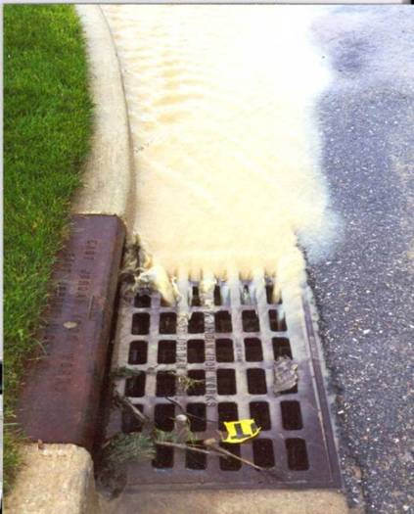
Michigan Water Quality Standards set a narrative standard that waters of the state shall not have any of the following unnatural physical properties in quantities which are or may become injurious to any designated use: turbidity, color, oil films, floating solids, foam, settleable solids, suspended solids, and deposits. Most observers consider water with a TSS concentration less than 20 mg/l to be relatively clear. Water with TSS levels between 40 and 80 mg/l tends to appear cloudy, while water with concentrations over 150 mg/l usually appears dirty. The nature of the particles that comprise the suspended solids may cause these numbers to vary. Standards have not been established for turbidity, but levels for turbidity have been set for stream segments that have been listed for impairment of biota.
A simple, though somewhat subjective, method of measuring water clarity in lakes uses a Secchi disk, which is an 8-inch diameter plate with alternating quadrants painted black and white. The observer lowers the disk into water until it disappears from view and then raises it until it becomes just visible. An average of the two depths, taken from the shaded side of the boat, is recorded as the Secchi disc reading. Nearly all Secchi disc measurements on Michigan inland lakes will be between one and forty feet, and this score is also an indicator of nutrient levels in the lake. EGLE classifies Secchi disk readings greater than 16 feet as indicative of oligotrophic (low nutrient) conditions. Secchi disk readings between 6.5 and 16 feet indicate mesotrophic conditions, and Secchi disk readings less than 6.5 feet indicate eutrophic (high nutrient) or hypereutrophic conditions.

2.3.1.8 Temperature
Water temperature directly affects many physical, biological, and chemical characteristics of a river. Temperature affects the amount of oxygen that can be dissolved in the water, the rate of photosynthesis by algae and larger aquatic plants, the metabolic rates of aquatic organisms, and the sensitivity of organisms to toxic wastes, parasites, and diseases. These factors limit the type of macroinvertebrate and fish communities that can live in a stream.

An average summer temperature of about 72º F is the warmest water that will support coldwater fish, such as sculpin and trout. Fish that can survive in warmer waters up to 77º F include smallmouth bass, rock bass, sunfish, carp, catfish, suckers, and mudminnows. Average summer temperatures above 77º F exclude many fish and cool water insects. Fluctuations in temperature also affect biodiversity. Extreme fluctuation in summer temperature, as defined by a difference of more than 18º F between the average maximum and average minimum stream temperature, have been found to decrease fish diversity at warm sites.

Thermal pollution—the discharge of heated water from industrial operations, dams, or stormwater runoff from hot pavement and other impervious surfaces—often causes an increase in stream temperature. The Michigan Water Quality Standards specify that the Great Lakes and connecting waters and inland lakes shall not receive a heat load that increases the temperature of the receiving water more than 3º F above the existing natural water temperature (after mixing with the receiving water). Rivers, streams and impoundments shall not receive a heat load that increases the temperature of the receiving water more than 5º F for warmwater fisheries. These waters shall not receive a heat load that increases the temperature of the receiving water above monthly maximum temperatures (after mixing).

All waters in the Watershed are warmwater fish streams. However, coldwater fish species are found occasionally in the Watershed, and the presence of EPT (Ephemeroptera-Plecoptera-Trichoptera) and sensitive aquatic insect families at monitoring sites is an indication of adequately cool stream temperatures. Sun exposure on impoundments, low flows below impoundments, removal of streambank vegetation, and inputs of stormwater runoff (which are typically substantially warmer than base stream flows) are all potential contributing factors to elevated water temperatures.

2.3.1.9 Dissolved Oxygen
Dissolved oxygen (DO) refers to the volume of oxygen that is contained in water.
DO is essential for fish and is an important component in the respiration of aerobic plants and animals, photosynthesis, oxidation-reduction processes, solubility of minerals, and decomposition of organic matter. Aquatic plants, algae and phytoplankton produce oxygen as a by-product of photosynthesis. Oxygen also dissolves rapidly into water from the atmosphere until the water is saturated. Dissolved oxygen diffuses very slowly and depends on the movement of aerated water. DO levels fluctuate on a diurnal basis. They rise from morning through late afternoon as a result of photosynthesis, reach a peak in late afternoon, then drop through the night as a result of photosynthesis stopping while plants and animals continue to respire and consume oxygen. DO levels fall to a low point just before dawn.

The amount of oxygen an organism requires varies according to species and stage of life. DO levels below 1-2 mg/L do not support fish. DO levels below 3 mg/L are stressful to most aquatic organisms. Minimal DO levels of 5-6 mg/L usually are required for growth and activity. Low DO levels encourage the growth of anaerobic organisms and nuisance algae. Cold water species like trout need between 9-12 mg/L, depending on the species. The accumulation of organic wastes and accompanying aerobic respiration by microorganisms as they consume the waste depletes DO in freshwater systems. High levels of bacteria from sewage pollution and high levels of organic matter can lead to low DO levels. Michigan Water Quality Standards states that surface waters protected for warmwater fish and aquatic life must meet a minimum dissolved oxygen standard of 5 mg/l.

2.3.2 Biological Parameters

2.3.2.1 Bacteria
Bacteria are microorganisms that are found everywhere. Coliform is a group of bacteria that includes a smaller group known as fecal coliforms, which are found in the digestive tract of warm-blooded animals. Their presence in freshwater ecosystems indicates that pollution by sewage or wastewater may have occurred and that other harmful microorganisms may be present. A species of fecal coliform known as Escherichia coli or E. coli is analyzed to test for contamination. E. coli counts are used as a measure of possible drinking water contamination, as high concentrations can result in serious illness. The potential sources of E. coli in surface waters are varied and difficult to pinpoint. They include human sources such as failed septic fields, but also wildlife sources such as geese and raccoons and pet or feral sources as well.

Rule 62 of the Michigan Water Quality Standards (Part 4 of Act 451) limits the concentration of microorganisms in surface waters of the state and surface water discharges. Waters of the state that are protected for total body contact recreation must meet limits of 130 Escherichia coli (E. coli) per 100 milliliters (ml) water as a monthly geometric mean of five sampling events (3 samples per event) and 300 E. coli per 100 ml water for any single sampling event during the May 1 through October 31 period. The limit for waters of the state that are protected for partial body contact recreation is a geometric mean of 1000 E. coli per 100 ml water for any single sampling event at any time of the year.

2.3.2.2 Macroinvertebrates

Insects living in the creek compose the benthic macroinvertebrate population, along with clams and other mollusks, crayfish, and other taxa. Typically, monitoring focuses on insects (in aquatic stages of development) as they are representative of a variety of trophic levels, are sensitive to local environmental conditions and are easy to collect. Since the macroinvertebrate population depends on the physical conditions of the stream as well as water quality, its composition indicates the overall stream quality. Insect diversity indicates good stream quality and is measured by the number of different insect families. 87 benthic insect families are found in the Huron River Watershed.
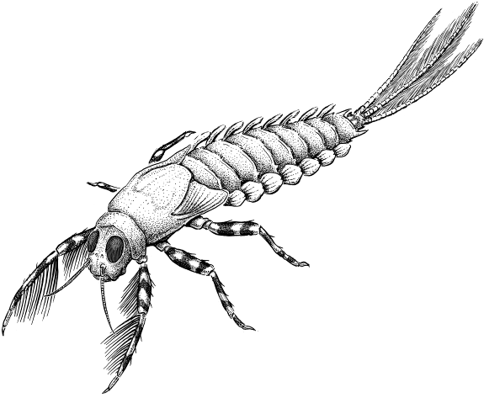
Macroinvertebrate data is collected through HRWC River Roundup event, formerly known as HRWC’s Adopt-a-Stream, which relies on trained volunteers to monitor more than 80 sites in the Huron River watershed, including 15 in the Watershed of this management plan. Monitoring data has been gathered since as early as 1992 at some sites through annual spring and fall collection days, and a winter stonefly search each January. Only one site in the Watershed is regularly sampled, on the Huron main branch in Ypsilanti.
Brush-legged Mayfly (Ephemeroptera isonychiidae) drawing: Matt Wimsatt
Insect families belonging to the orders of Ephemeroptera (mayflies), Plecoptera (stoneflies), and Trichoptera (caddisflies) are known as the EPT families, which are indicators of alterations in stream flow, temperature, oxygen and other changes that raise metabolic rates.
HRWC also uses Hilsenhoff’s Index of Biotic Integrity to understand the level of organic pollution tolerance in the insect community. Sensitive insect families, such as Perlidae (Perlid stonefly) and Brachycentridae (log-cabin caddisfly), are highly sensitive to organic pollution. William Hilsenhoff’s conducted a study that ranked macroinvertebrates on a scale of 0-10 in terms of pollution sensitivity. Organisms ranked 0, 1, or 2 are considered sensitive in HRWC’s protocols. 19 of the 87 benthic insect families living in the Huron River Watershed are sensitive. HRWC looks at numbers of Sensitive families as well as computing an overall Hilsenhoff IBI which is essentially a weighted average of the Hilsenhoff ranking, with 0 being Excellent and 10 being Very Poor. It is possible that a site with a high total insect family count can still have a poor Hilsenhoff IBI if the insect community there has a high proportion of pollution tolerant taxa.
The presence of winter stoneflies, which are active in January and require high levels of oxygen, are indicators of good stream quality. Absence of winter stoneflies suggests that toxic pollutants may be present. Since there is usually little or no stormwater runoff in January, there is a greater likelihood that any pollutants in the stream are persistent toxic substances present in the bottom of the streambed. Conversely, at a site where insect diversity is lower than expected but winter stoneflies are present, pollutants connected or related to stormwater runoff (i.e. nutrients or sediment) are more likely to be the problem.

2.3.2.3 Fish

Fish depend upon aquatic insects for food, and they also need good quality stream habitats and free-flowing reaches for all life cycle phases. More than 90 species of fish are native to the Huron River Watershed, however at least 99 species now live in its waters due to human-induced changes to the river’s fish communities. Many native species still are present and abundant, yet many have declined to the point of rarity and are considered threatened or endangered. Increased peak flows, reduced summer base flows, increased and more varied temperatures, and increased turbidity and sediment loads have negatively affected critical fish habitat requirements, particularly as they relate to spawning and survival of young fishes. Dams have also affected fish populations by altering temperature and flow patterns, as well as inundating more high-gradient reaches and blocking migrations among critical seasonal habitats within the river.
No information is available on the pre-European settlement fish community in the Middle Huron system. The headwaters and most tributaries of the Huron River had fairly stable flows. Summer water temperatures remained cool due to substantial water volumes, shaded banks, and local inflow of additional groundwater. Diverse habitats existed, including extensive gravel and cobble riffles, deep pools with cover, channel-side marshes, and flood plain wetlands.
A 1938 survey of the headwaters and tributaries upstream of Ann Arbor found about 25 species. Higher-gradient stretches with extensive gravel riffles and pools held mudminnow, hornyhead chub, silver shiner, rosyface shiner, common shiner, lake chubsucker, northern hog sucker, golden redhorse, black redhorse, yellow bullhead, stonecat, tadpole madtom, brindled madtom, longear sunfish, rock bass, smallmouth bass, rainbow darter, fantail darter, and greenside darter.
Vegetation-dependent mud pickerel, northern pike, blackstripe topminnow, and least darter were also present. Most common in the faster flowing, low gradient stretches connecting natural lakes were white sucker, largemouth bass, bluegill, pumpkinseed, Johnny darter, logperch, and yellow perch.
Today, the Huron River throughout most of the Watershed area is considered to be a good smallmouth bass recreational fishery and attracts many shoreline anglers and occasional wading anglers. Ford and Belleville Lake are known for walleye fishing and highly fished by shoreline anglers and by boaters. Details are available in Creekshed Current Conditions, Section 2.4.

The Huron River tributaries in the Watershed are considered mostly to be a “second quality warmwater fishery”. Second quality warmwater feeder streams are those that contain significant populations of warmwater fish, but game fish populations are limited by such factors as pollution, competition, or inadequate natural reproduction. Small streams are often difficult to fish because of their small size; typically less than 15 feet wide.

2.3.3. Limnology
Limnology is the physical, chemical, and biological science of study of freshwater systems, including lakes. Ford and Belleville Lakes are very important features in this Watershed. Thus, a general review of key lake processes and sources of water quality degradation are pertinent here.

Lake Productivity
While numerous water quality parameters are studied to determine the trophic status and water quality status of lakes, in-lake phosphorus concentrations are often the determining factor. Trophic status is a useful means of describing the water quality of a lake since it defines the expected productivity and biotic composition of the system. While many factors influence the overall trophic status of a lake, the interaction of climate, watershed characteristics (e.g., soils), and human influences are the most dominant (Figure 2.19).

Generally, a lake with concentrations of phosphorus less than 0.01 mg/L will be considered oligotrophic. A lake will be considered mesotrophic at concentrations of 0.01 mg/L to 0.02 mg/L and eutrophic to hypereutrophic at or greater than 0.02 mg/L or 0.03 mg/L. Oligotrophic and mesotrophic lakes normally support cold- or cool- water fisheries (e.g., trout, some species of bass) and numerous recreational activities. The water in these lakes is also often suitable for drinking water supply. Eutrophic lakes often support warm water fisheries (e.g. bass, bluegill, catfish, carp, etc.) and have a more limited recreational value compared to oligotrophic or mesotrophic lakes because of periodic nuisance algal blooms and aquatic macrophyte growth. Hypereutrophic lakes, which experience frequent and intense nuisance algal blooms, do not ordinarily support cold or warm water fisheries and offer little or no recreational value. In addition, these lakes often exhibit decrease in open water surface areas because of layers of algal and aquatic plant masses.

Temperate zone lakes, like those in the watershed, experience changes in water chemistry and biology throughout the year. As winter ice thaws in the spring, winds and temperature changes in surface waters cause mixing within the water column. The result is water with temperature, dissolved oxygen, and other variables that are essentially equal at all depths. This event is often referred to as a spring turnover. In the summer months, warm air temperatures interact with surface waters causing stratification or layering of lake water due to water temperature and density relationships. During this time of thermal stratification, little mixing of lake water occurs. Lakes that receive increased pollutant loading can exhibit quantifiable reductions in water quality at this time because of the lack of oxygen in the bottom water. As fall approaches, cooler air temperatures increase surface water density and mixing establishes uniformity within the water column in what is termed as fall turnover. During the winter months, the lake may stratify again.

Lakeshore Erosion and Development

Healthy shorelines are an important and valuable component of the lake ecosystem. The shoreline area is a transition zone between water and land and is a very diverse environment that provides habitat for a great variety of fish, plants, birds, and other animals. A healthy shoreline area is also essential for maintaining water quality, slowing runoff, and limiting erosion. Riparian areas also provide a critical influx of woody debris to our rivers and lakes; dead trees and branches along the shoreline provide critical fish habitat that is necessary for healthy fisheries and a dynamic ecosystem. Woody debris also reduces wave action against the shoreline, allowing aquatic plants to take root and provide more diverse habitat for other species to thrive. However, extensive development, often combined with poor shoreline management practices, can reduce or eliminate natural shoreline habitat and replace it with lawn and artificial erosion control such as seawalls and rock. As a result, shoreline vegetation is dramatically altered, habitat is lost, and water quality declines.

Ford and Belleville Lakes are known to have areas of high bank erosion (likely caused by shoreline development and exasperated by steep bank slopes). A DEQ survey was conducted in 2012 on Ford and Belleville Lakes (details in Section 2.4.3.3), but no other known surveys have been conducted on either lake.

Exotic Invasive Plants

Rooted aquatic plants are a natural and essential part of the lake, just as grasses, shrubs and trees are a natural part of the land. However, sometimes a lake is invaded by an aquatic plant species that is not native to Michigan. Some of these exotic plants, like Curly-leaf pondweed, Eurasian milfoil, Starry stonewort, and European frog-bit can be extremely disruptive to a lake’s ecosystem and recreational activities. These exotic plants can take over a lake by crowding out beneficial native plant species. An overabundance of exotic species can also negatively affect fish populations and human recreation.

Aquatic plants have not been well documented in Ford and Belleville Lakes (see section 2.4.2.9, Exotic Invasive Aquatic Plants)

Michigan Department of Environmental Quality. R 323.1004. Definitions; M to W. Rule 44.
EGLE, Part 91 Soil Erosion and Sedimentation Control Permitting Agencies https://www.michigan.gov/egle/about/organization/water-resources/soil-erosion/part-91-agencies. Accessed April 2023.
Southeast Michigan Council of Governments. https://semcog.org/custom-community-profiles. Accessed 2021.
Southeast Michigan Council of Governments. https://www.semcog.org/population-estimates. Accessed 2021.
Southeast Michigan Council of Governments. https://semcog.org/custom-community-profiles. Accessed 2021.
Southeast Michigan Council of Governments. https://www.semcog.org/population-estimates. Accessed 2021.
Southeast Michigan Council of Government. https://semcog.org/gis. Accessed 2021
Huron River Watershed Council, Huron Chain of Lake Watershed Management Plan. https://www.hrwc.org/wp-content/uploads/2013/08/HCOL_WMP.pdf, Accessed 2022.
Michigan Department of Environment, Great Lakes, and Energy. MiWaters Map, https://mienviro.michigan.gov/ncore/external/home. Accessed May 2023.
Steen, P. 2014. Procedure for the Stream Habitat Assessment. Huron River Watershed Council, https://www.hrwc.org/wp-content/uploads/Measuring-Mapping-Procedure_2014.pdf. Accessed May 2021.
Michigan Department of Environment, Great Lakes, and Energy.2008. Qualitative Biological and Habitat Survey Protocols for Wadeable Streams and Rivers https://www.michigan.gov/documents/deq/wb-swas-procedure51_280711_7.pdf. Accessed May 2021.
Livingston County Department of Public Health Environmental Health Division. 2002. Environmental Awareness Handbook. Livingston County, MI.
Aichele, Steven S. 2005. Effects of Urban Land-Use Change on Streamflow and Water Quality in Oakland County, Michigan, 1970-2003, as Inferred from Urban Gradient and Temporal Analysis. U.S. Geological Survey Scientific Investigations Report 2005-5016.
Dakin, T. and Martin, J. 2003a. Monitoring Gazette, Winter-Spring 2003. Ann Arbor, MI: Huron River Watershed Council.
Mahler et al. 2012. Coal-Tar-Based Pavement Sealcoat and PAHs: Implications for the Environment, Human Health, and Stormwater Management. Environmental Science and Technology 46, 3039-3045.
Lawson et al. 2020. The Middle Huron Watershed Management Plan, Section 2. https://www.hrwc.org/what-we- do/programs/watershed-management-planning/middle-huron-WMP-section-2/. Accessed May 2021.
Mahler et al. 2014. Concentrations of polycyclic aromatic hydrocarbons (PAHs) and azaarenes in runoff from coal-tar- and asphalt-sealcoated pavement. Environmental Pollution 188: 81-87.
EGLE, 2023. Water Quality and Pollution Control in Michigan Sections 303(d), 305(b), and 314 Integrated Report. https://www.michigan.gov/egle/-/media/Project/Websites/egle/Documents/Programs/WRD/SWAS/2022-Integrated-Report.pdf?rev=0a6b006c0cc44bcd936c75d5608659ed&hash=03A5B2B0F3379B07D369F289BA32C483. Accessed July 2023.
Phillips, P.J., Smith, S.G., Kolpin, D.W., Zaugg, S.D., Buxton, H.T., Furlong, E.T., Esposito, Kathleen, and Stinson, Beverley, 2010, Pharmaceutical formulation facilities as sources of opioids and other pharmaceuticals to wastewater treatment plant effluents: Environmental Science and Technology 210: 4910-4916.
Skadsen, Janice M.,B.L Rice, D. J. Meyering, 2004. “The Occurrence and Fate of Pharmaceuticals, Personal Care Products and Endocrine Disrupting Compounds in a Municipal Water Use Cycle: A Case Study in the City of Ann Arbor.” City of Ann Arbor, Water Utilities. < http://www.ci.ann-arbor.mi.us/PublicServices/Water/WTP/EndocrineDisruptors.pdf>
Michigan State Legislature. Part 4. Water Quality Standards. Promulgated pursuant to Part 31 of the Natural Resources and Environmental Protection Act, 1994 PA 451, as amended.
Bednarz, R, H. Wandell, P. Steen, P. W. Dimond, J. Latimore, and M. Wilmes. 2015, revised 2019. Cooperative Lakes Monitoring Program Manual. Michigan Department of Environment, Great Lakes, and Energy Report Number MI/DEQ/WRD‐15/004.
Dakin and Martin. 2003a.
Wehrly, et. al. 2003. in Huron River Watershed Council, Winter-Spring Monitoring Gazette, 2003.
Michigan State Legislature. The State of Michigan's Part 4 Rules, Water Quality Standards (of Part 31, Water Resources Protection, of Act 451 of 1994).
Michigan State Legislature. Michigan State Legislature. The State of Michigan's Part 4 Rules, Water Quality Standards (of Part 31, Water Resources Protection, of Act 451 of 1994).
Michigan Department of Environment, Great Lakes, and Energy. Online: https://www.michigan.gov/egle/0,9429,7-135-3313_3681_3686_3728-383659--,00.html. Accessed 2019
Martin, J. and Dakin T. 2003b. The Quality of a Hidden Treasure: the Davis Creek Report. February 2003. Ann Arbor, MI: HRWC.
Hilsenhoff, William L. 1988. Rapid Field Assessment of Organic Pollution with a Family-Level Biotic Index. Journal of the North American Benthological Society 7:65-68.
Dakin and Martin. 2003a.
Michigan Department of Natural Resources. 1995. Huron River Assessment. Fisheries Special Report No. 16
Brown and Funk 1938 in Michigan Department of Natural Resources. 1995. Huron River Assessment. Fisheries Special Report No. 16
Michigan Department of Natural Resources. 2000. Michigan stream classification: 1967 system. Chapter 20 in Schneider, James C. (ed.) 2000. Manual of fisheries survey methods II: with periodic updates. MDNR Fisheries Special Report 25. Ann Arbor, MI: MDNR.
U.S. Environmental Protection Agency. 1980. Modeling Phosphorus Loading and Lake Response under Uncertainty: A Manual and Compilation of Export Coefficients. EPA report No. 440/5-80-011.
U.S. Environmental Protection Agency, Office of Water. 2000. Nutrient Criteria Technical Guidance Manual: Lakes and Reservoirs, 1st Edition. Report No. EPA-822-B00-001.

