aChapter 2: Current Conditions

An effort has been made to collect all readily available information to establish a baseline of current conditions of the Watershed. The information collection effort included requests to Advisory Committee members and researchers in the area. Numerous studies and datasets of relevance were obtained in this process. In addition, spatial data was gathered and analyzed in various Geographic Information System’s projects. It is difficult to explain the full breadth of what the GIS provides in text and static picture alone, so the projects and maps shown in this chapter are available from HRWC for any future project that could benefit from zooming up on specific locations.

2.1 Landscape and Natural Features

2.1.1 Climate

The rapidly changing climate in Southeast Michigan merits special consideration and for this watershed management plan was given a separate chapter (Chapter 3).

2.1.2 Geology, Soils, and Groundwater

In the upper section of this Watershed, the primary underlying glacial geology are moraines of fine or medium-textured till (Figure 2.1). End moraines are areas where glacial processes have deposited huge quantities of rock and soil material of various sizes in one place. The mixture of varying sized soil particles increases the soils’ ability to hold moisture and nutrients, which is conducive to agriculture and can also create large areas of groundwater storage. The other upstream surficial geology in the Watershed are glacial outwash sand and gravel. Glacial outwash plains were created by melting glaciers whose runoff sorted soils into layers of similarly sized particles. These well-sorted soils include sand and gravel that allow rapid infiltration of surface water to groundwater aquifers and stream systems.

As the Huron travels downstream through Ypsilanti, it enters a new region of glacial impact—the ancestral lakebed of Lake Erie. From this point and downstream, the Huron River cuts through a glacial geology of lacustrine sand, gravel, clay, and silt. The slope of the land pushes most of the water in this area to drain in a west to east configuration toward Lake Erie and as a result the Huron River watershed grows very narrow. Stream substrates are more composed of fine textured particles and less apt to hold bigger particles like cobbles and boulders that provide hiding places for macroinvertebrates and fish. Fine particles are less permeable and thus much of the Watershed has a very low groundwater recharge rate (Fig. 2-2).

Figure 2.1. The Watershed’s Glacial Geology.
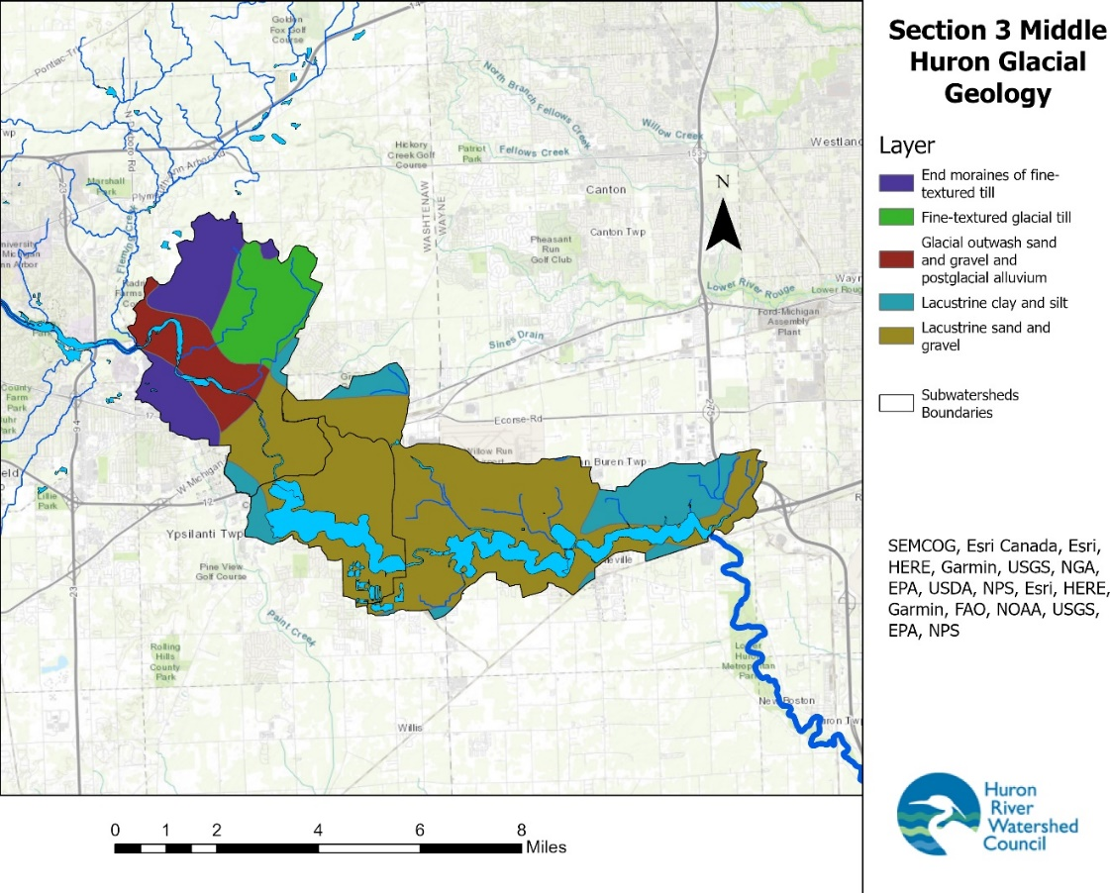

Figure 2.2. General groundwater recharge rates across the Watershed.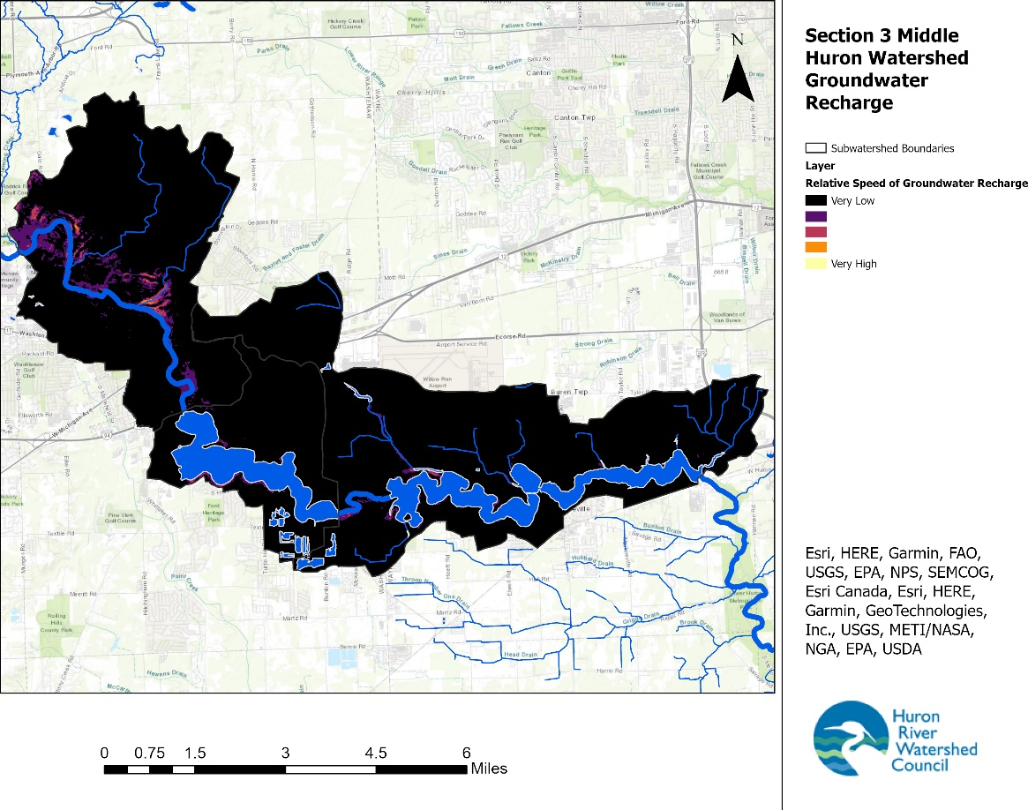

2.1.3 Hydrology

Hydrology refers to the study of water quantity and flow characteristics in a river system. How much and at what rate water flows through a river system, and how these factors compare to the system’s historic or “pristine” state, are critical in determining the long-term health of the waterway. In a natural river system, precipitation in the form of rain or snow is intercepted by the leaves of plants, absorbed by plant roots, infiltrated into groundwater, soaked up by wetlands, and is slowly released into the surface water system. Very little rainwater and snowmelt flows directly into waterways via surface runoff because there are so many natural barriers in between.

When vegetated areas are replaced by roads, rooftops, sidewalks, and lawns, a larger proportion of rainwater and snowmelt falls onto impervious (hard) surfaces. In less developed areas, this stormwater runoff flows either into roadside ditches that drain to the nearest creek, or, in the more densely developed areas, it flows into a system of storm drainpipes that eventually outlet to the creek. During a rain event, this increased runoff causes the flow rate of the creek to increase dramatically over a short period of time, resulting in what is referred to as “flashy flows.” In addition to rapidly increasing flows during storm events, the increase in impervious surface also decreases base flows during non-storm conditions because less water infiltrates into the ground to be slowly released into the creek via groundwater seeps.

Extreme flashiness can lead to rapid erosion of streambanks (especially in areas where the streambank vegetation has been removed or altered) and sedimentation. These impacts create unstable conditions for the macroinvertebrates and fish. Directly connected impervious landscapes pose a significant problem to hydrology. An example of a directly connected impervious surface is a rooftop connected to a driveway via a downspout that is then connected to the street where stormwater ultimately flows into the storm drain and into local creeks and streams.

The Huron River and its tributaries in the Watershed have been altered substantially by wetlands drainage, stream channelization, dam construction, deforestation, and urbanization. These activities have affected the hydrology of the Huron River and its tributaries: flow volume and flow stability have changed substantially, along with channel morphological features, such as gradient and shape. The extensive network of dams and lake control structures, developed areas, engineered drains, farm-field tile drains, and construction sites all play a role in producing flashy, sediment-laden flows.

The Huron River begins at an elevation of 1016 feet in the headwaters and descends 444 feet to an elevation of 572 feet at its confluence with Lake Erie, for an average gradient of 3.3 feet per mile (0.06% grade). The Huron River flowing through our Watershed region is steeper than average at 4.4 feet per mile (0.08% grade), but less steep as the previous section of the river as it flows through Ann Arbor (7.6 feet per mile (0.14% grade)). The river channel gradient has a controlling influence on river habitat such as flow rates, depth, width, channel meandering, and sediment transport. There are particular areas in the Watershed with localized steeper slopes and these are the areas most likely to be dammed; which is clearly the case, with the Huron River extensively dammed throughout this Watershed (and upstream through the Ann Arbor area).

Stream flow data for the Huron River in the Middle Huron Watershed has been collected at the U.S. Geological Survey (USGS) gage stations at the Huron River (#04174500) between Argo and Geddes dams since 1914 (near Wall Street, its current location since 1947). While not in this Watershed section of interest, this is the closest USGS gage.

In 2022, the mean annual flow at the Wall Street station was 691 cubic feet per second (cfs), representing a drainage area of 729 square miles, or 0.94 cfs per square mile. Across the whole historical data record, an average year would flow at 475 cfs. Examining the average years over time, the data record show that flow has increased in the Huron River since 1914 (Figure 2.3).

When HRWC made a similar graph in 2018 for the Middle Huron Section 2, the average flow at Wall Street for the time period was 470 cfs. Flow continues to increase—the slope of red line is approximately +2 cfs/year.

While monthly streamflow naturally varies from year to year, Figure 2.4 shows that despite the year, conditions in the watershed vary most in the spring and early winter and remain relatively constant over the summer months (Figure 2.8). Seasonally high flows generally occur in early spring during winter snowmelt and spring rains, with baseflow conditions most apparent between July and October.

Figure 2.3. Average Annual Discharge of the Huron River at Wall Street, from water year 1915-2022. The red line indicates an increasing linear trend over time.

Figure 2.4. Variety of monthly flow conditions over the flow data on record for the Huron River, Wall Street. (USGS station #041744500).
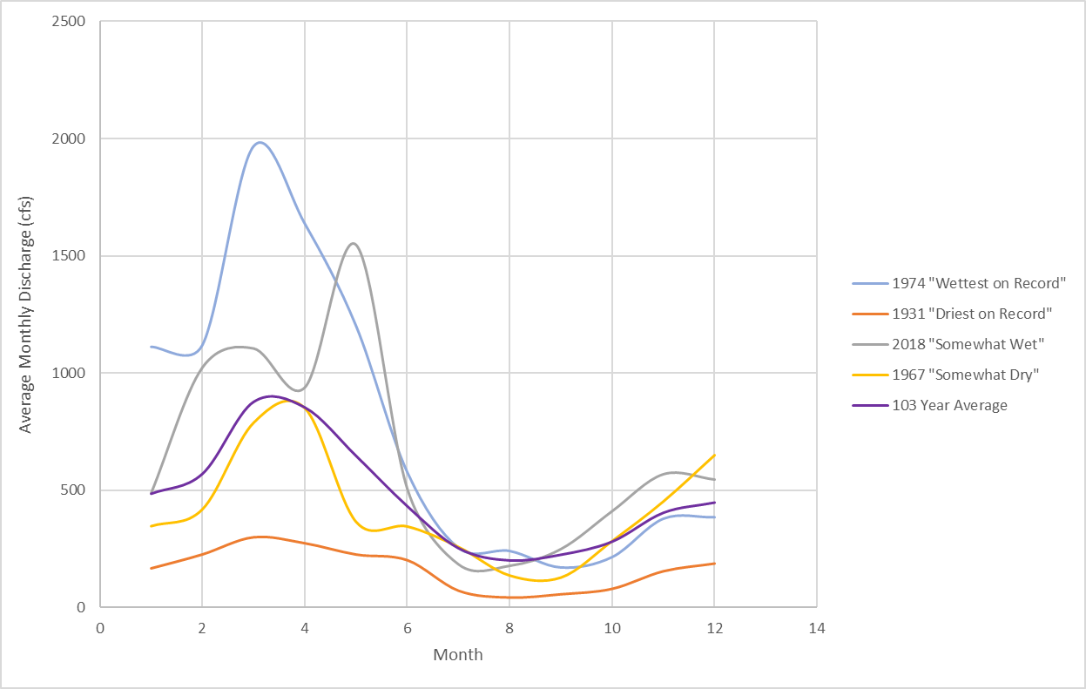

HRWC also installed a water level and flow sensor at the Forest Avenue river crossing within the Watershed, which drains an area of 800 square miles. That sensor has only provided reliable data since February 2022. With just over a year of data, the mean flow was 619 cfs, which compares to 419 cfs for the Wall Street USGS gage for the same time. For that year period, the extra 71 square miles of drainage generated 2.81 cfs/sq mi, which is much larger than the 0.57 cfs/sq mi for the USGS station. This suggests that runoff is flowing to the river surface water in the study Watershed at a much faster rate than upstream. However, the flashiness index at the Forest Avenue site is only 0.16, which puts it among the least flashy quarter of all sites studied across Michigan, at least for this one year of data. The maximum discharge during the record period was 3,340 cfs and the minimum was 95 cfs, as 2022 was wetter than average at the USGS station.

Development and resulting changes to hydrology and hydraulics are a significant threat to the Watershed. Human impacts and development have generally increased daily fluctuations in the Huron’s streamflow. Land drainage for urban or agricultural use has degraded the original, more stable flow regime. Draining wetlands, channelizing streams, and creating new drainage channels have decreased flow stability by increasing peak flows and diminishing recharge in groundwater tables.

2.1.3.1 Dams and Impoundments

Another component contributing to the hydrology of the Middle Huron Watershed is the presence of dams and impoundments. According to the National Inventory of Dams, eight dams are located in the Watershed (Figure 2.5 and Table 2.2).
Dams may be constructed for uses such as hydropower, recreation, or stormwater and flood control. Most of the dams in the Watershed were developed for hydropower—100 years ago, this area was full of industry. However, dams that were previously useful can outlive their intended purposes and become hazards and ecological detriments to the river. In the full Huron River Watershed, there are only 4 dams still used to produce hydroelectric power; 3 of them are found in this section 3 Middle Huron—Superior Dam, Ford Lake Dam, and French Landing Dam.
Dams can create hazards by collecting debris or simply by requiring recreationalists to circumnavigate them. They act as ecological detriments by holding back silt and nutrients, altering river flows, decreasing oxygen levels in impounded waters, blocking fish migration, eliminating fish spawning habitat, increasing nuisance plant growth in impoundments, altering water temperatures, and injuring or killing fish.
Several of the dams in the Watershed have specific issues worth discussing here.
Peninsular Paper Dam: Peninsular Paper Dam (Pen Dam) in Ypsilanti is of particular concern and HRWC is actively supporting the City of Ypsilanti to remove the dam. Pen Dam is a high-hazard dam since loss of life is probable following catastrophic failure. In 2022, EGLE downgraded the condition of the dam from “fair” to “low,” underscoring the urgency to remove the dam. Planning and assessment efforts to remove the dam are well underway with an anticipated removal of the dam in 2025. Impoundment restoration activities will run concurrently to dewatering of the impoundment and demolition of the dam and will continue for several years after the removal of the spillway.

French Landing Dam: As of 2023, the operators of French Landing Dam are working with Van Buren Township officials to relicense the dam for hydropower generation through the Federal Energy Regulatory Commission (FERC). The relicensing procedure is comprehensive and has revealed several opportunities to improve safety for recreation and flow management near French Landing Dam. In particular, the portage around this dam is considered the most dangerous along the entire Huron River Water Trail. The entire portage trail is subject to routine vandalism, and the downstream portage launch is a narrow set of wooden steps anchored to a concrete retaining wall. Given the position and dimension of the portage, along with flow management of the dam, it’s common for the wooden steps to be suspended several feet from sure footing for launching small watercraft. All options should be considered for improving, fortifying, or relocating the portage access points, as climate change will likely make flows even less predictable and more dangerous to people accessing the portage.
Of interesting historical note- not water quality.
Susterka Lake Dam: This dam and impoundment are an odd piece of local history as the site of a 1920’s-1950’s era “dance hall frequented by nearby college students, and a loosely regulated summer swimming hole for families and school children.” The impoundment and dam seem to exist solely for recreational purposes even today, though just for the local property owners.
The What Shall We Weird blog tells this odd story:
https://whatshallweweird.com/3387/below-susterka-lake/.

Tyler Dam and Beyer Dams: Tyler and Beyer Dams, on Willow Run Creek and within the Belleville Lake watershed, were constructed in the 1940’s to support operations at the Willow Run Bomber Plant. In the late 1970s, General Motors gave ownership of Beyer Dam to the Washtenaw County Drain Commissioner (now Water Resources Commissioner, WCWRC).
Due to deteriorating conditions, in 2017, Ypsilanti Township with engineering firm Stantec permanently drew down the impoundment at Tyler Dam and decommissioned the structure, though the structure itself was left in place. Shortly after, the Township was able to transfer the dam ownership to WCWRC. In 2022, the WCWRC made the decision to remove the Tyler Dam structure and the upstream Beyer Dam, turn it into a County Drain, and restore the creek to a wetland and stream ecosystem. As of the time of this writing, the WCWRC is seeking funds for the $10 million price tag and proceeding forward with the studies and engineering plans needed to facilitate both removals and ecosystem restoration.

Table 2.3. Inventoried Dams in the Watershed
Dam Name | Waterway | Ownership | Downstream Hazard Potential^{t} | Purpose | Date Built | Dam Height (Feet) | Impound-ment Area (acres)
beyer Dam | Willow Run Creek | Racer Properties | Low | Retired Hydro | 1941 | 20 | 8.5
Ford Lake Dam | Huron River | Ypsilanti Township | High | Hydroelectric; Recreation | 1932 | 45 | 1050
French Landing Dam | Huron River | Van Buren Township | High | Hydroelectric; Recreation | 1925 | 38 | 1270
Lower Willow Run Dam | Willow Run Creek | Wayne County Road Commission | Low | Unknown (Related to Willow Run Airport) | Un-known | 9 | 5
Peninsular Paper Dam | Huron River | City of Ypsilanti | Significant | Retired Hydro; currently Recreation | 1914 | 16 | 177
Superior Dam | Huron River | City of Ann Arbor | High | Hydroelectric; Recreation | 1920 | 28 | 93
Susterka Lake Dam | Tributary to Belleville Lake | Private landowner | Low | Recreation | Un-known | Un-known | 1
Tyler Dam | Willow Run Creek | Ypsilanti Township | Formerly Significant. Altered to low after drawdown | Former Fire Suppression | 1942 | 22 | Prior to drawdown: 23
^{t}Dam Hazard Potential:
Three hazard potential categories:
High- expected loss of life, severe impacts
Significant- possible loss of life, significant impacts
Low- no loss of life, minor impacts

Figure 2.5. Eight dams are located in the Watershed.
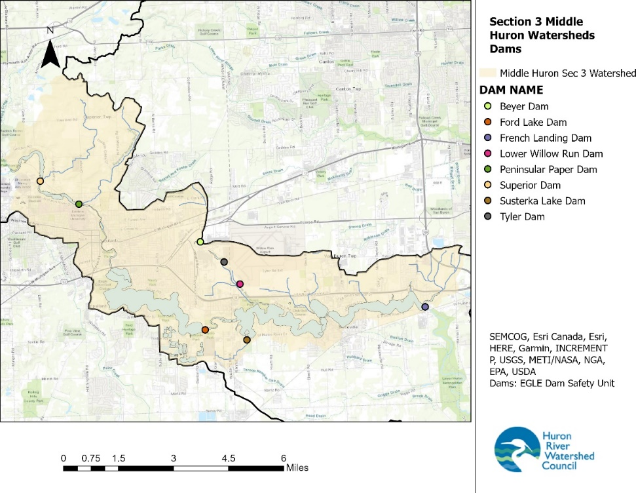

2.1.4 Significant Natural Features and Biota

2.1.4.1 Threatened, Endangered, and Special Concern Biota

With the fast growth of Washtenaw and Wayne County, significant building pressure has caused the Watershed to become altered and degraded. Still, pockets of high-quality habitat and diverse species persist due to conscientious planning and policy-making efforts that seek to preserve wildlife habitat. The expansiveness and ecological quality of the remaining open spaces and native habitats directly impact the quality of life and quality of water in the Watershed.

Researchers have recognized plant and animal species and plant community types as integral parts of the Watershed that deserve protection. Among those conservation targets are the threatened and endangered species that have been observed in the Watershed (Appendix B). Many of the plant and animal occurrences in the table are partially or entirely dependent on aquatic ecosystems for survival. In total, there are 263 plant and animal species in Washtenaw and Wayne Counties that are federally or state listed as Endangered, Threatened, or Species of Concern.

2.1.4.2 Critical Habitat and Ecosystem Services

Recovering these species requires protecting the ecosystems on which they depend. Key conservation areas of the Watershed system include critical habitat for plant and animal communities (including habitat for rare, threatened or endangered species), such as wetlands; large forest tracts; springs; spawning areas; the aquatic corridor, including floodplains, stream channels, springs and seeps; steep slopes; and riparian forests Figure 2.6 shows the location of Endangered and Threatened species from the Michigan Natural Features Inventory overlaid on hydric soils (Soils regularly saturated with water and indicating wetland and riparian conditions).

Figure 2.6. Location of Endangered/threatened species or communities and regions of hydric soils.

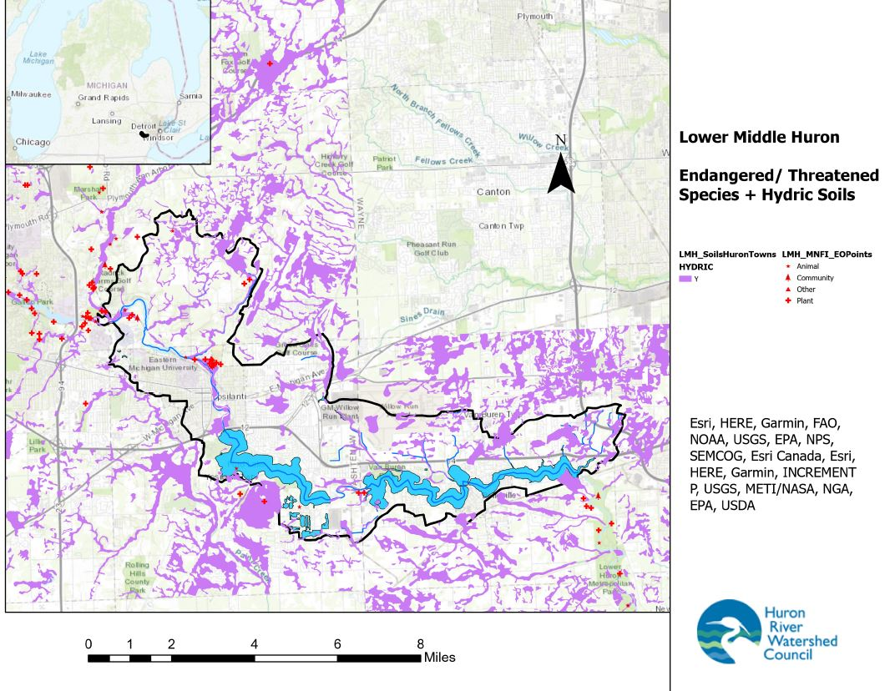

Natural areas close to and draining directly to tributaries and lakes are highly important to water quality, creeks rely on those areas to filter pollution and hold floodwaters after our ever-increasingly intense storms. Areas that encompass headwater streams provide a host of services to the river system – their close connection to groundwater, wetlands and subsurface water flows provides base flow to streams, controls flooding downstream, and spawning areas for fish.

In addition to their importance as wildlife habitat, undeveloped areas, such as forest, meadow, prairie, wetlands, ponds and lakes, and groundwater recharge areas, provide a host of ecosystem services to the watershed otherwise unobtainable by human invention, including the following:

- Groundwater. Natural systems allow rainwater and snowmelt to infiltrate into groundwater aquifers. About 50% of Michigan residents rely on groundwater for drinking water. Groundwater also provides irrigation water for agriculture and cooling water for industry.
- Surface water. By intercepting runoff and keeping surface waters supplied with a constant flow of clean, cool groundwater, natural systems keep streams, rivers and lakes clean.
- Drinking water: Residents of Ann Arbor rely on the Huron River for drinking water, while residents of the rest of the Huron River Watershed rely on private or municipally controlled drinking water wells that pull groundwater from aquifers replenished through natural areas.
- Pollutant removal. As water infiltrates into the ground or passes through wetlands, soil filters out many pollutants. Vegetation also takes up nutrients and other pollutants, including phosphorus, nitrogen, bacteria, and even some toxic metals.
- Erosion control. Vegetation intercepts water and soil absorbs it, keeping it from eroding streambanks and hillsides. River- and lakeside wetlands are especially important for erosion control along riverbanks and lakeshores.
- Air purification. Vegetation purifies the air we breathe.
- Flood and drought control. Vegetation and soil intercept runoff water, moderating floods and droughts.
- Wildlife habitat and biodiversity. Natural systems are vital to the survival of aquatic and terrestrial wildlife. In addition to its aesthetic value, maintaining the biodiversity of species is vital to our economy and health.
- Recreation. Natural areas provide recreation such as hiking, bird-watching, canoeing, hunting, and fishing that generate revenues for the local community.
- Cooling. Tracts of undeveloped land soak up solar heat and prevent heat islands from forming. Heat islands warm water runoff, which leads warm water to flow into streams and disrupts the aquatic climate.
- Carbon storage and sequestration. Plants take up carbon as a major nutrient and store it as they grow; when they die, the soil stores the degraded plants as carbon.
- Property values. Natural areas enhance the value of neighboring properties.

Undeveloped natural areas in the Watershed were mapped and prioritized in 2002, and updated in 2007 and 2018 through the Natural Areas Assessment and Protection (NAAP) project of the Huron River Watershed Council. In order to prioritize protection and conservation efforts, the mapped sites were ranked based on the following ecological and hydrological factors: size; core size, presence of water; presence of wetlands; groundwater recharge potential; potential for rare remnant plant community; topographical diversity; glacial diversity, how connected they were or could be to other natural areas, vegetation quality, potential for restoration, and biodiversity.
Thirty-four sites (2329 acres) in the Watershed were identified as priority natural areas, with six sites (573 acres) ranked as highest priority for protection, 12 sites (150 acres) ranked as medium-high priority for protection, 11 sites (413 acres) ranked as medium-low priority for protection and three sites (136 acres) ranked as lower priority for protection.
One of the highest priority sites encompasses both sides of Superior Pond and includes over 20 parcels with different landowners. A portion of this natural area is owned by Trinity Health Hospital and includes a rare prairie fen, as reported by HRWC field assessment volunteers. Over the years, members of the hospital staff and local naturalists, ecologists, and botanists have managed the site for invasive species.
Of the 2329 acres of natural areas identified as priorities, only 579 acres are protected as parks and other public ownership, preserves owned by conservancies and other nonprofits, and lands with conservation easements. This includes the 175-acre natural area that is part of the LeFurge Woods Preserve of the Southeast Michigan Land Conservancy, as well as a 147-acre natural area designated as “conservation” but with unknown ownership south of Ford Lake.

The parcels outlined in red in Figure 2.7 are the sites that do not have a protected land status and that would be good candidates for HRWC field assessments to determine priority for protection. Protection options for municipalities, state and federal agencies, and nonprofit conservation groups include programs such as the Regional Conservation Partnership Program, property-tax funded land protection millages, grants through foundations, carbon sequestration and storage funding, the Clean Water Act State Revolving Fund, Clean Water Action Section 319 Funding, among others.

Figure 2.7. HRWC’s NAAP priority natural areas overlaid with protected lands. Credit: Conservation and Recreation Lands-“CARL”

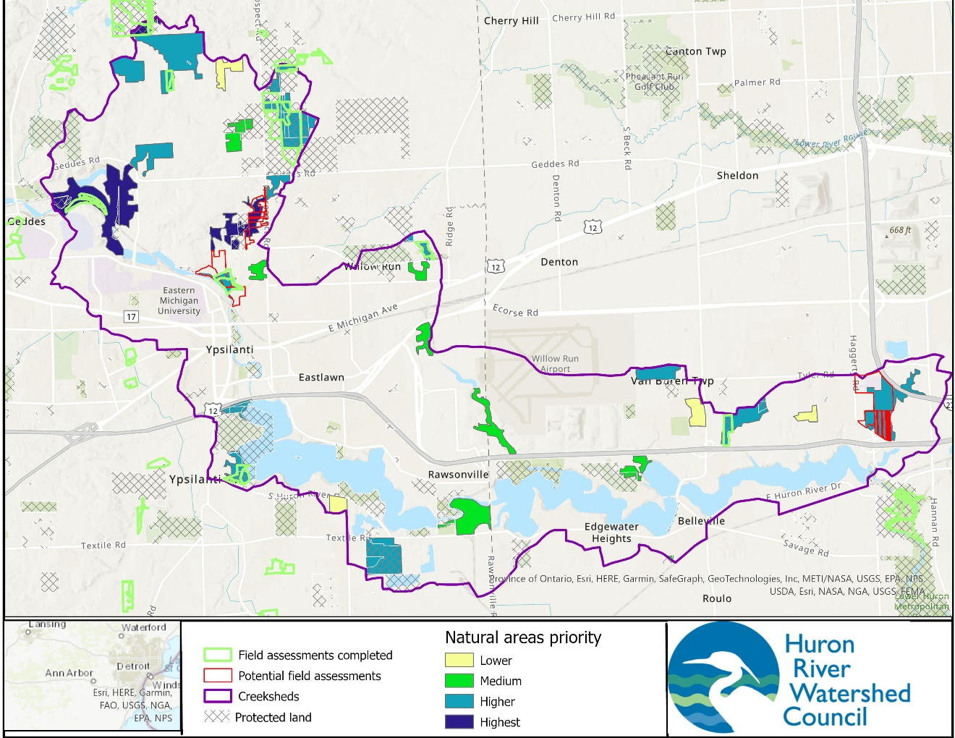

USGS National Water Information System. https://waterdata.usgs.gov/mi/nwis/inventory/?site_no=04174500&agency_cd=USGS. Accessed September 2019.
Michigan Department of Natural Resources. 2000. National Inventory of Dams database. Lansing, MI.
Stantec Consulting, Ltd. 2017. https://www.stantec.com/en/projects/united-states-projects/t/tyler-dam-study-drawdown. Accessed June 2023.
Michigan Features Natural Inventory, 2023. https://mnfi.anr.msu.edu/resources/county-element-data. Accessed August 2023.
Appel, Michael D, and Rome, Clea D. 2002. Identifying and Ranking Natural Areas in the Huron River Watershed. https://www.hrwc.org/wp-content/uploads/ IdentifyingAndRankingNaturalAreasintheHuronRiverWatershed.pdf. Accessed June 2022.
DEQ MiWaters. Conservation and Recreation Lands. http://gisp.mcgi.state.mi.us/arcgis/rest/services/DEQ/MiWaters/MapServer/49. Accessed June 2022.

