Chapter 1:
Introduction

1.1 The Middle Huron River Watershed Management Plan: Section 3

The Middle Huron River Watershed Management Plan (WMP): Section 3 is part of an effort led by communities in this area seeking to plan activities to address water quality issues highlighted in the State of Michigan’s Clean Water Act §303(d) report on impaired waters. The original WMP was completed in 1994, updated in 2000, 2008, and 2011, but was written for a larger area, covering the entire Middle Huron Watershed which covers the confluence of Mill Creek down to the end of Belleville Lake, and all tributaries draining to the Huron through that length. This 2023 version is the fourth update of that WMP, but it is narrower in scope as it only covers the lower geographic portion of that earlier WMP. Separate WMPs have been written for the upper (Section 1) and middle (Section 2) geographic portions.

For the purposes of this plan, Section 3 of the Middle Huron Watershed (Figure 1.1) will be referred to as the Watershed. It is composed of the Huron River starting just downstream of the confluence of Fleming Creek, and continuing through the Ford and Belleville Lakes, which are dammed impoundments in the Huron River. There are no major creeksheds in this section but there are several smaller tributaries often referred to as “direct drainage”.

The Watershed is part of the larger Huron River Watershed, one of Michigan’s natural treasures. The Huron River supplies drinking water to approximately 150,000 people, supports one of Michigan’s finest smallmouth bass fisheries, and is the State’s only designated Scenic River in southeast Michigan. The Huron River Watershed is a unique and valuable resource in southeast Michigan that contains ten Metroparks, two-thirds of all southeast Michigan’s public recreational lands, and abundant county and city parks. In recognition of its value, the State Department of Natural Resources has officially designated 27 miles of the Huron River and three of its tributaries as “Country-Scenic” River under the State’s Natural Rivers Act (Act 231, PA 1970). The Huron is home to 670,000 people, numerous threatened and endangered species and habitats, abundant bogs, wet meadows, and remnant prairies of statewide significance.

The Huron River Watershed encompasses approximately 900 square miles (576,000 acres) of Ingham, Jackson, Livingston, Monroe, Oakland, Washtenaw, and Wayne counties. The main stem of the Huron River is approximately 136 miles long, originating at Big Lake and the Huron Swamp in Springfield Township, Oakland County. The main stem of the river meanders from the headwaters through a complex series of wetlands and lakes in a southwesterly direction to the area of Portage Lake. Here, the river begins to flow south until reaching the Village of Dexter in Washtenaw County, where it turns southeasterly and flows to its final destination of Lake Erie. The Huron is not a free-flowing river. At least 98 dams segment the river system, of which 17 are located on the main stem.
Figure 1.1. The Huron River Watershed is located in Southeast Michigan. The focus of this report is on the subwatersheds highlighted in this map.
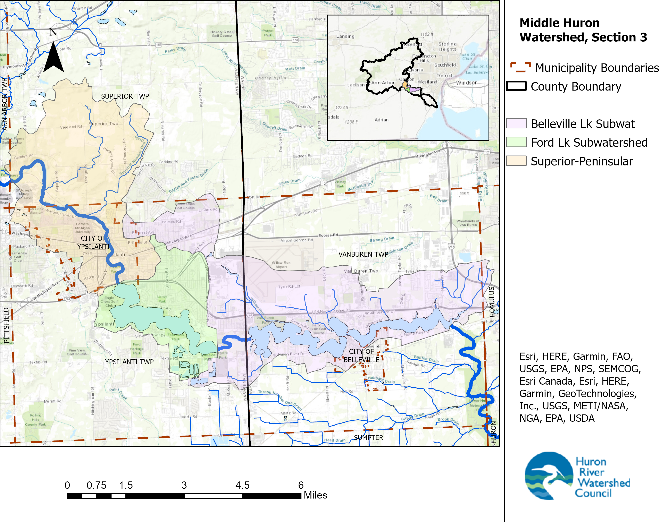

The drainage area to the Watershed is 36 square miles (23,039 acres), representing approximately 4% of the total Huron River Watershed. All or portions of 9 municipalities (not counting Federal or State) are situated in the Watershed, as show in Table 1.1.
The Watershed lies both in Washtenaw County (66% of the Watershed) and Wayne County (34%).

Communities with more than 10% of their municipality in the Watershed, and both Washtenaw and Wayne County, are called “Core Communities” throughout this document.

Table 1.1. Breakdown of Municipalities in the Watershed

Municipality | Size of Watershed in Municipality (sq mi) | % of Watershed in Municipality | % of Municipality in Watershed
Ann Arbor Township | 0.03 | <1% | <1%
City of Belleville | 0.5 | 1.3% | 43%
City of Ypsilanti | 4.3 | 12% | 91%
Romulus Township | 0.2 | <1% | <1%
Superior Township | 8.4 | 23% | 24%
Van Buren Township | 11.6 | 32% | 32%
Ypsilanti Township | 12.0 | 33% | 38%
Washtenaw County | 24.7 | 66% | 3%
Wayne County | 12.3 | 34% | 2%

The Huron River in the Watershed begins just downstream of Fleming Creek, where it very shortly gets impounded in Superior Pond, and then Peninsular Pond. The river then free flows through the City of Ypsilanti until it enters Ford Lake, and then Belleville Lake. The mainstem of the Huron River in the Watershed is 18 miles long, with 1.5 miles of that being free flowing water and 16.5 of that being impounded (if drawing a straight line through the impoundments). The elevation drops 33 feet over this distance for an average gradient of 2 ft/mi for the Huron River. For comparison, the entire Huron River has an average gradient of 3.3 ft/mi. Numerous small creeks enter the Huron River through this section, totaling 23.6 miles in length.

As of 2020 data, the watershed’s land use is dominated by developed areas (37% of Watershed). Natural lands and farms are scattered about like a mosaic (Forest: 12%, Wetland: 7%, Open land/Old Field: 9%, Agriculture: 9%). There are 4 major dams on the Huron River through this stretch, and there are another 4 dams on the smaller tributaries. The dams create a massive amount of open water on the Huron River, including Ford and Belleville Lakes, adding up to about 12% of the total Watershed acreage.

In recent decades, the Watershed has experienced amplified development pressures from a growing economy and urban sprawl. According to the U.S. Census data and the Southeast Michigan Council of Governments (SEMCOG), Washtenaw County is currently the fastest growing county in the southeast Michigan. Wayne County, if leaving out the City of Detroit which is not in the Watershed, has experienced slight growth. The region has increased from a population of about 100,00 in 1990 to a population of about 125,000 in 2020, a 22% growth rate. The fastest area of growth in this time frame in the Watershed area is Superior Township (70% change) and Van Buren Township (45% change). On the other hand, the City of Ypsilanti has shrunk by 17% since 1990. These population numbers are not precise to the Watershed since they are based on census data and political boundaries, but they give a good rough estimate. [See Chapter 2.2 for complete details]

The SEMCOG forecast to 2040 predicts a 13% increase in population from 2020 levels, This indicates that the speed of growth in the Watershed could slow by half as compared to the rate of development that occurred in the recent past. This also presents a good opportunity for fixing as many of the problems caused by the rapid expansion as possible; sort of like cleaning your house after a major renovation.
Growth on the scale seen in the past decades hastened the degradation of the hydrology and water quality of surface waters. Through the processes of development, the Watershed has undergone wetland draining, deforestation, straightening and dredging streams (“drains”), removal of riparian vegetation, installation of impervious surfaces and storm sewers, inadequate control of soil erosion, and installation of poorly designed stream crossings. Such practices resulted in altered hydrology (“flashy” flows and flooding), soil erosion and sedimentation, elevated nutrients, nuisance algal blooms, dangerous levels of pathogens, degraded fisheries, and destruction of natural lands that provided wildlife habitat, recreation, air quality, filtering of polluted runoff, temperature regulation, flood control, groundwater storage, drinking water supply, carbon storage and sequestration, and a host of other ecosystem services.
The time is now to fix these issues wherever possible and prevent them from occurring again in the future.

1.2 Purpose of the Watershed Management Plan
The primary purpose of this plan is to address water quality impairments for the Middle Huron Watershed, Section 3. The plan represents a broad effort to restore and protect the integrity of water quality and quantity of the watershed system. This plan presents a state-approved methodology to diminish the adverse effects of nonpoint source pollution to meet the established impairment elimination plans and proactively address others that will be developed within the watershed. This plan outlines both quantitative and qualitative steps considered necessary to meet water quality goals for the Huron River and its watershed.

In order for the State of Michigan to approve a watershed plan, the plan must meet the following criteria as established in State Rule 324.8810:

A watershed management plan submitted to the EGLE for approval under this section shall contain current information, be detailed, and identify all of the following:
(a) The geographic scope of the watershed.
(b) The designated uses and desired uses of the watershed.
(c) The water quality threats or impairments in the watershed.
(d) The causes of the impairments or threats, including pollutants.
(e) A clear statement of the water quality improvement or protection goals of the watershed management plan.
(f) The sources of the pollutants causing the impairments or threats and the sources that are critical to control in order to meet water quality standards or other water quality goals.
(g) The tasks that need to be completed to prevent or control the critical sources of pollution or address causes of impairment, including, as appropriate, all of the following:
(i) The best management practices needed.
(ii) Revisions needed or proposed to local zoning ordinances and other land use management tools.
(iii) Informational and educational activities.
(iv) Activities needed to institutionalize watershed protection.
(h) The estimated cost of implementing the best management practices needed.
(i) A summary of the public participation process, including the opportunity for public comment, during watershed management plan development and the partners that were involved in the development of the watershed management plan.
(j) The estimated periods of time needed to complete each task and the proposed sequence of task completion.

The above criteria are necessary for approval under the Clean Michigan Initiative guidelines. To be approved for funding under federal Clean Water Act section 319, a plan must also meet the “9 Minimum Elements:”

- An identification of the causes and sources or groups of similar sources that will need to be controlled to achieve the load reductions estimated in this watershed-based plan (and to achieve any other watershed goals identified in the watershed-based plan). Sources that need to be controlled should be identified at the significant subcategory level with estimates of the extent to which they are present in the watershed.
- An estimate of the load reductions expected for the management measures described under paragraph (c) below. Estimates should be provided at the same level as in item (a) above.
- A description of the NPS management measures that will need to be implemented to achieve the load reductions estimated under paragraph (b) above (as well as to achieve other watershed goals identified in this watershed-based plan), and an identification (using a map or a description) of the critical areas in which those measures will be needed to implement this plan.
- An estimate of the amounts of technical and financial assistance needed, associated costs, and/or the sources and authorities that will be relied upon, to implement this plan.
- An information/education component that will be used to enhance public understanding of the project and encourage their early and continued participation in selecting, designing, and implementing the NPS management measures that will be implemented.
- A schedule for implementing the NPS management measures identified in this plan that is reasonably expeditious.
- A description of interim, measurable milestones for determining whether NPS management measures or other control actions are being implemented.
- A set of criteria that can be used to determine whether loading reductions are being achieved over time and substantial progress is being made towards attaining water quality standards and, if not, the criteria for determining whether this watershed-based plan needs to be revised or, if a NPS TMDL has been established, whether the NPS TMDL needs to be revised.
- A monitoring component to evaluate the effectiveness of the implementation efforts over time, measured against the criteria established under item (h) immediately above.

1.2.1 Designated and Desired Uses

According to Michigan’s Department of Environment, Great Lakes, and Energy (EGLE), the primary criterion for water quality is whether or not the water body meets its designated uses. Designated uses are recognized uses of water established by state and federal water quality programs. In Michigan, the goal is to have all waters of the state meet all designated uses. It is important to note that not all of the uses listed below may be attainable, but they may serve as goals toward which the watershed can move.

All surface waters of the state of Michigan are designated for and shall be protected for all of the following uses. The designated uses that apply to the Watershed are in boldface:
Photo: HRWC

- Agriculture
- Industrial water supply
- Public water supply
- Navigation
- Warmwater fishery
- Fish Consumption
- Other indigenous aquatic life and wildlife
- Partial body contact recreation
- Total body contact recreation between May 1 and October 31
- Coldwater fishery

Due to human impacts and the impairments they cause throughout the Watershed, not all of the designated uses are fulfilled.

That being said, there are many miles of streams in the Watershed that have not yet been assessed for the pollutants that may impair these designated uses.

1.2.2 Total Maximum Daily Load Program
A Total Maximum Daily Load (TMDL) is the maximum amount of a particular pollutant a waterbody can assimilate without violating state water quality standards. Water quality standards identify the applicable “designated uses” for each waterbody, such as swimming, agricultural or industrial use, public drinking water, fishing, and aquatic life. EGLE establishes scientific criteria for protecting these uses in the form of a number or a description of conditions necessary to ensure that a waterbody is safe for all of its applicable designated uses.

The state also monitors water quality to determine the adequacy of pollution controls from point source discharges. If a waterbody cannot meet the state’s water quality criteria with point-source controls alone, the Clean Water Act requires that a TMDL must be established. TMDLs provide a basis for determining the pollutant reductions necessary from both point and nonpoint sources to restore and maintain the water quality standards. Point sources is the term used to describe direct discharges to a waterway, such as industrial facilities or wastewater treatment plants. Nonpoint sources are those that enter the waterways in a variety of semi- or non-traceable ways such as stormwater runoff.

In Michigan, the responsibility to establish TMDLs rests with EGLE. Once a TMDL has been established by EGLE, affected stakeholders must develop and implement a plan to meet the TMDL, which will bring the waterbody into compliance with state water quality standards

1.2.3 Assessment Unit Identifiers

As of the 2022 EGLE Integrated Report and the Statewide E.Coli Total Maximum Daily Load Addendum-2022 , three waterbodies as delineated by Assessment Unit Identifiers (AUID) in the Watershed are listed for water quality problems that can be addressed by this plan (Figure 1.2, Table 1.2).

Multiple waters throughout the Huron River watershed are listed as impaired for fish consumption due to PCB and mercury. The impairments are addressed by statewide TMDLs,. The AUIDs listed for these are included in Table 1.3, but because the problems associated with PCB and mercury pollution are linked to broadly diffuse air-deposition originating outside of the Huron River Watershed, actions designed to address this TMDL are not emphasized in this plan, which focuses on locally-sourced impairments.

Figure 1.2: AUIDs reaches within the Section 3 Middle Huron River
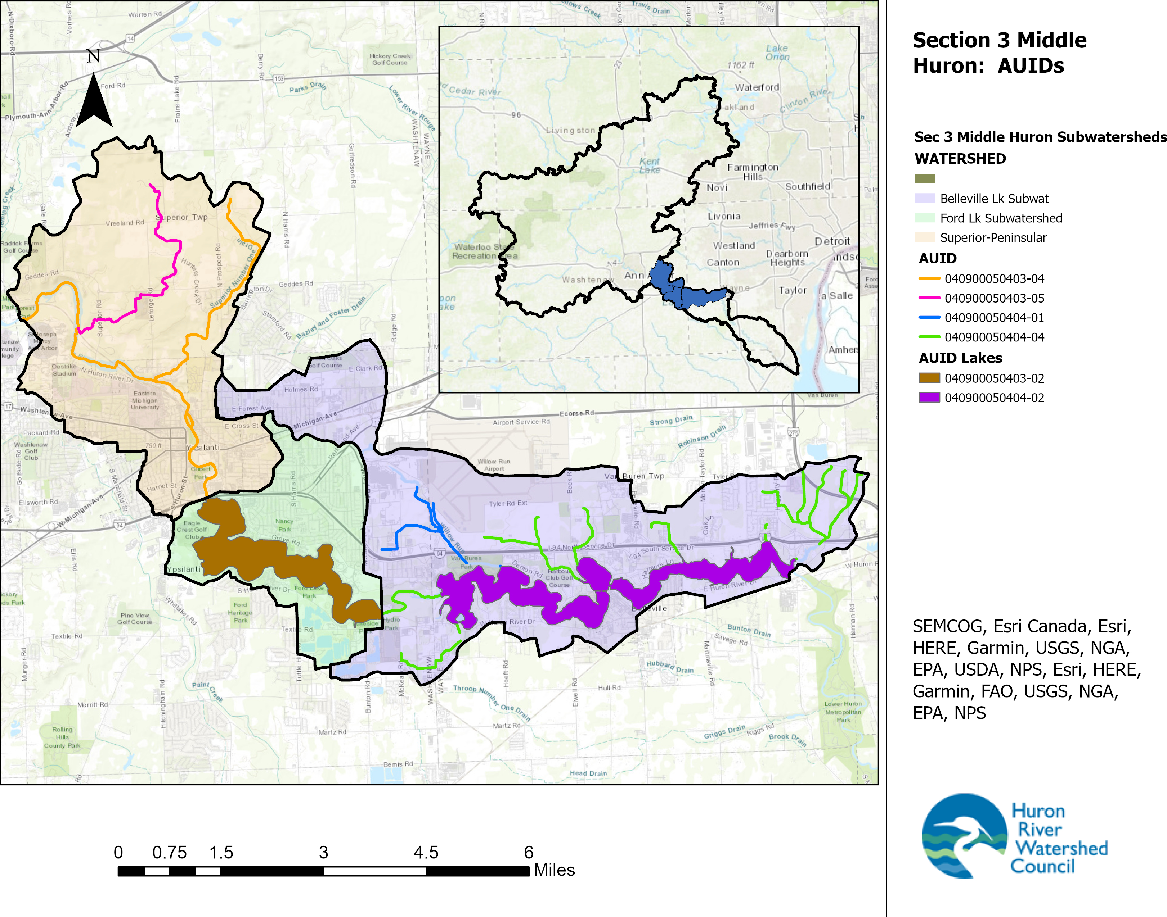

Table 1.2: Stream reaches within the Watershed, highlighting Impaired Designated Uses and established TMDLs (not including Fish Consumption: PCB and Mercury)

AUID | AUID Name | Designated Uses | Pollutant/Cause | Stream length (miles)
MI040900050404-01 | Willow Run Drain | Not assessed for warm water fishery, total and partial body contact, other indigenous aquatic life and wildlife |  | 3.1
AUID | AUID Name | Designated Uses | Pollutant/Cause | Stream length (miles)
MI040900050404-04 | Tributaries to Belleville Lake | Not assessed for warm water fishery, total and partial body contact, other indigenous aquatic life and wildlife |  | 12.1
 |  | Not supporting Fish Consumption | PFOS
AUID | AUID Name | Designated Uses | Pollutant/Cause | Stream length (miles)
MI040900050403-04 | Huron River, Superior Number One Drain | Fully supporting warm water fishery and other indigenous life |  | 10.3
 |  | Partial Body Contact: Fully Supporting, Total Body Contact: Not Supporting | E. Coli
 |  | Not supporting Fish Consumption | PFOS
AUID | AUID Name | Designated Uses | Pollutant/Cause | Stream length (miles)
MI040900050403-05 | Snidecar Drain | Fully supporting warm water fishery and other indigenous life |  | 4.0
 |  | Not supporting Partial or Total Body Contact | E. Coli
 |  | Not supporting Fish Consumption | PFOS
AUID | AUID Name | Designated Uses | Pollutant/Cause | Lake Size
040900050403-02 | Ford Lake | Not assessed for warm water fishery and total and partial body contact |  | 951 acres
 |  | Not supporting:
 |  | Other indigenous aquatic life and wildlife | Total Phosphorus, Algae
 |  | Fish Consumption | PFOS
AUID | AUID Name | Designated Uses | Pollutant/Cause | Lake Size
040900050404-02 | Belleville Lake | Not assessed for warm water fishery and total and partial body contact |  | 1248.2 acres
 |  | Not supporting:
 |  | Other indigenous aquatic life and wildlife | Total Phosphorus, Algae
 |  | Fish Consumption | PFOS

Table 1.3: Stream reaches with Fish Consumption impaired use due to PCB or Mercury (None listed for Mercury).

AUID | AUID Name | Designated Use Not Met | Pollutant/Cause | Stream length (miles)
MI040900050404-01 | Willow Run Drain | Fish Consumption | PCB | 3.1
MI040900050404-04 | Tributaries to Belleville Lake | Fish Consumption | PCB | 12.1
MI040900050403-04 | Huron River, Superior Number One Drain | Fish Consumption | PCB | 10.3
MI040900050403-05 | Snidecar Drain | Fish Consumption | PCB | 4.0
040900050403-02 | Ford Lake | Fish Consumption | PCB | 951 acres
040900050404-02 | Belleville Lake | Fish Consumption | PCB | 1248.2 acres

1.3 The Watershed Management Plan Community Input

The first task involved in developing the original 1994 Watershed Management Plan was the formation of a Policy Advisory Committee, with members representing each of the communities in the project area. In January 1993, an initial meeting of this group was convened to discuss issues related to nonpoint source pollution in the planning area and individual community concerns. Following this introductory meeting, goals and objectives for controlling water quality were developed and submitted to committee members for review and approval. Since that time the Committee has continued to meet on a regular basis to assist in watershed planning activities throughout the Middle Huron basin. Currently, the Middle Huron Partnership Initiative coordinates the meeting of these communities with the expressed intent to plan and implement activities to address the Ford and Belleville Lakes TMDL for phosphorus.

The Huron River Watershed Council (HRWC) was the primary author of the WMP starting in 1994 and continues this role for this 2023 update.

For the 2008 update, an Advisory Committee was established, with representation from each of the communities in the Middle Huron Watershed, with the exception of Van Buren Township and the City of Belleville, as Belleville Lake was added to the geographic scope late in the update process. Project staff held bi-monthly meetings with the Advisory Committee to get feedback on different sections of the WMP. Materials were also distributed to Committee members and other interested parties for review, comment and input. All communities were given draft copies of the WMP for review prior to finalizing. Small updates to the plan were made in 2011.

For the 2023 update, HRWC assembled a stakeholder committee which consisted of the Core Communities in the Watershed (all those with >10% of their municipality in the Watershed, Table 1-1.) Not all these invitees elected to join the stakeholder committee, but all were welcomed. Stakeholders were given an overview of HRWC’s data collection and monitoring efforts over the past 10 years, and gave input as to what projects their municipalities had been accomplished since 2008 and what projects they would like to see implemented. All stakeholders were given draft copies of the WMP for review and comment prior to final changes and approval by EGLE.

1.3.1. Technical Advisory Committees

Several Technical Advisory Committees were established to provide input to individual components of this plan. A Committee was established to assist in revising the Drain Commissioner's standards governing the design of stormwater management systems in new developments. Members included staff from local planning, engineering, building inspection and utilities departments. Private engineering and planning consultants were also represented, as well as the HRWC, the County Soil Conservation District and the MDNR. Committee members were provided with working drafts of the Drain Commissioner's standards (including explanations about how revisions work to improve water quality and quantity control) and asked to provide feedback on their practicality for implementation within Washtenaw County. Revised standards were adopted in 1994. Public involvement and review also guided the 2000 update and the 2008 update.

Additionally, the Middle Huron Partnership was formed to address the Ford and Belleville Lakes TMDL. The Partnership originally formed in 1999 following development of the TMDL, and an updated Cooperative Agreement was signed in 2005 (Appendix A) and was effective through 2009. The group still continues to meet and work in 2022, and is still facilitated by HRWC. While the agreement has expired, the Agreement still serves as a voluntary guide for the partners to address the phosphorus reduction targets described in the TMDL. The Partnership now meets multiple times a year to report on progress, and were also given this plan for opportunity to review and comment prior to its finalization.

1.3.2 Other Subwatershed Management Plans
This Plan was developed with the intention of fulfilling the watershed management planning criteria for the U.S. EPA’s Clean Water Act §319 Program and EGLE’s Clean Michigan Initiative Program. It is a revision from the previous plan approved in 2008.

Additionally, point source and nonpoint source Pollutant Reduction Implementation Plans have been developed as part of the voluntary Middle Huron Partnership Initiative to implement the Ford and Belleville Lakes TMDL. These plans and efforts are described in further detail in other chapters of the plan. Information and recommendations from all these plans have been incorporated into this watershed management plan, so it is the most current assessment and prescription for action.

Southeast Michigan Council of Government. https://semcog.org/gis. Accessed 2021.
SEMCOG, the Southeast Michigan Council of Governments. November 2018. Population and Household Estimate for Southeast Michigan. www.semcog.org.
U.S Dept of Commerce, Michigan: 2010. 2010 Census of Population and Housing. https://www.census.gov/prod/cen2010/cph-2-24.pdf. Accessed 2021.
Brown, E., A. Peterson, R. Kline-Roback, K. Smith, and L. Wolfson. February 2000. Developing a Watershed Management Plan for Water Quality; and Introductory Guide, Institute for Water Research, Michigan State University Extension, Michigan Department of Environmental Quality, P.10.45 R323.1100 of Part 4, Part 31 of PA 451, 1994, revised 4/2/99.
EGLE, 2023. Water Quality and Pollution Control in Michigan Sections 303(d), 305(b), and 314 Integrated Report. https://www.michigan.gov/egle/-/media/Project/Websites/egle/Documents/Programs/WRD/SWAS/2022-Integrated-Report.pdf?rev=0a6b006c0cc44bcd936c75d5608659ed&hash=03A5B2B0F3379B07D369F289BA32C483. Accessed July 2023.
EGLE. 2022. https://www.michigan.gov/egle/-/media/Project/Websites/egle/Documents/Programs/WRD/SWAS/TMDL-Ecoli/statewide-ecoli-tmdl-2022-addendum.pdf
EGLE 2020. Final 2020 Statewide PCB TMDL. https://www.michigan.gov/egle/0,9429,7-135-3313_3681_3686_3728-292645--,00.html. Accessed June 2021
EGLE 2020. Final 2020 Statewide Mercury TMDL. https://www.michigan.gov/egle/0,9429,7-135-3313_3681_3686_3728-301290--,00.html. Accessed June 2021

