REDUCING BACTERIA IN HONEY CREEK
Honey Creek, which flows to the Huron River, is listed as impaired by the State due to elevated bacteria levels (E. coli).
in 2014, HRWC produced a watershed management plan and through that process we found that Honey Creek has some critical areas with higher bacteria concentrations than others. Given these findings, we applied for and received a grant to address some of the issues.
The goal of our Honey Creek project is to reduce bacterial contamination. HRWC is reaching out to residents to encourage them to take specific actions to address the pollution. In addition, we will monitor the creek after our outreach efforts to see where gains are being made.
To help us understand Honey Creek residents’ knowledge of local water conditions and opinions about water, we sent out a ‘social survey’ at the beginning of this project in 2017 and again in 2020. Results will be posted to our Resource Library when they are finalized. For results from the 2017 social survey go to the “Key Products” section below.

HONEY CREEK PROJECT
Through this project, we will:
- Identify and encourage the elimination of human sources. Canine detection is being used to identify failing septic systems followed by homeowner outreach.
- Educate residents about pathogen problems and how they can help. Outreach materials will be delivered primarily within “critical areas.” We will also meet with farmers to discuss ways they reduce contamination from their practices.
- Reduce pet waste entering storm systems. A combination of regulation, education and pet waste disposal stations will be used to reduce pet waste inputs to Honey Creek.
- Evaluate the success of these efforts to guide future investments. Year three will involve extensive monitoring and analysis to gauge progress.
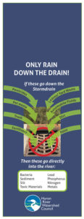

OUTCOMES
This project is unique because it is likely that together, we can remove human-sourced pathogens and significantly reduce overall bacteria levels in Honey Creek. Given the level of contamination in the creek, it is quite possible that the pathogen impairment could be completely removed and the creek returned to full beneficial use status. We hope this project will serve as a model for reducing bacteria levels in similar watersheds around the state.
FUNDED BY: Michigan Department of Environmental Quality, Non Point Source Pollution Program
PROJECT BUDGET: $149,740
TIMELINE: November, 2016 – October, 2020
Edit"Honey Creek"

ABOUT THE 2011-2013 HONEY CREEK WATERSHED PLAN

Key Products
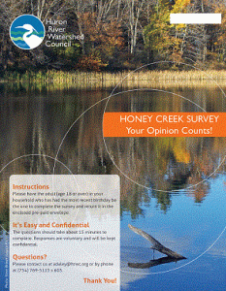Thanks to those who got a survey in 2017 and responded! 35% of you participated. Click on this image to see the results.
Honey Creek Watershed Management Plan
Honey Creek Bacterial Study
Honey Creek Social Survey 2017

Advisory and Stakeholder Committee Meeting Schedule
A kick-off meeting was held with the Advisory Committee on December 1, remedy 2011. The first Stakeholder Committee was held on March 29, 2012. Several Advisory Committee meetings were held through the course of the project.
A final Stakeholder Meeting to review the draft Watershed Management Plan was held on October 1, 2013.

Project Overview
The following presentation was developed for the project kick-off meeting and covers major project elements. A special thank you to Molly Rippke, Michigan DEQ for much of the background content.
Honey Creek Kickoff Presentation (5 mb)

Honey Creek Contamination Background
In 2009, the DEQ (then DNRE) developed a pollution limit policy (called a Total Maximum Daily Load (TMDL)) for Honey Creek due to body contact impairments as a result of elevated bacteria levels. Specifically, high E. coli counts were recorded at a sampling location near the Honey Creek outflow. Also, HRWC has been monitoring E. coli levels in the creek since 2006. Under HRWC’s program, the mean E. coli count was 405 per 100 ml, with a maximum count of 3000 per 100 ml (June, 2009) and a median of 305 per 100 ml – all above the single event water quality standard of 300 E. coli per 100 ml for total body contact (TBC).
DNRE collected additional E. coli data in 2007 at four sites along Honey Creek to develop the TMDL. All sites exceeded the TBC standards, and many events exceeded the partial body contact standard. The highest counts were found at the most upstream location, where the 30-day geometric mean exceeded 1,000 E. coli per 100 ml (the PBC standard) for the entire sampling period (dry and wet weather). E. coli counts were progressively lower at each downstream location for most sampling events.
These results suggest that a source exists near or upstream of sampling station 1. One sample from station 1 was analyzed for human biomarkers and none were found, suggesting animal sources. Potential sources in the area of station 1 identified in the TMDL include livestock manure, horse pastures, pet waste and urban/suburban wildlife. One high-density housing development, Scio Farms, was identified with high pet ownership and storm water runoff that enters Honey Creek upstream of station 1.

Project Goals and Objectives
The overall project goal is to collect information and develop a Watershed Management Plan that will foster activities that will reduce the quantity of bacteria entering Honey Creek and eventually meet water quality standards. Specific objectives are to:
Conduct E. coli monitoring, including Bacterial Source Tracking (BST), to narrow the identification of sources.
Develop a watershed management plan (WMP) to address the pathogen and other identified impairments.
Involve relevant residents in the plan-development and inform them about their roles and responsibilities through a workshop and educational materials.

Project Timeline
Oct 2011 – Apr 2012
Collect data and background information to assess overall watershed impairments, threats, causes and potential sources, and determine monitoring sites.
Meet with local stakeholders to get early input.
Monitoring data, along with results from BST, will determine the most likely sources of E. coli contamination.
May 2012 – Dec 2012
Conduct E. coli monitoring, including BST, statistical analysis, and follow-up monitoring. Report results in December 2012.
Conduct other field investigations to collect information on land uses and potential sources.
Dec 2012 – August 2013
Evaluate results and revise plan to fill in data and knowledge gaps.
Collect additional data and summarize results.
Jan 2013 – March 2014
Complete draft WMP (final WMP produced in March 2014).
Conduct a public stakeholders meeting to gather feedback and provide guidance about individual actions to address bacteria and other impairment sources.
These activities resulted in a planning project that cost-effectively targets actions that have the greatest likelihood of successfully reducing or eliminating identified impairments.
Management Plan, Monitoring Plan, Data and Results
The Honey Creek Watershed Management Plan (WMP) was completed in Spring 2014, reviewed by MDEQ and revised, and then approved by MDEQ and the U.S. Environmental Protection Agency in September 2014. The WMP references appendices that were too large to post. Contact Ric Lawson to request any or all appendices.
A monitoring plan was developed and implemented to collect water quality data from different stream sections. Details and results can be viewed on the Honey Creek Study webpage.

Partners
This project was funded through a Nonpoint Source grant from the Michigan Department of Environmental Quality, with match funding and additional contributions provided by the following partners.
Washtenaw County Water Resources Commissioner
Scio Township
Middle Huron Initiative (includes 17 signatory communities or agencies to the TMDL cooperative agreement)
Middle Huron River Watershed Stormwater Advisory Group (includes 7 member municipalities and agencies)

MORE ABOUT BACTERIA

Bacteria Comes from Many Sources

DOMESTIC PETS

The issue
Most pets that poop on the lawn are warm blooded mammals, which means that their excrement contains E. coli bacteria. During snowmelt or rainwater events, this bacteria is often washed into local streams and eventually finds its way to the Huron River. When bacteria levels are elevated, the river and tributaries become potentially unsafe for recreation, preventing uses such as canoeing, swimming, or fishing. The water also becomes unhealthy for wildlife and river ecosystems.

Be part of the solution
Poop-scooping. It is now the social norm to scoop your pet’s poop. So grab a baggy on your way out the door and stoop, scoop, and drop into the nearest trash can. It’s the neighborly thing to do.
Wise-walking. When taking you pet for a walk, consider first how close the nearest water body is? If you’re within 50 yards of a stream, pond, or lake, it is likely that bacteria from your pet’s poop is washing directly into the water body following the next snowmelt or rain event. To protect the stream, stay as far back as possible. Avoiding “pet walk” areas that are adjacent to streams, and especially areas that have a steep gradient toward the stream. In general, the closer you are to a body of water, the more diligent you should be in scooping your pet’s poop.
This is especially important in winter months when lakes and streams are frozen. Allowing your pet to poop on the ice will cause a direct deposition of bacteria into the lake or stream when the ice melts. In addition, when the snow pack is heavier, spring runoff is heavier. Keep these geological processes in mind when walking your pet.

SEPTIC SYSTEMS
See how septic systems work with HRWC’s Septic Systems 101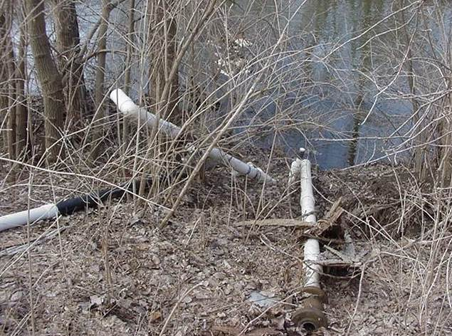

The issue: illicit connections
Fifty years ago, it was common practice to connect septic tank outlets directly to water ways (e.g., ditches and streams) or to storm sewers. While this practice is no longer legal, old systems often retain this setup. In Washtenaw County, septic systems are inspected at the “Time of Sale.” Systems that are illicit are brought up to code, or as close as possible to code, depending on the situation. This may include repairs or the installation of a leach (or drain) field at the end of the system. The leach field filters out the solids and purifies the water before returning it naturally to the groundwater.

Be part of the solution
Don’t wait for a time-of-sale inspection to eliminate your illicit connection. Install a leach field and protect our streams.

The issue: leakage and failing systems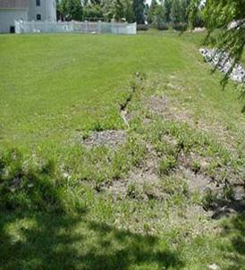
Septic systems can leak and eventually fail. Leakage can result from broken drainage pipes due to settling or ground compaction. It can also be the result of overloading the system by directing rainwater drainage from roofs through the septic tank. It is unnecessary to treat such water. Once a septic system becomes overwhelmed, sewage can pond on the ground near the septic tank or drainfield or back up into buildings. This, in turn, can pollute ditches, creeks, and shallow groundwater supplies.

Be part of the solution
Maintain your system by having it pumped and inspected every 2 to 3 years. This can prevent costly repairs. See our Maintain Your Septic page for more detailed information and service providers.
In addition, run rainwater gutters and sump pumps onto the lawn, away from your house. Avoid connecting them to your septic system.
For more detailed information on septic systems, Washtenaw County’s Maintaining Septic Systems web pages.

AGRICULTURE

The issue: pasture runoff and unrestricted access to water for livestock
Pasturing of livestock (including horses) is a common practice throughout the state. Runoff from these pastures can carry significant amounts of nutrients and bacteria into water bodies if not properly managed. Occasionally, livestock find or are given unrestricted access to water. This can be the result of improper fencing, broken fencing, or standing water in pastures as a result of heavy rainfall. Livestock are often attracted to water, especially during hot summer months. This can be one of the most significant sources of E. coli contamination due to the direct deposition of manure into surface waters.

Be part of the solution
Erect permanent or temporary fencing around all exposed surface water, including drain tile outflows, ditches, and seasonal ponds or flows. In addition, vegetative buffer strips can be used to reduce runoff and filter nutrients and bacteria out before runoff percolates into the groundwater adjacent to streams. Such measures prevent both erosion and bacterial contamination of lakes and streams.

The issue: manure spreading
Spreading livestock manure in the spring or fall is a common practice and can be a rich and sustainable source of Phosphorus (P), Potassium (K), and Nitrogen (N) for pastures or croplands. However, manure also contains strains of E. coli and other potentially harmful bacteria and, therefore, needs to be treated responsibly. Application before rain events or upon snow-covered or frozen fields can lead to rapid runoff into streams and dramatically elevate bacteria counts to dangerous levels, leading to enforcement measures by the MDEQ. Storage of manure in lagoons or bunkers can lead to similar problems.

Be part of the solution
The Michigan Department of Agriculture and Rural Development has developed Generally Accepted Agricultural and Management Practices (GAAMPS) for handling manure in ways that protect farmland, neighbors, and the environment. These guidelines can be found in their GAMPS for Manure Management and Utilization. Two of the most important considerations are proximity to surface water and slope of the field, and a general guideline is to not spread within 150 feet of surface water. For guidance on winter surface application, download Michigan State University Extension’s Keeping Land-applied Manure in the Root Zone, Spreading on Frozen and Snow-covered Ground.

WILDLIFE

The issue: waterfowl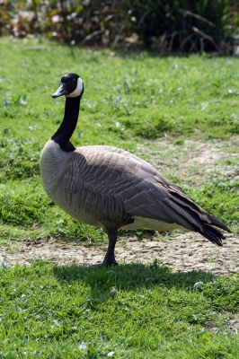
Open, grassy areas near water bodies attract waterfowl, such as geese or ducks. If you own property adjacent to a lake or stream, you are familiar with the mess these birds can leave behind. They contaminate both the beaches and riparian zones. Rainwater washes these bacteria-laden contaminants directly into the lake or stream.

Be part of the solution
Waterfowl congregate in open, grassy areas because they can clearly see any approaching predators. Disrupting lines of sight and offering possible hiding places for would-be predators decreases the likelihood that geese will find your property an attractive roosting ground. Waterfowl are also attracted to long, uninterrupted shorelines. Placing obstacles such as trees or shrubs near the water’s edge can be effective deterrents.
Likewise, planting denser riparian vegetation, such as trees and tall grasses, within the first 15 yards of a shoreline will decrease waterfowl traffic. Merely leaving the lawn to grow longer near the shoreline can also be effective. In general, leaving the shoreline to develop naturally can lead to a more healthy and robust stream ecosystem.

The issue: four-legged wildlife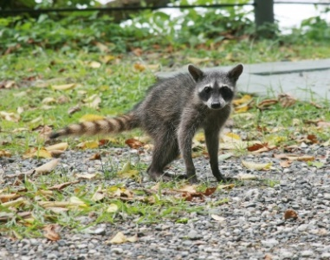
Other wildlife (e.g., raccoons, opossums, skunks, deer, etc.) can also pose the threat of bacterial contamination. These animals often roam throughout the neighborhood or countryside at night and are attracted to human wastes. Some wildlife may also occupy storm sewer drains.

Be part of the solution
To discourage nighttime visitors, avoid leaving food or waste outdoors overnight. Especially avoid leaving it near streams or lakes.

COMBINED OR SANITARY SEWER OVERFLOWS (CSOS OR SSOS)

The issue
In some older communities outside the Huron River Watershed, sewer systems were built that combined domestic waste water with storm water loads in the same drainage pipes. During dry seasons, this drainage is treated by wastewater treatment plants. However, during storm events, wastewater treatment plants become overwhelmed and some of the drainage must be released untreated as a Combined Sewer Overflow (CSO). Though there has been a long-term effort to separate the two drainage systems where they exist, some of these systems are still in use in cities throughout the state today. (See the St. Louis Clean Rivers Healthy Communities Program for an interactive visual explanation.)

Be part of the solution
Sanitary Sewer Overflows (SSO), on the other hand, are illegal discharges of raw or inadequately treated sewage or industrial waste from municipal separate sanitary sewer systems that are designed to carry only domestic sanitary sewage. The discharge may end up in basements, city streets, properties, rivers, or streams. These often occur during wet weather conditions because of infiltration of groundwater through cracks in drainage pipes; rainwater drainage from residential roof drainage systems; pump or power failures; undersized sanitary systems; or system failures due to tree roots, shifting or settling pipes, or sediment buildup. When SSOs are frequent in a watershed, they can lead to serious public health concerns and water body impairments. The MDEQ has broad authority to regulate SSOs. However, because they are illegal, they often go unreported.
Source: MDEQ.
Bacteria Section images by: freedigitalphotos.net: graur razvan ionut, keattikorn, tina phillips, dan, David Castillo Dominici

