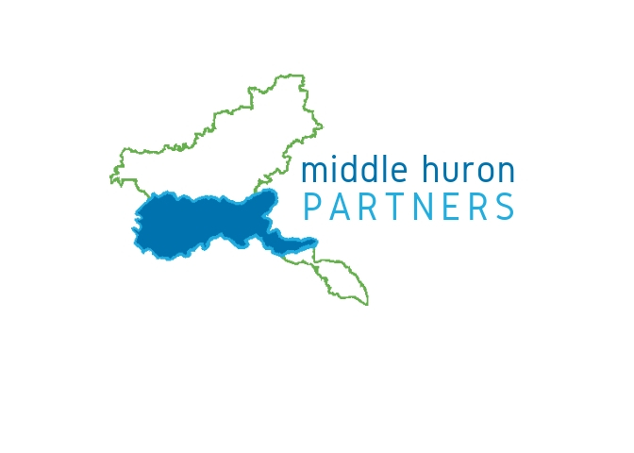

2023 Biennial Stormwater Progress Report Template
September 2023
Most of the Middle Huron Partners have biennial progress reports due by October 1, 2023. HRWC prepared a set of documents for you to include with your 2021-2023 MS4 Progress Report. MS4s ultimately need to review the documents, update them to include your individual MS4 activities, and submit final reports through EGLE’s MiEnviro Portal online reporting system. If you have any problems with MiEnviro Portal, contact Deb Snell at snelld@michigan.gov or 517-539-1097.
This document outlines the report elements, provides answers to many questions you will be asked via MiEnviro Portal (formerly MiWaters), and indicates which parts individual MS4s will need to prepare on their own. You will need to cut-and-paste answers or use them as a guide, then edit and upload additional report documents. It is important to note that it is the responsibility of the individual permit holders to tie these summaries of MHP activities back to your permit.
Many communities still do not have their final MS4 permits issued by EGLE. The MiEnviro Portal reporting follows much of the new permit format. As instructed by EGLE, do your best to document activities you have completed/are doing and include a comment noting your permit has not been issued in sections that do not apply.
HRWC staff is available to help you work through issues you might have preparing your reports. If in the process of developing your report, you find sections or questions not covered by this outline or the collaborative reporting pieces from HRWC, please contact Andrea Paine at apaine@hrwc.org.
Global Elements
Permit Types: Only the Washtenaw County Water Resources Commissioner has an individual permit, and their report is due in April 2024, so HRWC will not address items in the Individual Permit report at this time. All other MS4s have either Watershed, Jurisdictional or Phase I permits. All those types follow the same report form, based on discussions with Deb Snell at EGLE.
Timeframe: HRWC will be reporting on activities, accomplishments, and data from September 2021 through August 2023. For consistency, it is recommended you use the same reporting timeframe.
Section 1. General Facility Information, Nested MS4s and Outfalls/Points of Discharge
Each MS4 is responsible for their own reporting information under this section.
Section 2. Enforcement Response Plan (ERP)
Each MS4 is responsible for their own reporting information under this section. As a reminder, ERPs were developed by MS4s and submitted with your permit application. Many MS4s do not yet have new permits issued. However, most MS4s have been doing ERP activities for years. It is suggested to look at your submitted ERP and report any activities you may have in place and been implementing.
Section 3. Public Participation/Involvement Program (PPP)
HRWC answered the 4 questions from this section below. A separate progress reporting document is also included for upload (see reference in answer 3 below). Note: Please review and edit the PPP Report document as needed. There are numerous places to include your organization’s name and information.
Question 1 – Were there any changes made to the approved PPP during the reporting period which have not been reviewed and approved in accordance with the permit language?
No
Question 2 – Did you complete each PPP measurable goal and/or implement ongoing activities consistent with the measurable goals?
Yes
Question 3 – Provide the reference to the document submitted above describing progress made toward implementing the PPP and meeting each measurable goal, including a summary of results.
PPP activities summarized in attached file Section 3 – PPP report
Question 4 – Will you continue to implement the approved PPP during the next reporting cycle? If you responded “Yes with changes” or NO” submit the SWMP modification request information as required in Part I.A.4. of the permit as an Unscheduled Permit Required Report in MiEnviro Portal.
Yes
Section 4. Public Education Program (PEP)
HRWC answered the 5 questions in this section below. A separate report document on progress in this area is also included that you will upload in the reporting process (see reference in answers 1 and 4 below). Note: Please review and edit the PEP Report document. There are numerous places to include your organization’s name, activities and information, and not all sections may apply to your MS4.
Question 1 – Were there any changes made to the approved PEP during the reporting period which have not been reviewed and approved in accordance with the permit language?
No
Question 2 – Did you complete each PEP measurable goal and/or implement ongoing activities consistent with the measurable goals?
Yes
Question 3 – PEP Topics
PEP Topic 1: Promo public responsibility and stewardship in the applicant’s watershed.
See Section 4 -- PEP report, Activities #1-12
PEP Topic 2: Inform and educate the public about the connection of the MS4 to area waterbodies and the potential impacts discharges could have on surface waters of the state.
See Section 4 - PEP report, Activities #1-8, 12
PEP Topic 3: Educate the public on illicit discharges and promote public reporting of illicit discharges and improper disposal of materials into the MS4.
See Section 4 - PEP report, Activities #2, 3, 4, 5, 7, 8
PEP Topic 4: Promote preferred cleaning materials and procedures for car, pavement, and power washing.
See Section 4 - PEP report, Activities #1-4
PEP Topic 5: Inform and educate the public on proper application and disposal of pesticides, herbicides, and fertilizers.
See Section 4 - PEP report, Activities #1-4, 12
PEP Topic 6: Promote proper disposal practices for grass clippings, leaf litter, and animal wastes that may enter into the MS4.
See Section 4 - PEP report, Activities #1-4, 12
PEP Topic 7: Identify and promote the availability, location, and requirements of facilities for collection or disposal of household hazardous wastes, travel trailer sanitary wastes, chemical, yard wastes, and motor vehicle fluids.
See Section 4 - PEP report, Activities #1-4, 12
PEP Topic 8: Inform and educate the public on proper septic system care and maintenance, and how to recognize system failure.
See Section 4 - PEP report, Activities #1-4, 12
PEP Topic 9: Educate the public on, and promote the benefits of green infrastructure and Low Impact Development.
See Section 4 - PEP report, Activities #1-4, 5, 10, 12
PEP Topic 10: Identify and educate commercial, industrial and institutional entities likely to contribute pollutants to storm water runoff.
See Section 4 - PEP report, Activity #1, 13, 14, 16, 17
Question 4 – Provide the reference to the document submitted above summarizing the evaluation of overall effectiveness of the PEP.
See Section 4 - PEP report
Question 5 – Will you continue to implement the approved PEP during the next reporting cycle? If you responded “YES with changes” or “NO,” submit the SWMP modification request information as required in Part I.A.4. of the permit as an Unscheduled Permit Required Report in MiEnviro Portal.
Yes
Section 5. Illicit Discharge Elimination Program (IDEP)
Each MS4 is responsible for their own reporting information under this section. You may also want to reference Section 9 - TMDL Implementation Plan and the attached Section 9 – TMDL report for coordination with chemistry monitoring.
Section 6. Construction Storm Water Runoff Control Program
Each MS4 is responsible for their own reporting information under this section.
Section 7. Post-Construction Storm Water Runoff Program (i.e. Post-Construction Control or PCC Program)
Each MS4 is responsible for their own reporting information under this section.
Section 8A. Pollution Prevention and Good Housekeeping Program (P2/GH) – Structural Controls, Standard Operating Procedures, Catch Basin Cleaning, and Street Sweeping
Each MS4 is responsible for their own reporting information under this section.
Section 8B. P2/GH - Operation and Maintenance Activities and Employee Training
Each MS4 is responsible for their own reporting information under this section.
Section 9. Total Maximum Daily Load (TMDL) Implementation Plan
HRWC answered the 6 questions in this section, and a separate report document was provided on progress in this area that you will upload in the reporting process.
Questions 1 – Is there a TMDL applicable to the discharge from your MS4 identified in your permit?
Yes
Question 2 – List the TMDLs in your permit.
Include all applicable TMDLs for your MS4. If you are unsure, HRWC can help you determine:
- Excessive nutrients (phosphorus) and algae in Ford Lake
- Excessive nutrients (phosphorus) and algae in Belleville Lake
- Excessive bacteria (E. coli) in the Huron River and tributaries downstream of Argo Dam to Geddes Dam
- Excessive bacteria (E. coli) in Honey Creek
- Excessive bacteria (E. coli) in other areas covered in the statewide bacteria TMDL
- Aquatic biota impairment in Malletts Creek
- Aquatic biota impairment in Swift Run
Question 3 – Were the prioritized BMPs implemented as per the approval TMDL Implementation Plan?
Yes
Question 4 – Provide the reference to the summary of any monitoring results – including outfall monitoring, in-stream monitoring, or modeling – in the document submitted above.
Monitoring results are provided in the attached Section 9 - TMDL report.
Question 5 – Provide the reference to the document submitted above with the assessment of progress made toward achieving the TMDL pollutant load reduction requirements.
Water quality conditions and TMDL progress evaluation are provided in the attached Section 9 – TMDL report and Section 9 – Appendix A – TMDL BMP Progress spreadsheet.
Question 6 – Will you continue to implement the approved TMDL Implementation Plan during the next reporting cycle? If you responded “Yes with changes” or “no”, submit the SWMP modification request information as required in Part I.A.4. of the permit as an Unscheduled Permit Required Report in MiEnviro Portal.
Yes

