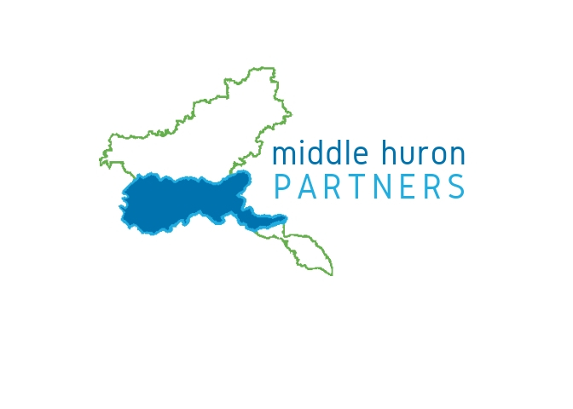
Stormwater Progress Report Template

August 30, 2019
Most of the Middle Huron Partners have biennial progress reports due by October 1. HRWC prepared a set of documents for you to include with your 2018-19 MS4 Progress Report. MS4s will ultimately need to prepare and submit final reports through EGLE’s MiWaters online reporting system (www.michigan.gov/miwaters). If you have any problems with that system, call Deb Snell with DEQ (snelld@michigan.gov; 517-780-7929).
This document outlines the report elements, provides answers to many questions you will be asked, and indicates which parts individual MS4s will need to prepare on their own. You will need to cut-and-paste answers or use them as a guide, and you will need to edit and upload the additional report documents. HRWC staff is also available to help any of you work through issues you might have preparing your reports. Also, if in the process of developing your report, you find sections or questions not covered by this outline or the collaborative reporting pieces from HRWC, please let Ric Lawson know (rlawson@hrwc.org; 734-769-5123 x609).

Global Elements
Permit Types: Only the Washtenaw County Water Resources Commissioner has an individual permit, and their report is due in April, so HRWC will not address items in the Individual Permit report at this time. All other MS4s have either Watershed, Jurisdictional or Phase I permits. All those types follow the same report form, based on discussions with Deb Snell at EGLE.
Timeframe: HRWC will be reporting on activities, accomplishments and data from September 2017 through August 2019. For consistency, it may be best for you to use the same reporting timeframe.

Section 1. General Information and Outfalls
Each MS4 is responsible for their own reporting information under this section.

Section 2. Public Participation
HRWC answered the 4 questions from this section below. A separate report document on progress in this area is also included that you will upload in the reporting process (see reference in answer 1 below). Note: Please review and edit the PEP Report document. There are numerous places to include your organization’s name and information.
Question 1: Section 2 – PPP Report.docx, pages 1-2
Question 2: YES
Question 3: YES, with changes
Question 3a: YES

Section 3. Public Education
HRWC answered the 4 questions in this section below. A separate report document on progress in this area is also included that you will upload in the reporting process (see reference in answer 1 below). Note: Please review and edit the PEP Report document. There are numerous places to include your organization’s name and information, and not all sections may apply to your MS4.
Question 1: Section 3 – PEP Report.docx, Pages 1-17
Question 2: YES
Question 3: YES, with changes
Question 3a: YES

Section 4. Illicit Discharges
Each MS4 is responsible for their own reporting information under this section. You may also want to reference the Section 8 – WQ Report for coordination with chemistry monitoring.

Section 5. Post-Construction Program
Each MS4 is responsible for their own reporting information under this section. You may also want to reference the section at the end of the Section 2 – PPP Report.

Section 6. Pollution Prevention/Good Housekeeping
Each MS4 is responsible for their own reporting information under this section.

Section 7. Enforcement
Each MS4 is responsible for their own reporting information under this section.

Section 8. General Permit Requirements
HRWC answered questions 4 and 5 from this section, and a separate report document was provided on progress in this area that you will upload in the reporting process.
Questions 1-3: MS4s will need to provide their own answers.
Question 4: Water quality conditions are assessed in Section 8 - WQ Report.docx, Pages 2-3.
Question 5: New water quality stresses are reported in Section 8 - WQ Report.docx, Pages 2-3, last two paragraphs.

