Bacteria Reduction
Implementation Plan
for the Honey Creek Watershed

October 2013 — September 2023

For the purpose of achieving the Total Maximum Daily Load (TMDL) and removing the bacteria impairment of Honey Creek

DRAFT 1.3
September 2013

Developed by the Huron River Watershed Council.

Acknowledgements

This document was produced as part of a Clean Water Act, Section 319 grant from the Michigan Department of Environmental Quality (MDEQ), grant number 2011-0066.

The authors wish to recognize the commitment of the many individuals, organizations, and communities whose resources, research, and talents have contributed to this plan.

[To be added]

The Honey Creek Watershed Management Plan was written by:

Ric Lawson, Watershed Planner;
Josh Miller, Watershed Planning Assistant; and
Rob Selesky, Water Quality Monitoring Intern

Huron River Watershed Council

Table of Contents

Implementation Plan Component Page

Problem Definition 6

The Nature and Sources of E. coli 6

TMDL Mandate and Applicable Water Quality Goals and Regulations 8

Water Sampling Data Summary 9

Sources of the Problem and Stakeholders involved 11

Specific TMDL Implementation Objectives 15

Current and New Programs for E. coli Reduction
in the Watershed 16

Overcoming Barriers, Gaps, and Other Forces 26

Accountability Structure for Implementation:
Participants, Reporting, Timeline, Monitoring, Contingency Plans 28

Appendices

A: Honey Creek E. coli TMDL

B: 2012-13 Honey Creek Sampling Report.

C. 2012-13 Honey Creek Sampling Data.

D: Bacteria Source Tracking Analysis Reports.

E: Honey Creek Sampling Study Quality Assurance Program Plan (QAPP)

F. Windshield Survey summary, photo log and photos

G. Stream Reach Survey Forms

H. Goose Control Best Management Practices

I. Participating Stakeholders List

J. Matrix of Current E. coli Reduction Efforts in the Watershed.

1. Introduction and Background

The following plan is designed to be a TMDL Implementation Plan that also meets the nine elements required for Watershed Management Plan approval by the Michigan Department of Environmental Quality

The Huron River, Middle Huron, and Honey Creek

Features. The Huron River (HR) is a Michigan gem. The Michigan Natural Rivers Act of 1970 designated a 27-mile stretch, from Kent Lake Dam, near Brighton, to Barton Pond, north of Ann Arbor, as a “country-scenic river,” Southeast Michigan’s only such designation. Flowing 136 miles, it originates in Indian Springs Metropark near Waterford, flows south of Brighton, through Ann Arbor and Ypsilanti to Lake Erie, south of Detroit. En route, it provides drinking water for 150,000 residents throughout its 900 square mile watershed. It does not flow free, however. It is dammed 98 times, 17 of which are on the main stem.

The Middle Huron (MH), a segment designated as downstream of the confluence with Mill Creek in Dexter through Ford and Bellville Lakes, east of Ypsilanti, comprises 40 of the 136 miles (plus another 593 miles of contributing streams), forming a 217 square mile watershed. All or portions of 13 local communities are situated in the Middle Huron Watershed, of which the largest portions are within the cities of Ann Arbor and Ypsilanti, and the townships of Scio, Ann Arbor, Superior, Pittsfield, Ypsilanti and Van Buren. Other communities with smaller areas in the watershed include the townships of Webster, Northfield, Salem, and Lodi, as well as the Village of Dexter and the City of Belleville. Because the MH’s gradient (5 ft. /mi.) is steeper than the Upper Huron or other Michigan watersheds, and because of intensive urban development, fewer lakes and wetlands remain in the MH.

Honey Creek. Honey Creek joins the western end of the MH at the upper end of Barton Pond, between Dexter and Ann Arbor (see Figure 1). The watershed encompasses 23 square miles and comprises most of the area of Scio Township, plus small portions of Lima, and Lodi Townships, and the City of Ann Arbor. Glacial typology of the region is flat clay lake plain with soils dominated by silt and clay loams dissected by broad glacial drainageways of sandy soil. The watershed contains a spectrum of land uses ranging from agricultural operations and small-scale animal farms near the headwaters to the urbanized City of Ann Arbor downstream. Land uses in the watershed are as follows based on consolidated Southeast Michigan Council of Governments’ (SEMCOG) aerial photographic data (2000): residential, 27%; forest, 9%; Agriculture, 31%; commercial/industrial, 9%; water/wetland 8%; open/public recreation, 17%.

The Huron River Watershed Council (HRWC) Adopt-a-Stream program has taken biological samples from 2001-2012 at four sites along Honey Creek. Ecological conditions, as determined by a combination of biological and physical data, have varied from ratings of poor, fair, and good at these sites. Aquatic invertebrate communities have remained stable, while insect diversity has increased steadily in some locations. As part of the baseline water quality monitoring program run by HRWC, a long term site has been monitored on Honey Creek since 2003 measuring for several water quality parameters, including E.coli starting in 2006. Results from this program are discussed in the water quality data section.

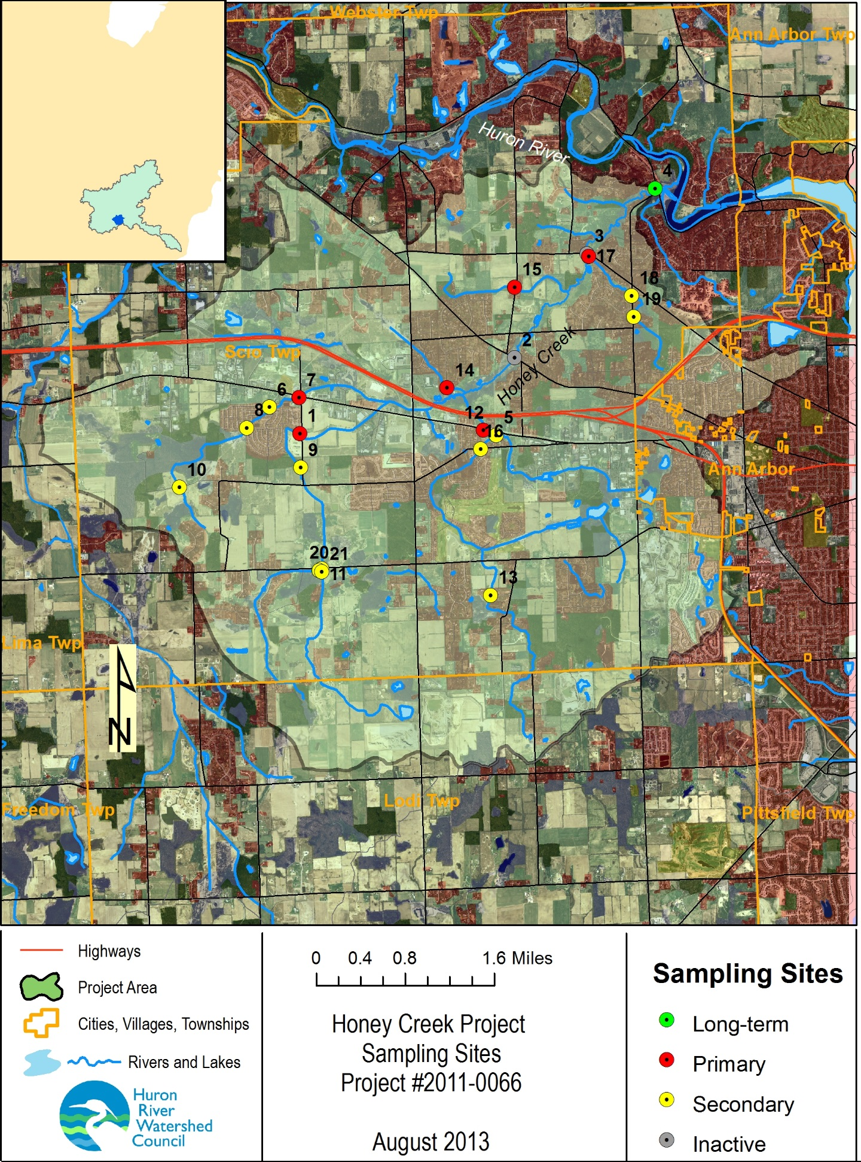
The Huron River Watershed Council (HRWC) Adopt-a-Stream program has taken
Figure 1. Honey Creek watershed with study sampling sites.

Land Use and Development in the Middle Huron

The Middle Huron in general. The MH watershed’s land cover is dominated by urban and sub-urban residential, commercial and industrial uses, with low-density residential areas, grasslands/old agricultural fields, forested lands, and wetlands scattered primarily in the northern and western fringes of the watershed. Permanent mixed density residential land use is the single largest use of the watershed (29.5%), followed closely by forest (27.1%), and rural (20.9%). In recent decades, the MH watershed has experienced amplified development pressures from a growing economy and urban sprawl. Its population will continue to grow through 2030, with 30% growth rates projected in Scio, Superior and Ypsilanti Townships (SEMCOG, 2000).

If current development practices are employed to accommodate the projected increase in population and associated infrastructure, then SEMCOG estimates 40% of the remaining open spaces will be developed within the HR watershed by 2020. Much of this projected conversion of undeveloped land will occur in the MH, with potential increases for negative environmental impacts, including water quality impacts from erosion, sedimentation, and increased inputs of stormwater pollutants. Potential impacts on water quantity also increase as wetlands, woodlands, floodplains and other natural features that regulate water quantity are altered or replaced with impervious surfaces. Land development results in significant changes to the hydrology of the watershed: it increases daily fluctuations in streamflow and diminishes groundwater recharge. All tributaries to the Huron River suffer from comprehensive channelization, lack of cover, and large flow fluctuations as a result of efforts to accelerate drainage through these streams.

Honey Creek. Honey Creek is a critical area for HR water quality because of its 14% imperviousness rate as an average over the creekshed. Generally, research indicates that once the impervious cover in a watershed exceeds 10%, surface waters begin to show signs of impairment. Imperious cover over 25% generally results in significant impairment, and watersheds with over 50% impervious cover required extensive and expensive management actions to maintain even modest water and habitat quality. Riparian buffer zones may mitigate the impact of impervious development. However, Honey Creekshed in general lacks quality buffer zones compared to other creeksheds on the MH, compounding the problem of pollution due to runoff. Honey Creek could be a target for better riparian buffer protection and restoration. As a result, ecological conditions have been rated as poor.

Management of the MH. Regulatory and enforcement responsibility for water quantity and quality regulation often lies with the United States Environmental Protection Agency (US EPA) and the Michigan Department of Environmental Quality (MDEQ). Major activities regulated by the state, through the MDEQ, are the alteration/loss of wetlands, pollutant discharges, control of stormwater, and dredging/filling of surface waters. Because the western end of the MH is designated as a Scenic River, special development restrictions apply along the river and tributaries. While state and county governments take an active role in many relevant watershed or water quality regulations and policies, local governments assume significant leadership in land and water management by passing and enforcing safeguards. These local ordinances can be more protective than state laws, though state regulations set minimum protections that cannot be violated. Local governments oversee enforcement of their policies.

Designated and desired uses. Following requirements in the federal Clean Water Act, the State of Michigan established designated uses for all state waterways: agriculture, industrial water supply, public water supply at the point of intake, warmwater fishery, other indigenous aquatic life and wildlife, partial body contact (PBC) recreation, and total body contact (TBC) recreation between May 1 and October 31. Due to human impacts and the impairments they cause throughout the MH Watershed, not all of the designated uses are fulfilled.

In addition to state-designated uses, the residents of the MH watershed wish to use its surface waters in ways that are not yet achievable. The following desired uses have been identified by the communities in the watershed over the course of the development and updating of the MH Watershed Management Plan (see below): coordinated development between environmental and economic considerations; protected and enhanced hydrologic functions; protected open space, recreation and urban amenities.

2. Problem Definition

Honey Creek, a feeding tributary to the Huron River in Washtenaw County, Michigan, is listed as an impaired waterbody on Michigan’s Section 303(d) list (Impaired Waterbodies List) due to impairment of recreational uses by the presence of elevated levels of pathogens. The listed segment addresses approximately 26 miles of branching stream channels, and 23 square miles of land drainage. Water sampling in this area has shown that Michigan Water Quality Standards (WQS) for Escherichia coli (E. coli) are not consistently being met in this waterbody or its tributaries.

Impairments to the Middle Huron

Impairments. The major impairments to the MH, in order of priority, are high nutrient loading, altered hydrology, sedimentation and soil erosion, and pathogen overloading. Pathogen overloading is the most relevant to this plan for Honey Creek and its effect on the MH. In 2006, the stream monitoring program under the Middle Huron Partnership Initiative added E. coli counts to the measurement parameters it had been monitoring since 2002. All but one site exceeded the single event standard, which indicates that E. coli bacteria contamination is a significant concern in the MH watershed. Major sources of pathogens, especially E. coli, in the Middle Huron include wildlife living in or near storm drains and outlets, pet and wildlife waste washed into streams from upland areas, failing septic systems, land application of untreated waste from these septic systems, and illicit discharges of sanitary waste into storm drains.

The overarching challenges to mitigating these impairments are land use change (e.g., suburbanization), loss of natural features (e.g., riparian buffer zones), need for public awareness and action, need for administrative support and institutional and financial arrangements, and monitoring programs and data. These challenges have been and are being addressed through the MH Watershed Management Plan (WMP).

The Middle Huron Watershed Management Plan

Background. The MH WMP was originally drafted in 1994 by a Policy Advisory Committee, consisting of members representing each of the communities in the project area. They have continued to meet on a regular basis, and the meetings are currently coordinated by the Middle Huron Partnership Initiative. The plan was updated in 2000, and a major redraft was completed in 2008 by HRWC under the coordination of the Washtenaw County Drain Commissioner (WCDC).

Intent. Though originally designed to reduce Phosphorus levels in Ford and Belleville Lakes at the direction of the MDEQ, it was also intended to proactively address other water quality issues throughout the watershed. However, the MH WMP serves as an umbrella plan, under which subwatershed plans are developed to address specific water quality issues unique to the sub-watersheds. Presently, sub-watershed and lake plans exist for several bodies throughout the MH watershed. Subwatershed plans are intended to address the challenges posed to the HR and are to be rooted in the HR WMP.

Creek groups have contributed a unique community-involvement component to the development of the original WMP and updates. Several creek groups have formed since the development of the original WMP, and several of these have developed the subwatershed plans or other sets of recommendations. Staff from the HRWC and the WCDC have met and will continue to meet with creek groups throughout the process of developing and implementing watershed plans.

Goals. The Advisory Committee prioritized goals in the WMP. Those that are most pertinent to Honey Creek include the following: reduce nonpoint source loading, increase public awareness and involvement, gain broad implementation of subwatershed plans, and continue monitoring and data collection for water quality, water quantity and biological indicators.

Action plan. The action plan of the WMP was determined by the plan’s authors (HRWC) and the Advisory Committee, based on the prioritized goals, environmental effectiveness, and likelihood of implementation. Because it is meant to be an umbrella plan for subwatershed plans, it presents the broad range of practices and general information about their application. The recommended actions most pertinent to Honey Creek fall under the following categories: ordinances and policies (e.g., ordinances for stormwater management), practices (e.g., street cleaning programs), public information and education (e.g., a public hotline for elicit discharge), illicit discharge elimination, and structural improvements (e.g., installing inlet filters). Several pathogen-reduction strategies, focusing on E. coli sources, were presented to diminish illicit discharges, domestic and feral animal sources, and wildlife animal sources, including strategies of land use planning and treatment (Appendix D of the MH WMP).

Implementation. Multi-layered advisory committees have been established to advocate and facilitate the plan. In addition, local subwatershed groups have participated, and program specific community involvement activities have taken place (e.g., Community Partners for Clean Streams, and Adopt-a-Stream). Evaluation methods for measuring success were put in place and monitoring responsibilities established. Specifically, E. coli levels have been analyzed one to two times per month, plus during rain events, by the HRWC and Ann Arbor Water Treatment Plant (AA WTP).

What is a TMDL?

When a water body is not attaining Water Quality Standards (WQS) for designated uses, it is put on the EPA’s 303(d) List, according to the Clean Water Act, and is required to have a Total Maximum Daily Load (TMDL), allowing the Michigan DEQ to establish controls to reduce pollution and restore the quality of the resource. A TMDL is a calculation of the maximum amount of a pollutant that a waterbody can receive and still meet water quality standards, and an allocation of that amount to the pollutant’s sources. It is a document which presents available information to determine potential sources of contaminants.

As of the 2010 303(d) List of Nonattaining Waterbodies, Honey Creek (HC) remains listed for water quality impairments. The HC TMDL, which specifically targets E. coli contamination, was completed by the MDEQ in April 2009 (see Appendix A).

Bacteria. Excess pathogens in water resources can become a public health concern and cause the public to lose recreational opportunities such as wading and canoeing. Coliform is a group of bacteria that includes a smaller group known as fecal coliforms, which are found in the digestive tract of warm-blooded animals. Their presence in freshwater ecosystems indicates that pollution by sewage or wastewater may have occurred and that other harmful microorganisms may be present. A species of fecal coliform known as Escherichia coli, or E. coli, is analyzed to test for contamination. It is used as an indicator organism to predict the presence of multiple harmful microorganisms. E. coli and associated microorganisms, when taken into the body, can cause severe sickness: bacterial infections (cholera, salmonellosis), viral infections (hepatitis, gastroenteritis), or protozoa infections (cryptosporidiosis, giardiasis). Once these pathogens are in a stream or lake, they can infect humans through ingestion, skin contact or contaminated fish.

Sources. E. coli can originate from single discharge points or more broadly across multiple points of similar types. Point-source discharge can emerge as treated (e.g., from wastewater treatment plants) or untreated (e.g., from raw or partially treated sewage overflows during storms). Untreated occurrences can result from Combined Sewer Overflows (CSO), of which there are none in the Huron River watershed, and Sanitary Sewer Overflows (SSO), which are illegal “spills.” This broadly sourced pollution can be the result of failing septic systems, overland run-off, agricultural inputs (e.g., maneuver spreading or unrestricted livestock access to streams), illicit connections (septic systems draining into stormwater drains or streams), pets, or wildlife.

Regulations. Rule 62 of the Michigan Water Quality Standards (Part 4 of Act 451) limits the concentration of microorganisms in surface waters of the state and surface water discharges. Waters of the state that are protected for Total Body Contact (TBC) recreation must meet limits of 130 E. coli per 100 (ml) water as a 30-day geometric mean of five sampling events (3 samples per event) and 300 E. coli per 100 (ml) water for any single sampling event during the May 1 through October 31 period. The TBC standard protects the public during summer months, assuming that people will swim with head submerged. The limit for waters of the state that are protected for Partial Body Contact (PBC) recreation is a geometric mean of 1000 E. coli per 100 ml water for any single sampling event at any time of the year. The PBC standard protects the public year-round, assuming that people will not swim in the winter season.

Why a TMDL for Honey Creek?

Standards for TBC and PBC of E. coli are being exceeded in Honey Creek, especially during times of heavy precipitation. The TMDL is based on data from four stations, monitored weekly from August through October 2007, an unusually dry year. The 30-day geometric mean hovers between 400 and 1,500 above TBC standards, especially at Station 1. In part, these impairments result from the lack of substantial riparian buffer zones and the rapidly growing human population in the creekshed, leading to a greater percentage of impervious surfaces. In part, they are due to point and non-point sources.

Bacteroidetes analysis determines presence or absence of bacteria specific to human feces. In a single sample taken from the worst site (Staebler Rd.) on 12 October 2007, no human marker was detected, but this does not rule out the potential for human sources.

Potential sources indicated by the TMDL include the following.

- Failing septic systems (according to the Washtenaw County Environmental Health Department inspection records, 8% of septic systems in the TMDL watershed are inadequate, and 4% had above ground sewage present);
- Illicit connections to stormwater drains;
- Sanitary Sewer Overflows (SSO) (there were two reported isolated events);
- Permitted point source discharges (there exists one NPDES permitted sanitary wastewater discharge, but it is not yet constructed, and permits require disinfection and contain appropriate limits to meet WQSs);
- Pets (Scio Farms MHC, located upstream from Station 1, is home to 650+ dogs in a quarter square mile community, with dog walk areas directly on the creek and around stormwater retention ponds);
- Wildlife (e.g., geese, raccoons, etc.); and
- Agriculture, which could cause both wet and dry weather contamination (e.g., manure spreading, animals with unrestricted access to streams, and pasture runoff—30% of the creekshed is in agricultural use, some as pasture).

The Nature of Escherichia coli

Bacteria are among the simplest, smallest, and most abundant organisms on earth. Bacteria are "procaryotic" organisms—a term which indicates a cellular structure lacking an organized nucleus and nuclear membrane. Instead of containing genetic information stored on several chromosomes, bacteria contain a single strand of DNA. These organisms reproduce by binary fission, which occurs when a single cell divides to form two new cells called daughter cells. Each daughter cell contains an exact copy of the genetic information contained in the parent cell. The process continues with each daughter cell giving rise to a generation of two new cells. The generation time is the time required for a given population to double in size. This time can be as short as 20 minutes for some bacteria species (e.g., Escherichia coli).

While the vast majority of bacteria are not harmful, certain types of bacteria cause disease in humans and animals. Examples of waterborne diseases caused by bacteria are: cholera, dysentery, shigellosis and typhoid fever. During the London cholera epidemics of 1853-1854, Dr. John Snow observed that nearly everyone who became ill obtained their drinking water from a specific well into which a cesspool was leaking. Those who became ill either drank water from the well or came into contact with fecally contaminated material while tending those already sick. Concerns about bacterial contamination of surface waters led to the development of analytical methods to measure the presence of waterborne bacteria. Since 1880, coliform bacteria have been used to assess the quality of water and the likelihood of pathogens being present. Although several of the coliform bacteria are not usually pathogenic themselves, they serve as an indicator of potential bacterial pathogen contamination. It is generally much simpler, quicker, and safer to analyze for these organisms than for the individual pathogens that may be present. Fecal coliforms are the coliform bacteria that originate specifically from the intestinal tract of warm-blooded animals (e.g., humans, beavers, raccoons, etc.). They are cultured in a special growth medium and incubated at 44.5º C.

The first U.S. standards for drinking water, established by the Public Health Service in 1914, were based on coliform evaluations. It was reasoned that the greatest source of human pathogens in water was from human waste. Each day, the average human excretes billions of coliform bacteria. These bacteria are present whether people are ill or healthy. Monitoring for coliform bacteria was designed to prevent outbreaks of enteric diseases, rather than to detect the presence of specific pathogens. Today, coliform bacteria concentrations are determined using methods specified by the Environmental Protection Agency (EPA) and Standard Methods for the Examination of Water and Wastewater (AWWA, APHA, and WEF, 20th ed., 1998).

Sources of Bacteria

Human sources of bacteria can enter water via either point or nonpoint sources of contamination. Point sources are those that are readily identifiable and typically discharge water through a system of pipes. Communities with sewer systems may not have enough capacity to treat the extremely large volume of water sometimes experienced after heavy rainfalls. At such times, treatment facilities may need to bypass some of the wastewater. During bypass or other overflow events, bacteria-laden water is discharged directly into the surface water as either sanitary sewer overflow (SSO) or as combined sewer overflow (CSO). Power outages and flooding can also contribute to the discharge of untreated wastewater.

Improperly functioning sewer systems and privately owned septic systems can have a profound impact on water quality. By carrying nutrients (phosphorus and nitrogen), bacteria, pharmaceutical agents, and other pollutants to waterbodies with little or no treatment, impaired systems can result in unhealthful conditions to humans and to aquatic organisms.
The Washtenaw County Health Department regulates the design, installation, and repair of privately owned septic systems. The County currently requires regular maintenance and inspection to assure proper functioning of these systems, which occurs at the time the property is sold, and has determined that nearly 20% of privately owned septic systems in the county are failing and require repair (a typical percentage for the area), nearly 50% have reached their service life expectancy, and more than 5% have an illicit discharge (i.e., a connection to a storm drain instead of a septic drain). Illicit discharges can have an even greater impact on water quality than impaired septic systems. Both county and local units of government covered by Phase II stormwater permits are required to identify and eliminate illicit discharges in their communities through an Illicit Discharge Elimination Program (IDEP).

Illicit connections to storm sewers are a source of bacteria in surface waters, even during dry periods. A connection to a storm sewer is "illicit" when the wastewater requires treatment prior to discharge and should be routed to the sanitary sewer. Only storm water and certain permitted discharges (e.g. clear, non-contact cooling water) should be discharged to a storm sewer.

Nonpoint sources are those that originate over a more widespread area and can be more difficult to trace back to a definite starting point. Failed on-site wastewater disposal systems (septic systems) in residential or rural areas can contribute large numbers of coliforms and other bacteria to surface water and groundwater.

Animal sources of bacteria are often from nonpoint sources of contamination. Concentrated animal feeding operations, however, may become point source dischargers. Agricultural sources of bacteria include livestock excrement from barnyards, pastures, rangelands, feedlots, and uncontrolled manure storage areas. Land application of manure and sewage sludge can also result in water contamination, which is why states require permits, waste utilization plans, or other forms of regulatory compliance.

Storm water runoff from residential, rural, and urban areas can transport waste material from domestic pets and wildlife into surface waters. Landscaping practices may create ideal habitat for geese and other migratory waterfowl, concentrating populations during the nesting season or creating year-round flocks, and creating hazardous quantities of fecal litter, leaving E. coli and other disease-causing organisms ready to be washed into ponds and waterways.

Bacteria from both human and animal sources can cause disease in humans. Bacteria-laden water can either leach into groundwater and seep, via subsurface flow, into surface waters or rise to the surface and be transported by overland flow. Bacteria in overland flow can be transported freely or within organic particles. Overland flow is the most direct route for bacteria transport to surface waters. Underground transport is less direct, because the movement of water and bacteria is impeded by soil porosity and permeability constraints.

TMDL Mandate and Applicable Regulations

Section 303(d) of the Federal Clean Water Act and the United States Environmental Protection Agency’s (U.S. EPA) Water Quality Planning and Management Regulations (40 CFR Part 130) require states to develop Total Maximum Daily Loads (TMDLs) for waterbodies that are not meeting Water Quality Standards (WQS). The impaired designated use for Geddes Pond/Huron River at this location is total body contact recreation. Rule 100 of the Michigan WQS requires that this waterbody be protected for total body contact recreation from May 1 to October 31. The target levels for this designated use are the ambient E. coli standards established in Rule 62 of the WQS as follows:

R 323.1062 Microorganisms
Rule 62. (1) All waters of the state protected for total body contact recreation shall not contain more than 130 Escherichia coli (E. coli) per 100 milliliters, as a 30-day geometric mean. Compliance shall be based on the geometric mean of all individual samples taken during 5 or more sampling events representatively spread over a 30-day period. Each sampling event shall consist of 3 or more samples taken at representative locations within a defined sampling area. At no time shall waters of the state protected for total body contact recreation contain more than a maximum of 300 E. coli per 100 milliliters. Compliance shall be based on the geometric mean of 3 or more samples taken during the same sampling event at representative locations within a defined sampling area.

The Michigan Department of Environmental Quality (DEQ) finalized the Honey Creek E. coli TMDL in April 2009. The TMDL was developed based in part on DEQ analysis of water sampling data collected in 2007.

All surface tributaries (not enclosed) are required to comply with the WQS of 130 E. coli per 100 ml as a 30-day geometric mean. Because enclosed tributaries are not considered waters of the state, the daily maximum WQS of 300 E. coli per 100 ml will apply as a monthly average to the few enclosed sections of Honey Creek. By maintaining the concentration of 300 E. coli per 100 ml in the enclosed tributaries, any area of WQS exceedance in Honey Creek will be minimized. If the pathogen inputs can be controlled so that surface tributaries meet a 30-day geometric mean of 130 E. coli per 100 ml, the enclosed tributaries meet a monthly average of 300 E. coli per 100 ml and background levels do not significantly increase, then total body contact recreation in this reach of the Huron River will be protected.

Sampling Effort and Data Summary

Sampling results include initial efforts by DEQ for TMDL development, ongoing monitoring by HRWC, and a sampling study used for plan development. For this study, in 2012 and 2013, HRWC sampled 21 locations throughout Honey Creek over three 5-week periods in three different seasons. Sampling was conducted to identify sources based on two factors: geographic distribution and host sources.

Geographic Distribution
DEQ Sampling. Honey Creek was placed on the Section 303(d) list in 2000, due to impairment of recreational uses by the presence of elevated levels of pathogens. The original listing was based on sampling conducted by Washtenaw County Environmental Health Department (WCEHD) and MDEQ. (MDEQ, 2009) MDEQ followed up with sampling to develop the TMDL (see Appendix A) in August through October, 2007. The sampling results showed broad exceedences of both total and partial body contact standards at four points along Honey Creek (see Figure 1 for sampling stations). Figure 2 below illustrates the results at all four sampling locations along with precipitation from 48 hours prior to sampling. E. coli concentrations exceeded standards at all four sampling locations. Bacteria colony counts were generally higher following rain storms. Bacteria concentrations were also generally highest at the most upstream location and progressively less at each downstream location. The TMDL identified this as a “decreasing trend of E. Coli concentrations from upstream to downstream.” This suggested a potential source or sources close to the upstream location (HC01).

Figure 2. Results from sampling events in 2007 at four stations along Honey Creek. Results represent E. coli cfu/100 ml and 2 days of pre-event precipitation.

HRWC Sampling. HRWC has been sampling Honey Creek (at the station identified as HC04 in Figure 1) as part of the Middle Huron Monitoring Program since 2003. In 2006, the program added E. coli as a parameter. Since that time, through 2012, the median E. coli concentration was 120 cfu/100 ml, though the geomean was 211 cfu. This figure is above the 30-day TBC standard. Complete results of this monitoring are included in Appendices B and C.

In an effort to confirm this geographic pattern of bacterial contamination, HRWC located sampling stations at all major branches and tributaries to Honey Creek. Sampling was conducted over three five-week periods starting in June and October in 2012 and July in 2013. This represented sampling across three different seasons. Following initial sampling, additional sites were selected upstream of branch or tributary sites that yielded E. coli concentrations above the sampling event standard of 300 per 100 mL. Detailed sampling methodology and complete sampling results are included in Appendix B.

Figure 2 depicts the results of sampling at Honey Creek branches and tributaries. The spring/summer 2012 geomean near the creek mouth was 425, exceeding the TBC standards for single sample and 30-day mean. Sample results at two branches were below concern levels and were not subsequently sampled in October. Those branches are represented by sampling sites HC12 and HC14. All other branches had bacteria concentrations well above TBC standards as well as the level at the downstream station HC04. Branches represented by sampling stations HC01 and HC17 had geomeans for June/July sampling that exceeded the PBC standard. Sampling upstream of these two stations did not result in levels that were substantially lower. Therefore, potential sources upstream could not be ruled out.
Figure 3. Geomeans of multiple sampling events at Honey Creek sites in cfu/100 ml E. coli. Red concentrations exceed 1,000 cfu, orange exceed 300 cfu and green are below 300 cfu. The first number represents June/July sampling and the second number represents October sampling.

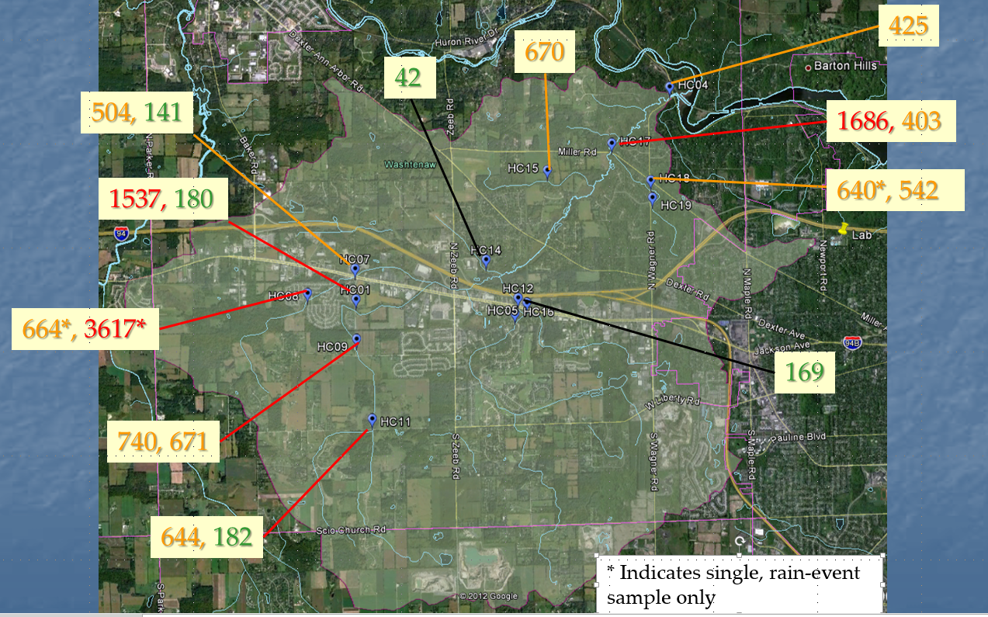
Several interesting observations emerged from October sampling. First, bacteria concentrations were generally lower. This may be primarily the result of lower temperatures. The second observation is that the levels at upstream station HC09 (671 cfu) were significantly higher than those downstream at HC01 (180 cfu) as well as the levels further upstream at station HC11 (182 cfu).

The results in Figure 2 combine bacteria levels detected in both wet and dry periods. It is important to look at the hydrologic state to gain an understanding of the relative contribution of consistent inputs or point sources (which should be detectable in dry conditions, but less so in wet conditions) and runoff sources (which should be absent in dry conditions and high in wet conditions). To look at this, one can compare results to the preceding rainfall conditions. Figure 3 and Figure 4 show the bacteria concentrations at the main branch stations along with the preceding 48-hours of rainfall. Downstream station HC04 is shown to be above the TBC standard in dry conditions, but then in excess of the PBC standard following a significant rain event. This suggests that the Honey Creek system has a combination of point sources and runoff sources. Likewise, upstream branches contributing to sites HC07 and HC01 show a similar pattern. Mean concentrations at HC01 are higher than HC07 or HC04 under all conditions.

In contrast, Figure 4 shows that the stream contributing to HC15 shows the opposite trend. Bacteria concentrations are high during dry conditions, but seem to get diluted following rain events. This suggests that there may be a consistent source in that branch. The trend for HC17 appears to be relatively unaffected by runoff conditions. Concentrations increase somewhat, but are also high during dry conditions.

Note: additional sampling is being conducted in July-August 2013.

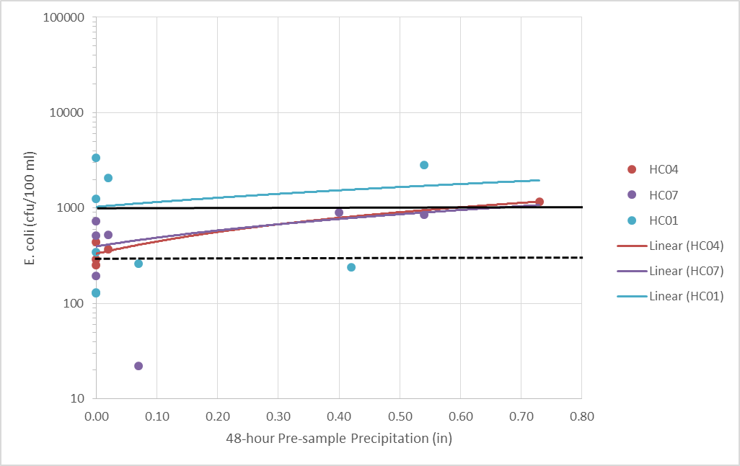
Figure 4. Maximum daily E. coli concentrations at 3 sites matched with precipitation for the 48-hours preceding sample collection. Colored lines indicate site trends (not significant), and black lines indicate PBC (solid) and TBC (dashed) daily standards.

Figure 5. Maximum daily E. coli concentrations at 3 sites matched with precipitation for the 48-hours preceding sample collection. Colored lines indicate site trends (not significant), and black lines indicate PBC (solid) and TBC (dashed) daily standards.

Bacterial Source Tracking
A subset of samples from sites that exceeded the TBC standard were set to a lab to conduct Molecular Source Tracking (MST) analysis of bacteriodes cells extracted from the samples. DNA material was assessed for the presence of five markers for which positive references were established: human (Hu), bovine or cow (B), canine or dog (C), Equine or horse (Eq) and goose (G).

Results of this analysis conducted at 10 sites is summarized in Figure 5. The downstream station was positive for all 5 markers as was HC01 and the two stations upstream of that. Stations HC17 and HC12 were also positive for human sources. This suggests that there may be septic system issues in these drainages. Bovine sources were positively identified at all sites tested. Since there are no active cattle or dairy operations in the Honey Creek watershed, this suggests that there may be active bacteria in manure or compost applications throughout the watershed. Canine sources were identified at all but one site. This indicates that pet waste is a source of bacteria throughout the watershed. Geese were positively identified as a genetic source for bacteria in all the upstream branches, as were horses.

Complete results of BST analysis are included in the sampling report in Appendix B and the BST reports in Appendix D.

Note: Additional testing is being conducted in July-August 2013, which includes relative quantification of source markers.

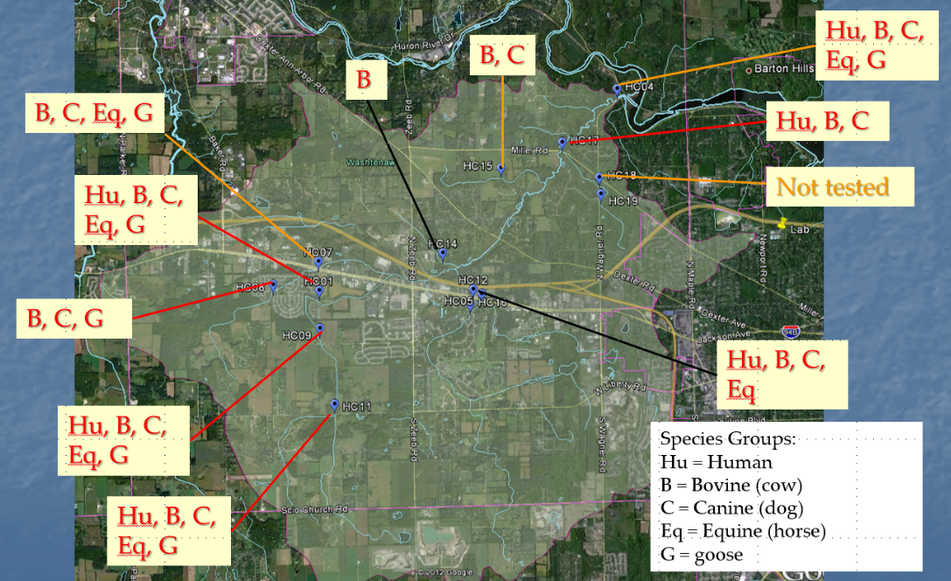
Figure 6. Bacterial Source Tracking (BST) analysis results for the presence of five DNA markers.
Load Analysis
The TMDL for Honey Creek determined that quantifying a load for biological content is not appropriate and that the concentration standards for total body contact must be met throughout the watershed to be protective. This standard is only being met in the stream segment represented by sampling station HC14. The 30-day standard is very close to being met at HC12. All other branches can be assumed (if not monitored) to be contributing E. coli bacteria that exceeds daily maximum and 30-day geomean concentration standards.

The TMDL also indicated that, while there are a number of facilities with NPDES permits in the watershed, none of them are regulated for bacteria or would be expected to be contributing effluent containing E. coli. Sources contributing concentrations of bacteria are therefore either distributed throughout the watershed and contaminating the watershed via runoff flow or as illicit connections or failing septic systems. Specific source characterization and critical area analysis is included in the following chapter.

3. Sources of the Problem and Stakeholders Involved

Potential pathogen sources for Honey Creek include sources typically associated with urban and suburban runoff, as well as many associated with agricultural watersheds. Land uses in the watershed are mixed. A commercial corridor crosses the middle of the watershed, following I-94 and Jackson Road. This corridor makes up most of the 9% commercial and industrial land uses, and a good portion of the 14% impervious cover, as described in chapter 1. This corridor splits the watershed roughly in half, but does not likely contribute significant pathogen concentrations, as it is connected to the Ann Arbor sewer system.

Downstream of the transportation corridor, three branches (flowing to monitoring stations HC14, HC15 and HC17) drain predominantly medium density residential areas to the east (HC17 stream), with some low density residential and row crop agriculture mixed in west of the main creek (HC14 and HC15 streams). Honey Creek itself has good riparian cover in this stretch. Sampling results discussed in the previous section identified HC17 and HC15 as significant pathogen contributing streams. Residential areas along the downstream portions of the HC17 tributary are on on-site wastewater treatment systems (septic systems), unlike the upstream portions east of M-14, which are connected to the Ann Arbor sewer system. Failing septic systems are a potential source of pathogens along the lower reach of the HC17 stream, as are pet and wildlife feces. This stream has not been inspected for illicit connections under any IDEP program, so such connections could also be a source of some contamination.

Sampling results suggest that there is a combination of ongoing release or seepage sources and runoff sources throughout the watershed, with the exception of the branch that contributes to sample site HC15. That branch may be limited to one or more point sources. The tributary drains mostly row crop agricultural areas, with a some portion south of the stream draining from residential on septic systems. It is unlikely that these residences contribute much as the same subdivisions also drain to the HC14 stream, which was below bacteria standards. The Washtenaw County Conservation District office (Olds, 2012) indicates that row crop farmers across the watershed may spread manure multiple times throughout the growing season. Illicit connections could also be an issue in the HC14 drainage, which would exhibit the point source characteristics observed in the sampling data. The stream was inspected once under Washtenaw County Water Resource Commissioner’s IDEP program, but no sampling was conducted and there was no follow-up effort.

Upstream or south of Jackson Road, there are two creek branches. The southeastern branch (draining to HC12) was shown to contribute relatively low concentrations of bacteria, so is not a focus of bacteria source identification. The eastern branch splits into two branches draining to stations HC07 and HC01. These branches consistently contained bacteria concentrations above all state standards. Both streams drain a high density manufactured home development, Scio Farms. This development contains multiple detention ponds that ultimately drain stormwater to the Honey Creek streams. Residents maintain a high pet density with little waste control, according to the TMDL, manager interview and windshield survey. Scio Farms is connected to Ann Arbor sewers, so should not be a source of septic leakage. Another small residential development along the HC01 branch is also connected to sewer, but could also contribute pet waste sources. Upstream of both branches is agriculture and low density residential on septic systems. The HC07 branch drains row crop sources, while agriculture upstream of HC01 is a mix of row crop and low density horse pastures. Animals appear to be excluded from the streams but riparian cover is thin. All animal markers show up in results from these stream segments.

Windshield and Reach Surveys
In an effort to learn more about common practices in the watershed and refine knowledge about potential sources, HRWC conducted two types of surveys of targeted potential source areas. First, a general windshield survey was conducted of residential and agricultural areas in high contamination drainage areas. This was comprised of a visual observation of the targeted areas and included notes on practices observed and photographs. A summary and photos are included in Appendix F. Windshield surveys were timed to correspond to times of the day when residents or farmers were most likely to be engaged in activities. Row crop practices were confirmed throughout the drainage areas upstream of HC01 and HC07 branches, but no manure spreading was observed. Horse pastures were observed south of Liberty Road (HC11) as well as stables near the creek north of Scio Church Road. Numerous dog walking areas were identified and observed in residential areas along the HC01 branch, as well as the HC17 branch. No pet waste practices were observed, but neither were pet waste stations apparent.

The second type of survey conducted was a reach survey of sections of creek branches HC17, and HC01. Teams of two were assigned stream reaches and asked to walk the length of the reach on October 31, 2012 and record observations in and around the creek onto survey forms. They also photographed anything deemed a potential source. The surveys yielded little new information on the HC01 reach between Park and Liberty Roads. Several unidentified outfalls were observed on the HC01 reach along Staebler Road. One was sampled and yielded E. coli at 313 cfu/100 ml (single sample). This pipe was tracked to a small detention pond in the Scio Farms development. A few outfalls were observed along the HC17 stretch, but none with flow or evidence of sewage. A chicken coop was identified to be located adjacent to the stream with free access for the chickens. Copies of completed surveys are included in Appendix G.

Stakeholders
HRWC conducted an initial stakeholders meeting at the beginning of the plan development process, a technical meeting during the mid-term of development and a final meeting to review and comment on the draft plan. HRWC also used the initial stakeholders meeting to recruit sampling volunteers for the water quality study.

Governmental units in the Honey Creek watershed include Scio Township, predominantly, and the City of Ann Arbor, Lodi Township, and Lima Township to a much lesser areal extent. In addition, the Washtenaw Water Resources Commissioner has jurisdiction over some stream reaches that are designated as county drains, the Washtenaw County Road Commission has jurisdiction over drains in the county road right-of-ways, and the Michigan Department of Transportation has jurisdiction over drains in the M-14 and I-94 highway right-of-ways. Of these, the following participate in the Middle Huron Stormwater Advisory Group (SAG) which meets to discuss continued planning and implementation of projects to address stormwater impairments of the middle Huron River watershed:

- City of Ann Arbor
- Washtenaw County Water Resources Commissioner
- Washtenaw County Road Commission.

These agencies also take part in the Middle Huron Partnership, which was developed as a voluntary partnership to address excessive phosphorus in Ford and Belleville Lakes. That group also meets with the SAG to discuss and implement projects to address other impairments, including bacteria. Scio Township is a member of the Partnership.

Table 1 shows the distribution of land in the Honey Creek watershed by government entity. Given that Scio Township contains the vast majority of land in the watershed and all the critical areas (see below), primary emphasis has been made to gain active involvement from the township, along with the Washtenaw County WRC and Road Commission. In addition to these municipal interests, efforts were made to invite the participation of various residential development representatives and agricultural interests. All stakeholders throughout the watershed have equal opportunity to comment on drafts of the implementation plan. A list of stakeholders who participated in initial planning meetings and draft watershed plan review meetings is included in Appendix I.

Table 1. Distribution of land by municipality in the Honey Creek Watershed.

 |  | Watershed Area |  | Percentage of Land Area
 |  | (sq. mi) |  | in Watershed
City of Ann Arbor |  | 1.3 |  | 5.5
Lima Township |  | 0.2 |  | 0.7
Lodi Township |  | 2.1 |  | 9.3
Scio Township |  | 19.6 |  | 84.5
Total area |  | 23.2 |  | 100

Critical Area Analysis
The study of the Honey Creek watershed described in previous sections was designed to identify likely sources of bacterial contamination to the creek. Water sampling points were distributed at tributary end points to isolate watershed sections geographically. Samples were evaluated for bacterial genetics to determine likely animal sources. Stream reaches with consistently high bacteria counts were surveyed for visible signs of bacteria sources. Key watershed areas were evaluated with a windshield survey to identify residential and agricultural practices that may be contributing bacteria to Honey Creek. Finally, interviews were conducted with representatives of area residents to confirm practices.

Water quality sampling indicated that there were occasional sample events at all sites that exceeded the single sample TBC standard. However, several sites were more generally below the standard and even below or near the 30-day standard. These areas will not be the focus of remedial efforts, and thus are not critical areas. The areas that remain are defined the critical subwatershed bacteria source areas (see Figure 7). Gaining control over bacterial contamination sources in these critical areas should lead to lower bacteria levels in the main section of Honey Creek and result in the creek achieving state standards for TBC. These critical areas are designated by subwatershed codes that correspond to sample site numbers.
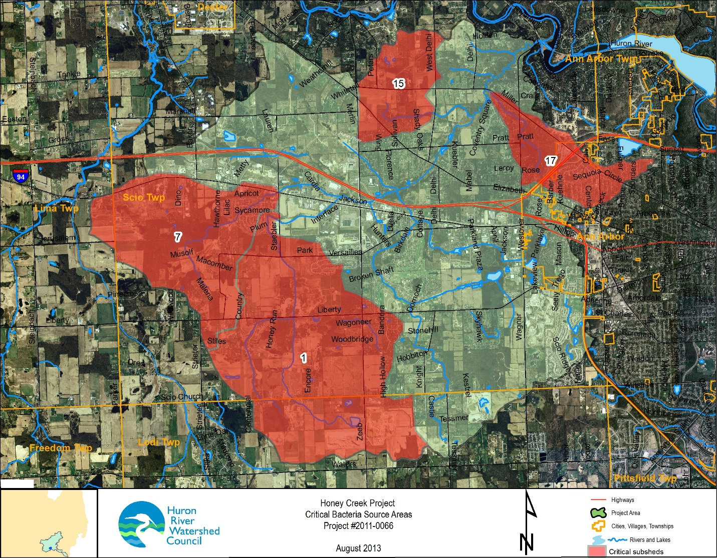
Figure 7. Critical bacteria source subwatershed areas in the Honey Creek watershed. Numbers indicate subwatershed designation.

Through the course of investigation, it was determined that multiple sources are contributing bacteria to Honey Creek. All five species markers that were selected for bacteria source tracking were positively identified in multiple samples at multiple locations. However, some markers are more critical to human health and others were more predominant at specific sample sites. The presence, especially the predominance, of the human marker in samples is of particular concern. The presence of human source markers in bacteria was identified in samples from all critical areas. The human marker predominated in subwatershed 15. Sampling in area 15 also suggested a non-runoff source. This combined information suggests that subwatershed 15 should be a high-priority target for investigation and remediation of human fecal contamination sources. Other critical areas should also be investigated for human sources, however, due to the presences and relative predominance of human sources throughout sampling in critical areas.

Other sources are more difficult to define geographically. Bovine, or cow manure source markers were identified in all but one sample, even in subwatersheds such as 17 that have little agricultural land use area. This source should be addressed throughout the watershed. Similarly, canine markers were identified in all critical areas. This source should be addressed in all residential areas within critical subwatersheds or across the entire watershed. Likewise, goose source markers were found in all source areas, though that source did not predominate in areas 1 or 7. Equine or horse fecal source markers were found in all critical areas, though less often in areas 7 and 15. Surprisingly, it was a predominant source in a sample from area 17 despite little evidence of horse ownership in that subwatershed. Identification and remediation of horse sources could be focused on just area 17 since that source did not predominate elsewhere.

4. Watershed Management Objectives

Specific Goals and Objectives

The overall goal for management of the Honey Creek watershed is to achieve all state water quality standards and allow Honey Creek to be fishable, drinkable (with standard treatment) and swimmable. The primary objective of this watershed management plan is to reduce bacteria contamination to achieve the WQS of 130 E. coli per 100 ml as a 30-day geometric mean and 300 E. coli per 100 ml as a daily maximum in Honey Creek and its tributaries. Data show that urban storm water runoff, with a significant bacterial component attributed to wildlife and pet sources, direct and indirect human septic sources, and agricultural runoff from manure application and light horse pasturing are the dominant source of E. coli in this area. Implementation activities to meet the TMDL require measures to reduce E. coli sources and loads. Secondary objectives are consistent with the Middle Huron Watershed Management Plan and include reducing nonpoint source loading of nutrients, increasing public awareness and involvement in watershed planning and management, gaining broad implementation of watershed plans, and continued monitoring and data collection for water quality, water quantity and biological indicators.

Measures to reduce E. coli will include some activities that, are already required of the National Pollutant Discharge Elimination System (NPDES) municipal storm water permittees within the watershed under Michigan’s municipal storm water permitting program. Currently, the City of Ann Arbor, the Michigan Department of Transportation hold NPDES Phase I municipal storm water permits. The Washtenaw County Water Resources Commissioner and Road Commission hold separate NPDES Phase II municipal storm water permits. In 2003, Lodi Township and Scio Township, were required to obtain NPDES Phase II permits. Both townships eventually had their permits removed. With Scio Township acting as the local government agency with jurisdiction over the vast majority of land in the watershed, some of the lessons learned about stormwater management practices will need to be transferred to and adopted by Scio Township.

Municipal storm water permits provide mechanisms for controlling bacterial loads to Honey Creek and its tributaries. Storm water permits require that a plan for effective elimination of illicit discharges and prohibition of illicit discharges be developed, that all catch basins be mapped and regularly cleaned, that effective storm water management in areas of redevelopment and new development occur, and that a public education program regarding storm water management and impacts of storm water pollution be implemented.

5. Current and New Programs for E. coli Reduction in the Watershed

The stakeholders in this TMDL are familiar with watershed-based cooperation, having partnered on point source and non-point source phosphorus reductions with the goal of meeting a nutrient TMDL for Ford and Belleville lakes. The Middle Huron River Watershed Initiative, the partnership working to meet the nutrient TMDL, has pursued pollutant reductions for over 15 years. Most of the stakeholders in the E. coli TMDL were signatories on two consecutive five-year agreements to voluntarily reduce phosphorus contributions to the middle Huron River. In the interim, the signatories revised these agreements to reflect current conditions within the watershed and renewed support to continue pollution reduction efforts.

Through the coordinated efforts of all stakeholders, coupled with the implementation of municipal storm water permit requirements and the current and ongoing efforts of the Middle Huron River Watershed Initiative, pathogen inputs to the tributaries and storm sewers can be reasonably controlled, with the possible exception of inputs from wildlife and feral domesticated animals. However, while this plan was developed with the goal and intention to reduce or eliminate bacteria sources in the watershed, it is unlikely that all sources will be able to be effectively eliminated. It is possible that, even if the TMDL plan is fully implemented, enough sources such as wildlife and feral domesticated animals, will remain to maintain water bacteria levels over state water quality standards. A literature review conducted by HRWC found few references to successful projects or programs to eliminate or control generalized urban sources. This presents a true challenge to the watershed, the partners within, and the Michigan DEQ.

Programs currently in effect in the watershed, or planned for the near future, include continued and new efforts to reduce illicit discharges, reduce domestic animal and wildlife sources, remove E. coli by treatment, and prevent or minimize pollution through land use planning, regulations and protection. A summary list of priority projects for the next 5 years is included in Table 2. A complete matrix of past, current, and future E. coli reduction efforts covering the full 10-year scope of the plan in the watershed is provided in Appendix J. Many of the past programs, initiated for municipal stormwater permit compliance, are still on-going and relevant today as viable opportunities to help achieve the objectives and requirements of the TMDL. Some of these programs need to be expanded to new areas of the Honey Creek watershed, and some new programs and projects need to be initiated.

Table 2. Summary of the initial 5-Year E. coli Reduction Strategy, 2013-17

Activity | E. coli Source Reduced | Implementation Timeframe | Cost Estimate 2013-2017 | Lead Agency*
Septic Inspection, Education and Remediation Program | Human | Ongoing in some areas, expand 2014-17 | $50,000 | WC Environmental Health, HRWC
Illicit discharge elimination program | Human | Ongoing in some areas, expand 2015-17 | $200,000 | WCWRC, WCRC, AA, Scio
Storm Water Drain Marking Project | Stormwater | Ongoing, expansion | $25,000 | WCWRC, AA, Scio
Public Education Program (PEP) | Multiple | Ongoing, expansion | $84,000 | SAG Members, Scio
Agriculture/Farmland Education | Agricultural | 2015-17 | $4,000-$6,000 | HRWC, Scio, NRCS
Increasing Farm Bill Program participation | Agricultural | 2014-17 | $5,000 | HRWC, NRCS
Education on Pet Waste | Pet waste | Ongoing, expansion | Part of PEP | SAG Members, Scio
Doggie Bags at target locations | Pet waste | Ongoing, expansion | $3,000 | WC Parks, Scio
Pooper Scooper Ordinance and education | Pet waste | 2014-15 | Not tracked | Scio
Goose Control Program | Wildlife | 2015-17 | TBD | HRWC, Scio, WC Parks
Community Partners for Clean Streams | Multiple | ongoing | $200,000 | WCWRC
Native Landscaping Ordinance Development | Wildlife, stormwater | Ongoing | $5,000 | Ann Arbor, Scio
Update Storm Water Management Standards (Pond Landscaping Section) | Wildlife | ongoing | $5,000 | WCWRC, Scio
Farmland Protection Program | Stormwater | ongoing | Unknown | City of Ann Arbor, Scio
Wetlands Protection Program | Stormwater | ongoing | $3,000 | Ann Arbor, Scio
Rules and Ordinances for Storm Water Management | Stormwater | Update in 2014 | Not tracked | WCWRC
Illegal Dumping and Pollution Incidence Response Enhanced Program | Human | Ongoing | Not tracked | WCWRC
Targeted Green Infrastructure Development and Retrofit Program | Runoff | 2015-17 | TBD | HRWC, Scio, WCRC, WCWRC
Totals |  | 2013-17 | $17,788,000
* Key:
HRWC: Huron River Watershed Council
WCWRC: Washtenaw County Water Resources Commissioner
WCRC: Washtenaw County Road Commission
NRCS: Natural Resources Conservation Service
SAG Members include all entities with stormwater permits who are participating in the Middle Huron Stormwater Advisory Group, as listed in the stakeholder section.

Interim Milestones

Along the course of long-term watershed plan implementation, it is important to establish shorter term milestones that will indicate that sufficient progress is being made to keep the plan on course toward achieving the ultimate goal of meeting water quality standards. The following annual milestones are established as interim goals.

2014
- Report on projects that were on-going prior to development of the WMP
- Meet with stakeholders to identify project details for 2015 implementation
- Develop detailed proposal for 2015-17 plan implementation
- Establish a goal for septic inspections
- Identify goose control areas
- Develop plan for ordinance development
- Finalize WCWRC development rules and standards

2015
- Implement existing program expansions to include:
  - review and marking of all unmarked drains,
  - 15 new doggie bag stations, and
  - IDEP inspection of all county drains in critical areas
- Achieve 33% of septic inspection goal
- Launch pre-education survey
- Develop and distribute educational materials and initiatives
- Launch all new projects, including the following milestones:
  - Achieve contact will all critical area farmers and large animal owners and identify needs
  - Implement multiple goose reduction methods at goose control areas
- Draft all new ordinances
- Establish Green Infrastructure development targets

2016
- Develop interim report on implementation progress
- Assess the need for mid-term change to programs and initiatives
- 30 total doggie bag stations in critical areas
- Conduct septic inspections to reach 67% of goal
- Establish new agricultural practices with 25-50% of farmers with practices needed
- Review and submit all new ordinances for board approvals
- Develop construction plans for 2-3 Green Infrastructure or stormwater retrofit projects

2017
- Construct 2-3 Green Infrastructure or stormwater retrofit projects
- Establish new agricultural practices with 50% of farmers with practices needed
- Conduct post-education survey
- Develop final report on 5-year WMP implementation including monitoring summary
- Assess the need for WMP revision and development of new 5-year priorities

Activities to Reduce Illicit Discharges

Septic System Inspection, Education and Remediation Programs

Septic System Inspection Programs are meant to identify and correct failing septic systems that discharge human waste into groundwater or on the surface, and directly or indirectly into surface water. These programs help identify illicit connections and prevent or eliminate illicit discharge.

Washtenaw County’s “Time of Sale” Ordinance requires that prior to any residential property transfer: 1) the septic system must be inspected by certified inspectors, 2) a report must be submitted to the Environmental Health Regulation Department and 3) the seller must receive an authorization letter from the Department. Over 4,300 systems have been evaluated annually, countywide, with over 540 septic system corrections documented to date. Most of the municipalities in Washtenaw County are now participating in this program.

The current program should serve as the basis for an expanded effort to educate residents on septic systems in critical subwatersheds (especially area 15), encourage inspections and remediate those that are failing. This new program should provide inspections free of charge to residents in target areas and provide a list of qualified contractors to remediate failing systems. An additional element to the program should be added to help finance failing systems for residents who lack the means to pay for expensive fixes. The availability of assistance may help to address reluctance on the part of home owners to participate in the inspection program.

Illicit Discharge Elimination Program (IDEP)

The purpose of the IDEP is to remove non-storm discharges to storm sewers to improve water quality. This program locates and eliminates any illicit connections in sanitary and storm pipes, thus preventing untreated sewage flow to Honey Creek and the Huron River. The program is also meant to help meet the Honey Creek TMDL, and fulfill storm water permit obligations.

Project data include sampling records, video and a dye-test database. The following entities are involved in the IDEP: Washtenaw County, the City of Ann Arbor, and Michigan Department of Environmental Quality (MDEQ).

The City of Ann Arbor inspects the storm sewer annually by closed circuit T.V., inspecting about 35,000 linear feet and removing debris from about 125,000 linear feet of line. The City sub-contracts to Washtenaw County, approximately four days per month, to do illicit connection screening. This program was in effect until December 2003. The estimated cost of the program is $225,000 per year for the City of Ann Arbor and Washtenaw County combined.

Currently, Washtenaw County (via the Water Resources Commissioner) only implements the program on county drains in the urbanized area to meet stormwater regulations. This leaves several county drains outside the urbanized area and many stream reaches that are not county drains that are not being inspected. The program should be expanded by the county to inspect and eliminate illicit connections in county drain segments outside the urbanized area. In partnership with Scio Township, the program could also be expanded to inspect and eliminate illicit connections in reaches within critical subwatersheds (especially area 15) that are not currently designated as county drains. Multiple inspections during differing conditions may be needed in these critical reaches to detect contaminated flow and trace it back to the source.

Storm Drain/Catch Basin Marking

The purpose of storm water drain marking is to eliminate waste entering Honey Creek through storm drains, by means of creating public awareness of the danger of dumping into these drains. Storm drains are marked with a warning stating that any waste entering the drain goes straight to the stream. Along with the marking, the project places educational fliers on the doors of residences in the vicinity of newly marked drains.

Markers are continuously placed on drains and replaced every few years, when old markers begin to fade or fall off. New storm drains have a warning engraved or cast into the iron frame stating "Dump No Waste - Drains to Waterways." This program began early in the last decade, with approximately 3,000 drain markers having been placed in the City of Ann Arbor. This is an ongoing project with no end date. Through the Water Resources Commission CPCS program, the WRC gave out 2,500 markers in one year.

Participants in drain marking activities include the Huron River Watershed Council, City of Ann Arbor, and Washtenaw County Water Resources Commission. Washtenaw County spends approximately $5,000 per year for their markers. Additionally, the City of Ann Arbor spends approximately $1.50 for each new lexan marker, while $3.05 is spent on each "crystal" coated marker. Volunteers provide the labor to apply markers and hang educational fliers on doors. Additional funding is needed to place markers in target areas of Scio Township.

Educational Activities

Information and Education Mass Media Campaign/Public Education Program (PEP)

The purpose of this program is to provide awareness and education about septic system maintenance and its effect on water quality. Information is distributed through "Keep your septic system safe" tip cards, “Smart Home Maintenance” flyers, articles in the HRWC newsletter, public service announcements on the radio, and calendars.

The program raises awareness of septic system maintenance requirements and storm drain pollution prevention, which should reduce E. coli entering Honey Creek through illicit discharges. However, the impact is difficult to measure beyond the number of homeowners who have received the materials throughout the watershed.

Those involved are: HRWC, local governments, businesses, local media, homeowner's associations, school districts, the USDA Home*A*Syst staff, and three watershed organizations. HRWC will continue to run its program to meet the obligations of the City of Ann Arbor’s Phase I permit. Limited quantities of the materials are available upon request, with mass reprints produced when several communities join in placing an order from HRWC. Additionally, HRWC produced new septic system education materials in 2013 as part of a separate initiative. These materials should be reproduced and distributed to residents as part of the septics education initiative described in the previous section.

Information and Public Education Through the Internet

The purpose of this program is to provide awareness and education about local water quality issues. Information is available at the web pages of local units of government, including the City of Ann Arbor at http://www.a2gov.org, Washtenaw County at http://www.ewashtenaw.org, and the Huron River Watershed Council at http://www.hrwc.org. Information and public education through the internet is an ongoing program with minimal cost.

Activities to Reduce Animal Sources – Domestic

Farmer Education

This program is meant to educate farmers on the potential impacts of current livestock and fertilizer management practices on surface water quality. Providing awareness and technical information to farmers, using various educational materials, should reduce the amount of E. coli in surface water from animal waste. Those involved are: HRWC, the Natural Resources Conservation Service (NRCS), the Washtenaw Water Resources Commission, Scio Township, and the USDA Farm*A*Syst staff. Primarily, HRWC will work with NRCS staff and other partners to tailor educational materials and workshops for a positive reception by farmers engaging in manure application in the watershed and those residents pasturing or training horses in critical areas. The time frame for the project is 2015-17. Estimated costs are $10,000.

Increasing Farm Bill Program Participation

HRWC will work with NRCS and Conservation District staff to communicate directly with all farms and large animal owners in the critical areas and improve bacterial reduction practices with financial support through a range of Farm Bill Programs. Several properties with horses do not currently exclude stream access. These will be targeted for funding for exclusion fencing support. Manure spreading and biosolid spreading practices have not been identified beyond general agreement that they occur on an unpredictable basis. Funds in this program will be used to assist farmers to develop fertilizer plans that minimize manure and biosolid application and time applications to avoid storm runoff.

Education about Pet Waste

This program provides awareness and education to the public concerning the impact of pet waste on surface water quality. The purpose of this education is to decrease the amount of E. coli entering Honey Creek due to pet waste. HRWC coordinates the production, printing, and distribution of educational flyers regarding the impact of pet waste on water quality. They also distribute storm water calendars that include this information. The impact of the plan will be measured by surveying the population after one year to see if recommendations are being followed. Currently, those involved include HRWC, and the City of Ann Arbor. The program runs from Spring 2003 forward. The cost of the fliers is $0.03 per piece, while the cost of the calendars is about $0.80 each. This effort should be expanded to include a partnership with Scio Township and distribute directly to homeowners in critical subwatersheds. Educational information could be combined with passage of a pooper scooper ordinance in Scio Township to be more effective.

Doggie Bags in Target Locations

This program provides bags for pet waste clean up. This should reduce pet waste in parks, and other high traffic areas, subsequently reducing the amount of E. coli entering Honey Creek from pet waste. This project is ongoing in the City of Ann Arbor, and should be expanded to include county parks and residential dog walk areas in Scio Township. This expansion should be completed in partnership with targeted home owner associations in critical areas of the watershed.

Pooper Scooper Ordinance

The purpose of this program is to educate the general public on the impact of pet waste on surface water quality, and to reduce pet waste entering the storm sewer. The plan should decrease illicit discharge into Honey Creek by reducing a source of pollution. Local units of government, including Washtenaw County and the City of Ann Arbor, are involved with this project. The City of Ann Arbor has enacted such an ordinance and efforts are made to publicize it through their website. A partnership with Scio Township should be developed to assist in the development of an ordinance, combined with proper residential education.

Efforts to Reduce Animal Sources – Wildlife

Goose Control Programs

Efforts have been made to decrease Giant Canada goose populations, eliminate year-round goose habitation, and in turn, reduce the amount of goose droppings containing E. coli that have potential to contaminate waterways in other parts of the Huron River watershed, but not in Honey Creek. Best management practices such as pond buffer plantings, replacing turf with shrubs and trees, and interfering with feeding and nesting will potentially reduce areas of contamination. Research on goose control BMPs (including programs within the Huron River watershed) shows availability of numerous successful and cost-effective methods. Those with expertise in goose control BMPs should be made available through a workshop for those managing detention ponds and other open water sources in critical areas of the Honey Creek watershed. It should be noted that DNR wildlife specialists report that there are no data showing harm to human health from the type of E. coli present in goose waste.

Community Partners for Clean Streams

This program provides education through public and private partnership, promoting the protection of watersheds and waterways through presentations, print material, and signed agreements to use BMPs and abide by good housekeeping measures. The intent is to address water fowl habitat and discourage geese through landscaping, storm water pond maintenance, and riparian elements. Those involved include Washtenaw County, businesses, institutions, and multi-family residences, totaling 120 partners countywide. This project is ongoing with no end date. Estimated costs are $160,000 per year.

Native Landscaping Ordinance Development

This program diminishes green grass cover, on which geese enjoy foraging with an unobstructed view, and encourages the growth of tall prairie species. The purpose of this plan is to displace foraging geese by creating an environment unfavorable to geese, subsequently reducing the E. coli count in Honey Creek from goose droppings. This program, involving the City of Ann Arbor, is ongoing. Estimated Costs are $5,000. Scio Township should develop a similar ordinance.

Update Storm Water Management Standards (Pond Landscaping Section)

This plan is meant to reduce nuisance geese habitat at storm water ponds by the installation of shoreline buffer planting or other means. The plan is utilized each time the storm water system is reviewed or equivalent, with no end date. Those involved include local units of government. Scio Township standards should be reviewed for possible revisions. In the future, parks departments may become involved to employ the same strategy near public water features. Estimated costs are unknown.

Efforts to Reduce E. coli by Land Use Planning & Protection

Farmland Protection Program

This program prevents surface and storm water pollution through permanently retaining large areas of permeable ground and the natural areas associated with farmland, such as windrows, swales, meadows, small wetlands, and woodlots. Preservation of farmland helps protect the headwaters of Honey Creek tributaries. Implementation of this plan is expected to eliminate future illicit discharges by precluding further urbanization and by promoting BMPs among farmers raising crops and animals. Under Purchase of Development Rights (PDR) programs, landowner applications are awarded points competitively, based on such factors as a history of good conservation and storm water management practices.

This program will be carried out by Ann Arbor City and Scio Township through ongoing implementation of PDR Ordinances, the Ann Arbor Parks Department Green Belt Program, with funding of PDR through local tax millage, the USDA Farm Bill, the Michigan Farmland Preservation Board, and land conservancies. Others involved are: the Washtenaw Farmland Conservation Group, Washtenaw County, Farm Bureau, farmers, farmland owners, the USDA Natural Resources Conservation Service, and the Ecology Center. This project began in 1998 with the passage of the County’s PDR Ordinance. Scio Township also adopted a PDR ordinance. Estimated costs are unknown.

Wetlands Protection Program

This program, consisting of local regulations and incentives, is meant to protect wetlands on one-fifth of an acre or larger, since damaged and destroyed small wetlands cannot provide the services of filtering and cleaning pollutants in storm water. The program will protect numerous wetlands in the Honey Creek watershed. A model local wetland ordinance is available from HRWC.

Those involved are: the City of Ann Arbor, and Scio Township. This program began in the spring of 2003 and continues. Cost of ordinance development was approximately $15,000 in staff and legal time.

Efforts to Reduce E. coli by Treatment

Rules and Ordinances for Storm Water Management

This program helps reduce the E. coli count of surface water by preventing flooding, controlling flow, treating storm water, and discouraging geese by using native landscape buffers near waterways and ponds. Additionally, this program is meant to revise existing storm water management ordinances to meet required design standards of the Washtenaw County Drain Commissioner. This program was implemented by detaining the first flush for a 24-hour period, thus reducing bacteria count. Revised rules are currently in final draft form and will require infiltration of first flush. The Rules of the Water Resources Commissioner are revised roughly every 2 years. The next revision of the Rules will be completed by 2014. All Phase II permitted entities have adopted stormwater ordinances which refer to the Water Resources Commission stormwater standards. Scio Township may need to develop an ordinance to require WRC development standards for all new developments.

Targeted Green Infrastructure Development and Retrofit Program

Research on bacteria reduction indicates that few structural BMPs work to significantly reduce bacteria levels in stormwater runoff. However, properly designed detention or retention basins have been shown to reduce bacteria in outflow. A program to incorporate key Green Infrastructure designs in new and redevelopment projects in the Honey Creek watershed should be developed. This program would promote the use of designs that slow and settle runoff waters from impervious surfaces like roads, drives and sidewalks and infiltrate as much of the runoff as possible. This allows a greater portion of runoff to be filtered through groundwater, where bacteria will not reproduce, thus reducing stormwater runoff sources of bacteria. Existing detention ponds and stormwater systems in critical areas of the watershed should be evaluated for retrofit opportunities to capture, settle and treat stormwater runoff. One high priority target is the combined set of detention ponds and stormwater system of Scio Farms.

6. Accountability Structure for Implementation

Overcoming Barriers and Closing Gaps

As framed by the terms of the TMDL, the ultimate measure of implementation success will be documented changes in water quality, showing improvement over time. However, potential barriers to this accomplishment exist and must be considered in implementation planning.

Positive feedback from even the most diligent efforts may be several years in the future due to the lead time needed to implement best management practices throughout the watershed. Participants must set realistic expectations about the amount of time needed to continue identified programs while awaiting positive results. Otherwise, impatience, discouragement, or competition for limited local funding could lead to discontinuation of effective programs. Prompt communication of small successes through news releases, web sites, and community newsletters will be important to encourage the continued efforts of TMDL partner communities.

The tracking of quantitative results over time carries a set of technical and logistical challenges. Variation in weather patterns over the years of a study adds to the complexity of trend analysis of the data. Collecting correctly timed wet weather samples is particularly daunting, as personnel may not be available during a particular major summer storm occurring outside of business hours. Over the past several years, there have been significant advances in source identification for E. coli pollution via DNA testing. The ‘bacteria source tracking’ (BST) methods were successfully used in the study used in this plan, but results were not entirely conclusive.

There are also gaps in our knowledge of bacterial survival and reproduction under conditions found in yards, parks, ditches, and ponds. For example, requiring a certain number of hours of onsite retention for storm water runoff is thought to guarantee that live E. coli bacteria will not escape and reproduce elsewhere. This has been established elsewhere. A systematic study of real world conditions to detail the effectiveness of retention, infiltration, and other strategies for control of bacteria, would further confidence in, and understanding of, these control measures. The knowledge gap has begun to close with a recent laboratory study conducted simulating urban stormwater runoff conveyed through conventional bioretention media to investigate the bacteria removal efficiency of this media. It was concluded that bacterial removal could be effective and sustainable, and that indigenous protozoa can facilitate this process. Exploring opportunities with the scientific community, such as this, may prove to be beneficial in finding a workable solution to E.coli contamination where the urban sources of the bacteria are difficult to control.

The next few years will provide a challenge to demonstrate that reductions in E. coli pollution of Honey Creek, the Huron River, and other rivers can be achieved given the difficulty to control general urban sources as demonstrated previously and in other parts of the country. With the current economic downturn restricting government and institutional resources, another challenge will be to identify the most cost-effective measures and to continue funding them. Managers and programs will both need to become adaptive, while continuing to appeal to the public’s expectation that the waters of our state will attain the standards set forth by Congress through the passage of the Clean Water Act in 1972.

Participants, Reporting, Monitoring, Contingency Plans

The stakeholders for this implementation plan are committed to continued water quality improvement in the Honey Creek watershed. Those who have taken on this responsibility are:

- City of Ann Arbor
- Huron River Watershed Council
- Michigan Department of Environmental Quality
- Washtenaw County Water Resources Commissioner
- Washtenaw County Environmental Health Department
- Washtenaw County Road Commission
- Scio Township

The following units of government will also be subject to the TMDL:

- Michigan Department of Transportation

Lodi and Lima townships have smaller land areas within the contributing basin and are not expected to be involved in plan implementation unless new information indicates potential sources within these areas.

The stakeholders listed above are committed to continued water quality improvement in the Honey Creek contributing area. Toward this end, local governments, the Huron River Watershed Council have conducted a variety of actions, prior to TMDL development, to improve water quality and promote stewardship. Pre-TMDL activities included bio-monitoring, habitat assessment, septic inspection at time of sale, illicit discharge elimination, mass media educational campaigns, development standards, water resources protection ordinances, wetlands protection and wetlands restoration. Many of these actions have involved stakeholder collaboration; others are unique to individual stakeholders and their constituencies. The variety and number of these programs can be seen in detail in Appendix J.

Although a great many ongoing actions to restore water quality and habitat in Honey Creek are voluntary, each stakeholder has assumed responsibility to continue their efforts, as resources allow and needs dictate. Through initiating and continuing these voluntary actions, each stakeholder has assumed responsibility for a share of water quality restoration in the Huron River Basin. These discretionary programs are dependent on funding, perceived needs, sound and reliable technical assistance, clear regulatory authority, constituent support, and demonstrated effectiveness. Some actions have been required under the permit regulations of the Clean Water Act.

Phase I communities have been under permit since December, 1995. Their permits specify best management practices to achieve water quality improvement, including E. coli reduction. Permit renewal applications will continue to include provisions consistent with the Honey Creek TMDL, such as illicit discharge elimination, and public information and education.

Phase II communities and entities must submit detailed compliance language that must also include provisions consistent with the Honey Creek E. coli TMDL. Phase II communities with Certificates of Coverage are required to submit an approvable plan to comply with all six minimum measures, including provisions consistent with any TMDL affecting the jurisdiction or watershed. The Michigan Department of Transportation, the Washtenaw County Water Resources Commissioner’s Office, and public school systems received separate Certificates of Coverage and must meet the same requirements as local governments.

Under their storm water permits, these communities and organizations are obligated to develop, implement, and enforce a storm water management program designed to reduce the discharge of pollutants from the drainage system to the “maximum extent practicable,” to protect the designated uses of the waters of the state, to protect water quality, and to satisfy the appropriate water quality requirements of state and federal law. Storm water controls designed to attain the goals of the TMDL must be incorporated into the storm water management plan, and each permittee must implement appropriate best management practices to comply with the TMDL implementation plan. Both separately and jointly, through a coordinated public education and involvement strategy, stakeholders will also engage in communication with the public that addresses E. coli TMDL problems, solutions, and successes.

Additionally, the permittees are required to submit biannual progress reports to the Michigan DEQ which shall contain the following: a description of the status of compliance with general permit conditions, an updated assessment of the water quality conditions within their jurisdiction, a description of identified water quality stresses, and a summary of all information collected and analyzed—including monitoring data. The report must include a summary of upcoming storm water activities and a description of planned changes in BMPs or measurement of goals.

Since each storm water permit requires biannual reporting, and TMDL goals and activities must be incorporated into the measures prescribed by the permit, separate TMDL reporting is unnecessary for those partners covered by permits. Scio Township is an active member of the Middle Huron Partners and reports annually to that group. While the focus of that effort is on phosphorus reduction efforts, the township could also report on progress to reduce pathogens. In 2007, and at subsequent five-year intervals, the MDEQ is scheduled to complete basin-wide monitoring of the Huron River watershed. Future projects under this implementation plan may incorporate additional monitoring if resources allow. Stakeholders’ storm water permit reporting will include an updated assessment of the water quality conditions within their jurisdiction in either narrative or numeric form. The purpose of this update is to show any obvious changes in E. coli levels since the previous progress report. Change may be demonstrated by use of data collected by other sources or a group monitoring program. The partners to this process continue to meet 3-4 times per year as part of a stakeholder group to evaluate progress.

Through adaptive management—a process that assesses conditions and trends throughout plan implementation, and provides feedback to stakeholders so that adjustments can be made—this implementation plan is intended to ultimately achieve TMDL compliance. Through the annual meetings of the Middle Huron Partners and Stormwater Advisory Group, the TMDL Implementation Plan working group will meet to review efforts and plans. The MDEQ will track permit compliance through storm water permit oversight, including monitoring activities that address the TMDL implementation goals. Unless the EPA determines that it is necessary to separate TMDL enforcement from the storm water permit process, enforcement authority will reside in the MDEQ’s authority under the provisions of the storm water rules.

Evaluation and Monitoring

The ultimate success of this watershed management plan will be determined by the degree to which it results in a decrease in bacterial contamination in Honey Creek. Although achieving water quality standards is the goal of plan implementation, other means will need to be employed to ascertain what effects individual and collective best practices have on water quality and associated indicators. In-stream monitoring, such as physical, chemical, and biological monitoring, is ideal because it allows direct measurement of environmental improvements resulting from management efforts. Targeted monitoring to evaluate practice-specific effectiveness is another option, whereas ambient monitoring can be used to determine overall program effectiveness. Alternatives to monitoring include using programmatic, social, physical, and hydrological indicators. Finally, environmental indicators can be used to quantify the effectiveness of best practices.

Quantitative Evaluation
Progress toward the goal of achieving water quality standards will be measured using an existing long-term monitoring program being supported by the Middle Huron Partners and SAG. The complete program is outlined in the Middle Huron Watershed Management Plan. Table 3 below is an excerpt that includes the ongoing monitoring included for one site at Honey Creek that corresponds to site HC04 discussed elsewhere in this plan.

Table 3. Middle Huron River Watershed Monitoring and Evaluation
Monitoring Site¹ | Parameter Target | Type of Analysis | Protocol | Frequency | Test Agent
Honey Creek |  | Stream Habitat Assessment | HRWC Protocol | 3- 5 yr interval | HRWC, MDEQ
Adopt (18,19,20,22) |  | Total Suspended Solids | SM20 2540 D | 1-2x/Mo + Rain event | HRWC to AA WTP
Middle Huron (MH03) | S, N, DO, T, | Total Phosphorus, Nitrates, Nitrites | SM20 4500 | 1-2x/Mo + Rain event | HRWC to AA WTP; MDEQ
 | I, B, Bio | Temp, DO, pH, Conductivity | Horiba U10 Meter | 1-2x/Mo Apr-Sept | HRWC
 |  | E. coli | SM20 9213 D | 1-2x/Mo + Rain event | HRWC to AA WTP
 |  | Benthic Macroinvertebrates | HRWC Protocol | 2-3x/year | HRWC, MDEQ
1) Adopt = HRWC Adopt-a-Stream; Middle Huron = Middle Huron Partners tributary nutrient monitoring; MDEQ = DEQ lake monitoring
2) S= Sediment; N= Nutrients; DO= Dissolved Oxygen; T= Temperature; I= Ions; B= Bacteria; Bio= Biota
3) Specific sites will be included as part of MDEQ Water Bureau's rotational water quality monitoring program; Lakes program monitors water quality monthly
4) HRWC staff and volunteers to collect samples and deliver to Ann Arbor Water Treatment Plant for analysis under their direction.
5) Analytical protocols follow “Standard Methods for the Examination of Water and Wastewater”, 20th edition, by the American Waterworks Association

In addition, stream flow is measured at that site each time samples are collected, and at least once in 5 years, flow is measured continuously from April until the threat of freeze-over (late November. Over the past 3 years, the HRWC has conducted wet weather/storm event sampling, deploying autosamplers programmed to take water samples tailored to the predicted length of the storm event. Capturing storm events is often challenging, however the HRWC has had considerable success in collecting this data to gain a better understanding of the impact of stormwater runoff on pollutant concentrations in the tributaries contributing to the stretch of the Huron River where the TMDL is designated. Finally, the monitoring program collects 5-7 samples from “investigative sites” that are selected based on need for information. Within 5 years, at least one of the Honey Creek tributary sites will be selected for investigation to determine if projects and programs have been successful at reducing bacteria concentrations.

Evaluation Method | Program/ Project | What is Measured | Pros and Cons | Implementation
Public Surveys* | Public education or involvement program/project | Awareness; Knowledge; Behaviors; Attitudes;  Concerns | Pro: Moderate cost.  Con: Low response rate. | Pre- and post- surveys recommended. By mail, telephone or group setting. Repetition on regular basis can show trends. Appropriate for local or watershed basis.
Written Evaluations | Public meeting or group education or involvement project | Awareness;  Knowledge | Pro: Good response rate.  Low cost. | Post-event participants complete brief evaluations that ask what was learned, what was missing, what could be done better. Evaluations completed on-site.
Stream Surveys* | Identify riparian and aquatic improvements. | Habitat; Flow; Erosion; Recreation potential; Impacts | Pro: Current and first-hand information.  Con: Time-consuming. Some cost involved. | Identify parameters to evaluate. Use form, such as the USA, to record observations. Summarize findings to identify sites needing observation.
Visual Documentation | Structural and vegetative BMP installations, retrofits | Aesthetics. Pre- and post- conditions. | Pro: Easy to implement. Low cost.  Con: Good, but limited, form of communication. | Provides visual evidence. Photographs can be used in public communication materials.
Phone call/ Complaint Records | Education efforts, advertising of contact number for complaints/ concerns | Number and types of concerns of public. Location of problem areas. | Con: Subjective information from limited number of people. | Answer phone, letter, emails and track nature of calls and concerns.
Participation Tracking | Public involvement and education projects | Number of people participating. Geographic distribution of participants. Amount of waste collected, e.g. hazardous waste collection | Pro: Low cost. Easy to track and understand. | Track participation by counting people, materials collected and having sign-in/evaluation sheets.
Focus Groups | Information and education programs | Awareness;  Knowledge; Perceptions; Behaviors | Pro: Instant identification of motivators and barriers to behavior change.  Con: Medium to high cost to do well. | Select random sample of population as participants. 6-8 people per group. Plan questions, facilitate. Record and transcribe discussion.
Qualitative measurements are important in determining changes in behavior and visible changes in the watershed. Surveys, participation records, and meeting/workshop evaluations can all be used to gauge whether activities aimed at public education and outreach are effective. Better survey results, an increase in participation, and favorable meeting/workshop evaluations can all be an indication of a greater understanding by the public on watershed-related issues. Results that do not yield improvements will signal that current activities and/or education methods should be modified and improved.

Visible changes in the watershed can also be used as an indication of progress in the watershed. Stream surveys can identify riparian and aquatic improvements and help identify recreational opportunities. BMP implementation can also be documented visibly, with the number and location of BMPs recorded.

Table 4 summarizes the qualitative methods that will be used to measure progress.

Determining the Need for Revisions

It is the intent of TMDL stakeholders in the watershed that this plan should be revised, on average, every five years. Several of the collaborative groups previously mentioned in this plan will continue to meet on a regular basis to ensure that the plan is being implemented on a watershed-wide basis. Many partners have a vested interest in assuring that the plan is implemented. In addition, updates regarding watershed plan implementation and activities related to it will be updated on the HRWC’s website.
Applying the concept of adaptive management to the revision process is essential for successful implementation of the plan. Evaluation of a specific management alternative (using the methods discussed in the next section) may suggest a change is needed to affect the desired result, or a shift in focus from one management alternative to another may be needed. The iterative nature of watershed planning, implementation, and revision is shown below in Figure 8.

Table 4. Summary of Qualitative Evaluation Techniques

* These surveys can be designed as quantitative evaluation tools, as well, and are used as such in the Honey Creek watershed. Adapted from: Rouge River Watershed, Lower One Subwatershed Advisory Group, 2001

Figure 8. Typical Steps in a Watershed Management Cycle
1. Conduct intial outreach and organize basin and watershed teams and committees

2. Collect relevant basin information

3. Analyze and evaluate information

4. Prioritize concerns and issues

5. Perform detailed assessments of priority issues

Public Participation
Repeat Cycle
6. Develop management strategies

7. Prepare/update draft watershed plan

8. Finalize/distribute watershed plan

9. Implement watershed plan

Text adapted from MDEQ, Surface Water Quality, NPDES Permits website. February 2003.
Text adapted from MDEQ, Surface Water Quality, NPDES Permits website. February 2003
Here and throughout the discussion of results, stream sections are referenced to sampling points identified by number code. The numbers correlate to station numbers in Figure 1. When referring to stream sections and watershed areas, the designation refers to the area upstream of the station, unless otherwise indicated.
See the Middle Huron Watershed Management Plan for more detailed information.
See the Honey Creek TMDL issued by the MDEQ for more in-depth information.
Adapted from: MSU Institute of Water Research, et al. 2000. Developing a Watershed Management Plan for Water Quality. Lansing, MI: Michigan State University.

