Stream
Name

SITE #:

STAFF
GAUGE: (in decimals)
Stream Nutrient Monitoring Program

FIELD DATA SHEET: Alliance of Downriver Watersheds

Investigators

TOTAL PHOSPHORUS, TOTAL SUSPENDED SOLIDS, NITRATE-NITRITE and ECOLI
Collection |  | Lab Submission  { STAFF GAUGE READING }  In boxes and picture below, write numbers and draw water level you see on the staff gauge.
Date: | Time: | Date: | Time:
QUESTIONS:
What TYPE of GRAB sample measurement was used? Circle one: INSTREAM / BUCKET
Was the bottle rinsed with stream water 3x, and water tossed downstream? Y / N
What is the DESCRIPTION for this sample? Circle one: INVESTIGATIVE / BASELINE
Were the TP samples refrigerated overnight? Y / N
If so, location?

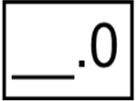
First whole number above the water (1.0, 2.0, etc)

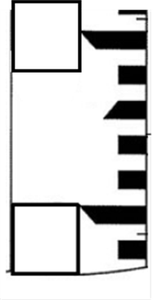
First digit
above the water.

Weather - past 24 hours Current Weather

_____ Storm (heavy rain) ______

_____ Rain (steady rain) ______

_____ Showers (intermittent rain) ______

_____ Overcast ______

_____ Clear/Sunny ______
SITE PARAMETERS (Horiba measurements)
Water temperature (°C)
Conductivity (mS)
pH
Dissolved oxygen

For Office Use only

db Visit ID ___________

Initials ___________
Comments:

