Total Maximum Daily Load (TMDL) Implementation Plan for the
Huron River Watershed MS4s in
Washtenaw County

The Michigan Department of Environmental Quality (MDEQ), under the National Pollutant Discharge Elimination System (NPDES) Storm Water Discharge Permit application, requires a plan or other documentation outlining how each Municipal Separate Stormwater Sewer System (MS4) will "make progress toward achieving the pollutant load reduction requirement" in each TMDL listed in each applicant's application notice. The purpose of this document is to provide the collective watershed plan for addressing relevant TMDLs in the Huron River Watershed in Washtenaw County by MS4s for the purpose of stormwater permit compliance. This document addresses the permit application sections VII.86 through VII.88.

I. TMDL and MS4 Coverage

This TMDL plan is submitted on behalf of the following Phase I and II MS4s within the Huron River Watershed, for each of the below-listed TMDLs:

A. Excessive nutrients (phosphorus) and algae in Ford Lake and Belleville Lake

City of Ann Arbor
Ann Arbor Public Schools
Barton Hills Village
Village of Dexter
Eastern Michigan University
Pittsfield Charter Township
City of Ypsilanti
Ypsilanti Charter Township
Washtenaw County Water Resources Commissioner
Washtenaw County Road Commission
University of Michigan

B. Excessive bacteria (E. coli) in the Huron River and tributaries downstream of Argo Dam to Geddes Dam

City of Ann Arbor
Ann Arbor Public Schools
Pittsfield Charter Township
Washtenaw County Water Resources Commissioner
Washtenaw County Road Commission
University of Michigan

C. Excessive bacteria (E. coli) in Honey Creek

City of Ann Arbor
Ann Arbor Public Schools
Washtenaw County Water Resources Commissioner
Washtenaw County Road Commission

D. Aquatic biota impairment in Malletts Creek

City of Ann Arbor
Ann Arbor Public Schools
Pittsfield Charter Township
Washtenaw County Water Resources Commissioner
Washtenaw County Road Commission
University of Michigan

E. Aquatic biota impairment in Swift Run

City of Ann Arbor
Ann Arbor Public Schools
Pittsfield Charter Township
Ypsilanti Charter Township
Washtenaw County Water Resources Commissioner
Washtenaw County Road Commission
University of Michigan

II. Prioritizing and Implementation BMPs

The MS4s in the Middle Huron River Watershed have put forth substantial effort and resources to reduce the sources of impairments related to the TMDLs listed in the previous section. These partner organizations, along with non-MS4 entities have developed a number of general and specific plans to address watershed impairments. These plans direct the current and future project and program priorities. The suite of projects and programs already put in place contributed to significant impairment reduction, as evidenced by data collected through on-going monitoring (see section III for details).

To comply with NPDES stormwater permit requirements, the above-listed MS4s submit that the suite of Best Management Practices (BMPs) contained in each Storm Water Management Plan (SWMP) represents each MS4s project priorities that will be implemented during the permit cycle and will collectively make progress toward achieving each of the TMDL pollutant load reduction targets. Each MS4s SWMP includes a schedule for BMP implementation and a prioritization process where appropriate. Where relevant, BMPs in the SWMPs identify TMDL pollutants that are targeted (i.e. phosphorus, sediments, or bacteria). The watershed MS4s submit that no additional prioritization or BMPs are needed beyond what is planned for addressing other sections of the stormwater permit application.

III. Monitoring Progress

The MS4s in the Middle Huron River Watershed have already made significant progress toward achieving TMDL pollutant reduction targets. The below sections highlight the progress that has been made to date for each TMDL listed in section I. Additional, detailed monitoring results can be obtained from the 2011 and 2012 monitoring reports on the HRWC website at http://www.hrwc.org/middle-huron-sag/.

A. Excessive nutrients (phosphorus) and algae in Ford Lake and Belleville Lake
The following is excerpted from the Phosphorus Reduction Implementation Plan for the Middle Huron River Watershed.

Water Sampling Data Summary

In September 1991, a hazardous material response team was summoned to investigate a reported "green paint spill" in Ford Lake. The "paint" was really a severe algae bloom. This incident brought MDEQ field scientists to the lakes to conduct intensive monitoring of the Huron River and its tributaries from 1992-1994; this monitoring formed the basis for the development of the phosphorus TMDL. The primary water quality parameter measured by MDEQ was Total Phosphorus (TP).

MDEQ has continued to conduct water quality monitoring in the Huron River and in Ford and Belleville Lakes since the development of the TMDL through 2006, and then again in 2009. Each monitoring season, from April to October, state field scientists visited the watershed one time per month to measure nutrients and ambient water quality parameters at two river sites — the Huron River at Bandemer Park, and the Huron River at Michigan Avenue, just upstream of where the Huron enters Ford Lake. In addition, they measured water clarity, chlorophyll a, various nutrients, and other water quality parameters at various depths at four locations within each of the two lakes. Every five years, MDEQ conducts more intensive and extensive monitoring in the middle Huron through its basin monitoring program. The Huron River Watershed has been monitored through this program in 1997, 2002, and 2007; 2012 is the next year in which MDEQ will monitor the Huron.

In addition to monitoring conducted by the State, in 2002 HRWC developed a companion monitoring program for nine of the tributaries flowing into the middle Huron. HRWC staff and trained volunteers measure stream discharge, collect grab samples for lab analysis of TP, Nitrate + Nitrite, and Total Suspended Solids, and monitor other water quality parameters. Each site was originally visited one time per month. In 2006, analysis for E. coli was added. In 2008, storm sampling was added and monitoring frequency was increased to twice per month. Finally, in 2010, monitoring at stormwater investigative sites was added. A river site upstream of the confluence of Mill Creek is monitored for upstream conditions, and 9 tributary sites from Dexter to Ypsilanti are included in the program.

The data collected by the State is used to measure the progress towards meeting the phosphorus TMDL. Now, HRWC’s tributary monitoring program is the only program collecting data on nutrients in the tributaries flowing into the middle Huron, while the University of Michigan, in partnership with the City of Ann Arbor, monitors river sites. One shortcoming of the program is that it does not monitor Total Nitrogen, which would enable estimating the ratio of TP:TN, an indicator of conditions favorable to the formation of nuisance algal blooms. Dr. John Lehman at the University of Michigan conducted a study of this ratio from 2003-06 and concluded that TP is the limiting nutrient for blooms under most conditions.

A few general comments can be made about the data. TP concentrations entering and within Ford Lake have generally decreased over time. Analysis of 2009 data by MDEQ showed that concentrations entering Ford Lake were below the TMDL target of 50 g/l every month except August (see Fig. 1). Concentrations within the lake were below the target except for in April and August. However, concentrations in Belleville Lake have been consistently above its lower target of 30 g/l. In 2009, the Belleville Lake concentration target was met only once.
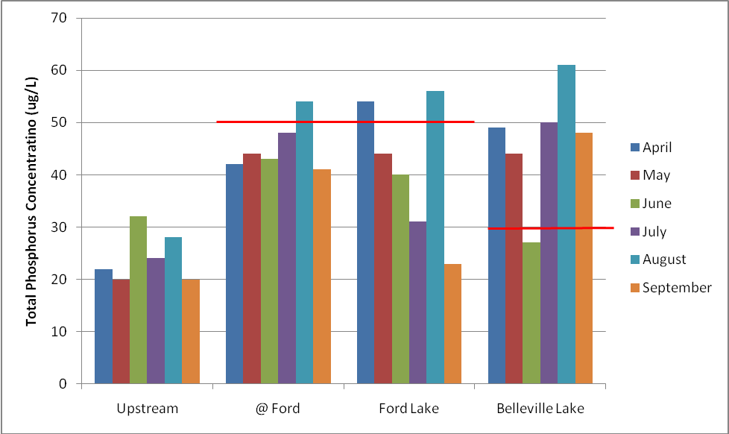
Figure 1. Total phosphorus concentrations at stream and lake stations sampled by MDEQ from April through September, 2009. There were only three instances for Ford Lake where results showed greater phosphorus concentrations than the goal of the TMDL. Belleville Lake was often well over its threshold for phosphorus loading.

Tributary monitoring indicates similar trends. Generally, total phosphorus concentrations have decreased in tributaries, especially those in urban areas, though 2010 results were highly variable. Concentrations outside of the urban area averaged 37 µg/l between 2008-10, while those inside the urban area around Ann Arbor averaged 52 µg/l. However, tributaries in urban areas declined by 28% from 2003-06 levels, while less-urban creeks only declined 17%. Finally, data from the station at the entry to Ford Lake showed an average concentration between 2008-10 of 53 µg/l, just above the target level of 50 µg/l (Fig. 2).
Figure 2. Total phosphorus concentrations for sampling across 10 tributary sites up to twice per month from May to September 2003 to 2010. Annual quartile and medians are shown in boxes, with maxima and minima in whiskers and annual means illustrated with points. Note the general decrease in total phosphorus concentrations from earlier years, especially 2003.

Phosphorus loading has also been assessed using a number of approaches. Extrapolating into seasonal loads suggests that the maximum load should reach 28,036 lbs April through September to be compliant with the TMDL. The TMDL assumes that about half (39,574 lbs) of the total modeled load comes during this growing season. This requires a total load reduction of 11,538 lbs. Of the total load, 24,293 lbs (61%) were estimated to be coming from nonpoint sources, with the remainder (15,561 lbs) from point sources. Again extrapolating from load allocations, the load reduction required of nonpoint sources is 14,035 lbs over the April to September growing season, while point sources are required to reduce by 1,165 lbs.

Based on past reporting, point sources have reduced loading to 9,438 lbs/yr or 34% below waste load allocations, though some monthly violations still occur. This represents a load reduction of 6,123 lbs from 1996 levels. The point source reduction represents a solid buffer for any load reduction shortfalls. Monthly point source load limit violations will need to be eliminated, and nonpoint source load reductions also must be accounted for to reach the TMDL for phosphorus in the watershed.

Current annual loading estimates vary from the original TMDL model. For 2003, the point source phosphorus load was reported as 23,800 lbs/yr. As indicated previously, the most recent reporting indicates an annual load of 24,355 lbs/yr by point sources – a significant reduction from 1996 levels. Loading from tributaries estimated by the 1996 model used for TMDL development indicates 22,000 lbs/yr was being contributed by nonpoint sources (see Table 5).

Table 5. Total Phosphorus Loading from Tributary Sources (Source: Kosek, 1996)
Significant Sources | Load from '96 Sampling | Load from '96 Model | Percent of Total | Percent Difference
Upstream Sources | 30,000 | 30,000 | 37.5%
Boyden Creek |  | 961 | 1.2%
Honey Creek |  | 1,039 | 1.3%
Other sources (upper section) | 2,000 |  | 0.0%
HBP Subtotal | 32,000 | 32,000 | 40.0%
Allens Creek | 1,000 | 1,813 | 2.3% | 81%
Traver Creek |  | 1,855 | 2.3%
Malletts Creek | 700 | 3,945 | 4.9% | 464%
Miller Creek |  | 1,957 | 2.4%
Swift Run | 300 | 1,210 | 1.5% | 303%
Other sources (middle section) | 9,700 | 920 | 1.2% | -91%
Dixboro Road Subtotal | 43,700 | 43,700 | 54.6%
Ann Arbor WWTP | 28,000 | 28,000 | 35.0% | 0%
Fleming Creek | 1,300 | 1,300 | 1.6% | 0%
Superior Drain |  |  | 0.0%
Other sources (lower section) | 7,000 | 7,000 | 8.8% | 0%
Michigan Avenue Total | 80,000 | 80,000 | 100.0%

However, due to the large set of data obtained through monitoring, there is a much richer set of data available for loading analysis. Instead of using land use models or extreme extrapolation from a few data points, HRWC was able to apply statistical techniques based on flow-concentration relationships that provide much more accurate and current loading estimates (Table 6). Load estimates were computed using all monitoring data for tributary sites from 2003-10. The statistical model also accounts for the sampling months. See Appendix A for statistical modeling details. Data from 1995 was also modeled for comparison.

Table 6. Total phosphorus loading estimates (lbs/day) for select river and tributary locations.
Site | TP Mean Daily Load Est. (2003-10) | TP Mean Daily Load Est. (1995) | % Difference
Huron @ N. Territorial (upstream) | 50.99 | 41.07 | +24.2%
Mill Creek | 39.51 | 30.25 | +30.6%
Honey Creek | 4.62 | 2.22 | +108.1%
Allens Creek | 3.27 | 2.74 | +19.3%
Traver Creek | 1.06 | 5.08 | -79.1%
Fleming Creek | 6.55 | 3.52 | +86.1%
Millers Creek | 0.38 | 5.36 | -92.9%
Malletts Creek | 11.72 | 14.76 | -20.6%
Swift Run | 1.60 | 0.82 | +95.1%
Superior Drain | 0.76 | NA | NA
Huron @ Ford Lake (US-12) | 151.43 | 200.59 | -24.5
Overall, this analysis indicates that loading to Ford Lake has decreased by an estimated 25%. Total phosphorus loading to Ford Lake over the April to September TMDL period is estimated to be 27,655 lbs, which is 381 pounds below the TMDL target.

In 2003, the U.S. EPA awarded a 3-year STAR grant to the University of Michigan for a new study of the middle reach of the Huron River and Ford Lake and Belleville Lake that provides a more comprehensive assessment of nutrients and the factors that influence nuisance algal blooms. Dr. John Lehman was the Principal Investigator. His team found the following results:
- From June 2003 to December 2004, 33427 kilograms (kg) of total phosphorus (TP) entered Ford Lake. During the same time period, AAWWTP reports discharging 12,427 kg TP to the Huron River (37%).
- Of the 12,427 kg P that AAWWTP discharged to the Huron River, only 8,854 kg (71%) emerged from Superior Pond. This represents 26% of the load to Ford Lake.
- More TP entered Ford Lake during May 2004 as a result of the 22 May flood than had been discharged by AAWWTP in the previous year.
- From June 2003 to March 2005, 4,279 kg of dissolved phosphorus (DP) was discharged from Barton Pond into the Huron River above Ann Arbor. During the same time, 12,205 kg DP was present below Geddes Pond and upstream of the AAWWTP outfall. This represents an increase of 7926 KG added within Ann Arbor above its WWTP.
- Also from June 2003 to March 2005, 22,804 kg DP exited Superior Dam, an increase of 10,599 kg from upstream of the WWTP (N.B. This is less than the reported discharge by AAWWTP owing to retention within Superior Pond).
- 23,002 kg DP entered Ford Lake, an increase of 198 kg from Superior Rd. to Spring St.
- For Particulate P (PP; DP + PP = TP), 16,771 kg discharged from Barton Pond; 12,043 kg discharged from Geddes Pond. This is a net loss of 4,728 kg PP removed by Argo and Geddes Ponds. The balance between PP retention and DP release resulted in the net addition of 3,198 kg P to the River within Ann Arbor.
- From June 2003 to March 2005, 16,190 kg discharged from Superior Dam. This is an increase of 4,147 kg compared to upstream of the AAWWTP. The N/P ratio of this added particulate matter is too low for it to be biological matter. It is almost surely eroded soil. 18,349 kg PP entered Ford Lake. This is an increase of 2,159 kg. The N/P ratio of this particulate matter is too low for it to be biological matter. It is soil, too.
- 41,351 kg TP entered Ford Lake and 32,445 kg exited. This was a removal of 8,906 kg or a retention of 21.5%. The proportioning between dissolved and particulates was such that 19.3% of DP and 24.3% of PP were retained.

The STAR project contributed much needed information on the role resuspension of phosphorus particles in Ford Lake plays in the production of nuisance algal blooms.
- Phosphorus release rates of sediment core samples in Ford Lake were up to 3X greater than release rates from multiple other eutrophic lakes located in western Michigan. Internal loading was found to play a key role in seasonal bloom development in Ford Lake.
- Internal loading of phosphorus is complicated, and interwoven with concentrations of other nutrients like nitrogenous compounds. Phosphorus release was found to be more prevalent with oxygen depletion of the lower water column, a common problem in the summer; an iron trap forms that causes phosphorus and iron to leach from the bottom sediments and into the open water, exacerbating the algal bloom.

Summary of Phosphorus Loading Reduction and Current Status

HRWC and volunteers have collected data since 2003 at nine tributary monitoring stations within the TMDL drainage area. The University of Michigan and DEQ have collected samples at Ford Lake, Belleville Lake and several sites in the Huron River. Seasonal (April – September) and annual loads were calculated based on original 1995 data collected by DEQ and 2003-10 data collected by HRWC and Dr. John Lehman at the University of Michigan.
- Sampling in pre-ordinance years (before local ordinances to reduce phosphorus use in lawn fertilizers were mandated), 2003-2007, at Ford Lake showed an average total phosphorus concentration of 0.0526 mg/L, which translates into an estimated TP load of 48,527 lbs/yr.
- Since 2008, the mean TP concentration entering Ford Lake was 0.0528 mg/L, which is approximately the same as the concentration from 2003-2006. Through 2009, the mean concentration was much lower than when results from 2010 are taken into account. Mean concentration was much higher in 2010 than in previous years pulling the mean concentration upward.
- The total TP concentration from 2003-10 was 0.0527 mg/L, which translated into an estimated TP load of 54,382 lbs/yr, or 27,191 lbs over the growing season (TMDL limit period). This total figure is below the total load limit calculated from the TMDL.
- Sampling from tributaries indicated a strong decrease in phosphorus concentrations through 2009, with greater variability in 2010.
- Reporting from point sources showed that, collectively, they discharged well below their cumulative waste load allocation, though a small number of exceedences of monthly limits occurred. Thornton Farms was not included in the analysis.

B. Excessive bacteria (E. coli) in the Huron River and tributaries downstream of Argo Dam to Geddes Dam

The following is excerpted from the Bacteria Reduction Implementation Plan for the Middle Huron River Watershed.

Sampling Effort and Data Summary

The Huron River (Geddes Pond) was placed on the Section 303(d) list in August, 2001, due to impairment of recreational uses by the presence of elevated levels of pathogens. Historical exceedances of state standards and high bacteria counts were common in the 1970s, 1980s, and 1990s, although improvements have been made since the peaks of the 1980s. The Huron River Pollution Abatement program of the late 1980s and early 1990s identified numerous sources of pathogens in the TMDL area and pursued their elimination. A compilation of this historical data is contained in Appendix C (Limno-Tech, Inc., 2000). These data indicate that Lower Geddes Pond has consistently exhibited the highest bacteria concentrations among all Huron River reaches in the Ann Arbor area. Geddes Pond is also the receiving water for three direct tributaries (Millers Creek, Malletts Creek and Swift Run Creek), plus Traver Creek and Allens Creek that enter upstream of Island Park. Historic data indicate that each of these tributaries exceed the WQS for pathogens as well. Background (upstream) levels of E. coli in Barton Pond were determined to be 10 E. coli per 100 ml. Additional sampling conducted in 2001 by the DEQ corresponds with the findings of the historical data and indicates that the listed reach and its tributaries continue to exceed the WQS for E. coli. These sampling results are included in Appendix D.

In 2002, sampling efforts were focused on source identification. With the input of stakeholders, appropriate sampling locations were selected throughout each tributary and sampled on a rotating basis from May to October, 2002. In addition, routine monitoring was conducted at the mouth of each tributary and on Geddes Pond. These sampling results are included in Appendix D. The Huron River Watershed Council (HRWC) established long-term monitoring sites on these tributaries and at the Allens Creek outfall in 2003 and began monitoring for E.coli in 2006 through present day. Sampling results from this effort are included in Appendix F.

The results of the 2002 data indicate that Geddes Pond exceeded the 30-day geometric mean (130 E. coli per 100 ml) for full body activities during the second half of July, and all of August. There was an additional single sampling event that exceeded the full body activity daily maximum standard (300 E. coli per 100 ml) in September. Each tributary sampled had elevated E. coli, and seemed to be influenced by wet weather events. Data collected by the HRWC over the past five years shows that the seasonal average E. coli concentration for each tributary still exceeds the 30-day standard of 130 E.coli per 100 ml, despite surrounding area municipal strategies to mitigate this situation. These data are shown in Figure 1. Although these seasonal averages are high, there were several individual sampling results at each site with E. coli concentrations that were below single event and 30-day standards. These lower results mostly occurred in May 2009. (see Appendix F).

Attempts were also made to identify the sources of E. coli to determine if the source was human, non-human, or a combination thereof. Initially, one DNA sampling event was conducted in August 2002, with results being inconclusive. In 2005, the Washtenaw Drain Commissioner’s office (now known as the Washtenaw County Water Resources Commissioner) conducted a study with the Ann Arbor municipal storm sewer system to identify species-specific sources of E. coli, applying library-based genotypic bacteria source tracking (BST) (see Appendix G). Storm sewers on Buckingham Rd and Sheridan Rd, the subjects of the study, are integral to the Malletts Creek IDEP program, and were found to have no illicit sewer connections during an IDEP investigation conducted in 2003. However, E. coli sampling results indicated that high concentrations of the bacteria were still present in the storm sewers, even in dry weather conditions (see Figure 2). BST analysis of samples collected in spring and fall of 2005 indicated that pets (primarily cats) and raccoons were the primary sources of E. coli in the storm sewers at both sites. Human sources were also identified in a couple of the samples.

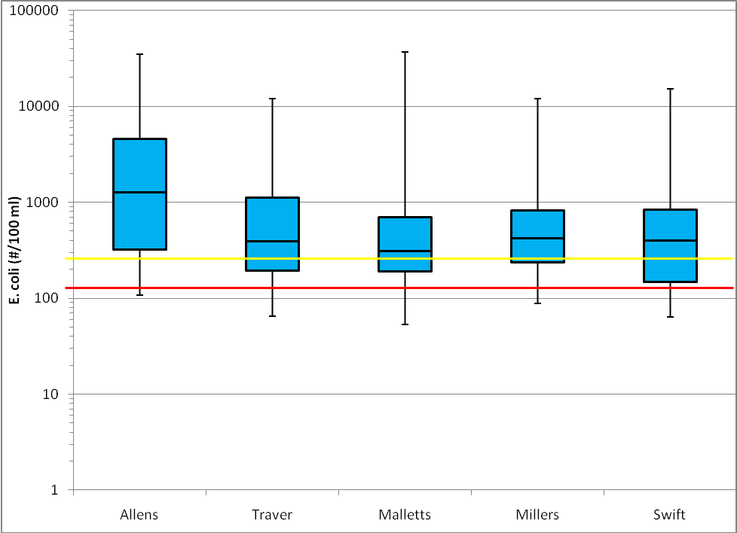
Figure 1. Range of E. coli sample results from monitoring 2006-10 at 5 tributaries to the TMDL section of the Huron River. Boxes represent 25-75% quartile data range, with the center bar representing the median. Wiskers represent minimum to maximum sample results. Lines indicate the full-body contact standard.

C. Excessive bacteria (E. coli) in Honey Creek
Note: the implementation plan for Honey Creek is currently under development. A summary from this plan will be provided upon completion and prior to October 1, 2013.

D. Aquatic biota impairment in Malletts Creek

The following is excerpted from the Implementation Plan for the Malletts Creek Biota TMDL.

Water Quality Sampling Data Summary
Water Quality data collected since 2003 by HRWC and partners at the Malletts Creek monitoring station at Chalmers Drive (Figure 3) is the primary source information to gauge TSS levels. The HRWC Water Quality Monitoring Program collects water samples for analysis of TSS, among other variables. Since the data collection began in 2003, the average TSS concentration is 18.1 mg/L, with samples showing a slight declining trend over that period of time. The mean concentration is well below the target of 80 mg/L. But this average represents all samples collected across a variety of conditions (i.e., wet and dry). Wet weather monitoring resulted in event concentrations of 33 and 222 mg/L or an average of 127.5 mg/L (Figure 4).

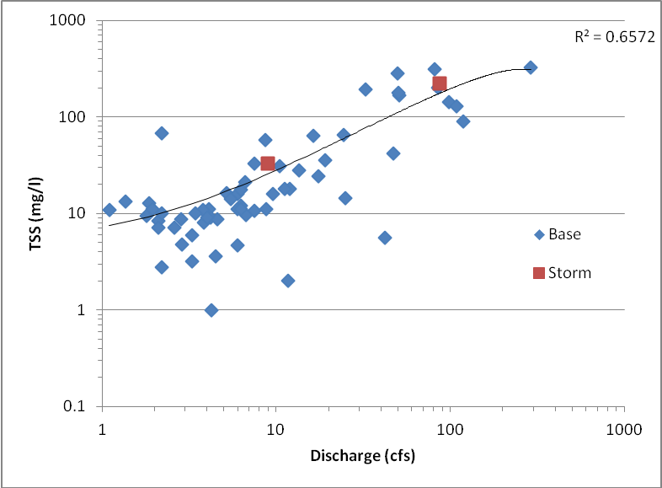
Figure 3. TSS samples showing the relationship to observed stream discharge in Malletts Creek at Chalmers Rd.

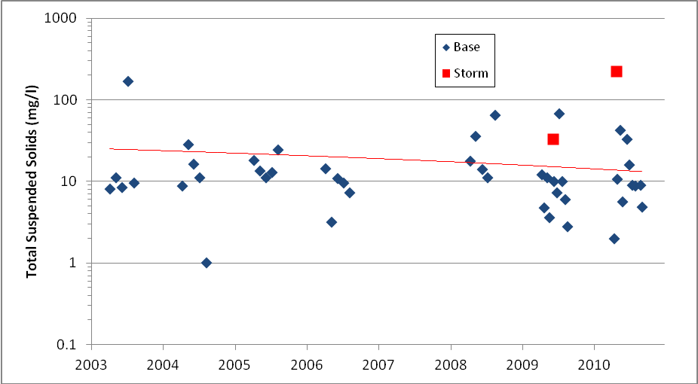
Figure 4. TSS samples by year from Malletts Creek at Chalmers Rd. Red line indicates a slight downward trend in concentration.

The estimated average daily load range is calculated at two to three times the target load. Inputting stream flow and the TSS sample concentrations into a load estimation model (LOADEST) results in an estimated average daily load range of 6,213 to 8,527 lb/day or roughly 1,100 to 1,500 ton/yr (2,464,000 to 3,360,000 lb/yr). The original TMDL model was based entirely on land use projections, while the estimation from HRWC is based on sampling data, so the estimates are not directly comparable. Further, the load estimates are imprecise because the sampling data were quite variable (Figure X). The full 95% confidence interval of load estimates ranges from 502 to 3,721 ton/yr (1,124,480 to 8,335,040 lb/yr).

Macroinvertebrate Sampling Data Summary
Macroinvertebrate data collected since 1992 by HRWC and partners at four monitoring stations is the primary source of information on the benthic macroinvertebrate community in Malletts Creek.
Insects living in the creek compose the benthic macroinvertebrate population, along with clams and other mollusks, crayfish, and some other taxa. Typically, monitoring focuses on insects (in aquatic stages of development) as they are representative of a variety of trophic levels, are sensitive to local environmental conditions, and are easy to collect. Since the benthic population depends on the physical conditions of the stream as well as water quality, its composition indicates the overall stream quality. Greater insect diversity indicates good stream quality, and is measured by the number of different insect families. Eighty-seven benthic insect families are found in the Huron River watershed.
Much of the benthic macroinvertebrate data cited is from HRWC’s Adopt-A-Stream Program, which relies on trained volunteers to monitor more than 70 sites in the watershed, including 30 in the Middle Huron watershed. Monitoring data has been gathered since as early as 1992 at some sites through annual spring and fall collection days, and a winter stonefly search each January. All sites have been monitored at least once per year since the commencement of the monitoring at that site.
Insect families belonging to the orders of Ephemeroptera (mayflies), Plecoptera (stoneflies), and Trichoptera (caddisflies) are known as the EPT families, which are indicators of alterations in stream flow, temperature, oxygen and other changes that raise metabolic rates. Sensitive insect families, such as Perlidae (Perlid stonefly) and Brachycentridae (log-cabin caddisfly), are highly sensitive to organic pollution; 19 of the 87 benthic insect families living in the Huron River watershed are sensitive.
Winter stoneflies, which are active in January and require high levels of oxygen, are indicators of good stream quality. Absence of winter stoneflies suggests that toxic pollutants may be present. This is because organic pollutants, such as fertilizer and human or animal waste, are associated with stormwater runoff in warmer months. Because there is usually little or no stormwater runoff in January, there is a greater likelihood that any pollutants in the stream are persistent (long-lasting) inorganic toxic substances that are present in the bottom of the streambed. Conversely, at a site where insect diversity is lower than expected but winter stoneflies are present, organic pollutants are more likely to be the problem.
The Adopt-A-Stream Program also rates the “ecological conditions” at each site, which are determined by both the biological and physical conditions of the site. Biological conditions include the diversity of insect families, EPT families, and sensitive families. Physical conditions are determined by conductivity results and “measuring and mapping” assessments of habitat. These assessments involve examining characteristics such as the stream banks, stream widths and depths, and bed material (such as sand, gravel, or muck). When interpreting the biological and physical conditions, more diversity is generally expected at larger sites or sites with cooler summer stream temperatures.

Following are the site summaries through January 2011:

Malletts Creek @ S. Main Street
This monitoring site is located on a headwater tributary to Malletts Creek and drains about 2 square miles. Approximately 75% of the watershed is developed. Monitoring began here in 1999 and has been visited 23 times by the Adopt-A-Stream program. Insect diversity is poor, and neither sensitive families nor winter stoneflies are present. The conditions of stream banks, streambed, and streamside vegetation are average. Water quality is poor.

The overall condition per the Adopt-A-Stream Integrated Model is POOR.

Malletts Creek near I-94
This monitoring site has a watershed of 4 square miles. Approximately 81% of the watershed is developed. Monitoring began at this site in 1992 and has been visited 31 times. Insect diversity is poor, and neither sensitive families nor winter stoneflies are present. The conditions of stream banks, streambed, and streamside vegetation are poor. Flashy stream flows are evident. Water quality is poor.

The overall condition per the Adopt-A-Stream Integrated Model is POOR.

Malletts Creek @ Scheffler Park
This monitoring site is located on the main channel of Malletts Creek and drains 11 square miles. Approximately 85% of the watershed is developed. Monitoring began here in 1992 and has been visited 29 times by the Adopt-A-Stream program. Insect diversity is poor, and neither sensitive families nor winter stoneflies are present. The conditions of stream banks, streambed, and streamside vegetation are fair to poor. Water quality is poor.

The overall condition per the Adopt-A-Stream Integrated Model is POOR.

Malletts Creek @ Chalmers Road
This monitoring site is located on the main channel close to the outlet into South Pond. Approximately 85% of the watershed is developed. Monitoring began here in 1993 and has been visited 31 times by the Adopt-A-Stream program. Insect diversity is poor, and neither sensitive families nor winter stoneflies are present. The conditions of stream banks, streambed, and streamside vegetation are fair. Flashy stream flows are evident. Water quality is poor.

The overall condition per the Adopt-A-Stream Integrated Model is POOR.

The health of the macroinvertebrate community is not very different than conditions reported in a 1999 bioassessment of Malletts Creek completed as part of the Malletts Creek Restoration Plan (Riseng, C. and K. Lawrence. May 6, 1999. For the Washtenaw County Drain Commissioner, the City of Ann Arbor and Pittsfield Township) that included habitat and macroinvertebrate surveys based on data collected from six stations. In general, the macroinvertebrate community observed during the field survey was indicative of small, warmwater streams with high sediment loads and organic pollution. Based on calculation of the Procedure 51 summary metrics the quality of the macroinvertebrate community in Malletts Creek varied from acceptable to poor. The results of the habitat survey and rating metrics indicated the habitat structure in Malletts Creek ranges from fair to poor. The report’s authors concluded that extreme flashiness of Malletts Creek controls channel morphology, limits bank vegetation and stability and, therefore, limits the aquatic community diversity and stability.

Based on the monitoring results for TSS and macroinvertebrates to date, one must conclude that the impairment of the designated use for indigenous aquatic life and wildlife persists in Malletts Creek.

The Role of Flashiness in Malletts Creek
The documented poor habitat conditions and insect populations that persist in Malletts Creek highlight the continued need to look beyond TSS to the stream flow regime if sustained restoration is going to happen, and to ameliorate the use of practices that can reduce extreme flows. One measure to assess the ecological function of a stream from a flow perspective is to evaluate the “flashiness,” or the rate and degree to which the stream increases and decreases in flow rate in response to a rain storm or event. The Richards-Baker Flashiness Index was developed for wadeable Michigan streams to provide a standard measure of flow dynamics. The index varies from 0 to over 1, where an index of 0 would represent a stream that never changes flow rate and 1 would indicate a highly variable and rapidly changing stream.
The USGS manages flow gages in Malletts Creek at Mary Beth Doyle Park (#04174514) and at Chalmers Road (#04174518). HRWC analyzed daily mean discharges at the Chalmers Rd. station from 1999 to 2010. Year to year, the flashiness of Malletts Creek has varied slightly with a slight downward trend (Figure 5). The most recent 3-year average flashiness index value is 0.723, which is among the flashiest quarter of all similarly sized streams in Michigan. It is also well above the median stream flashiness in a six-state Midwestern survey.

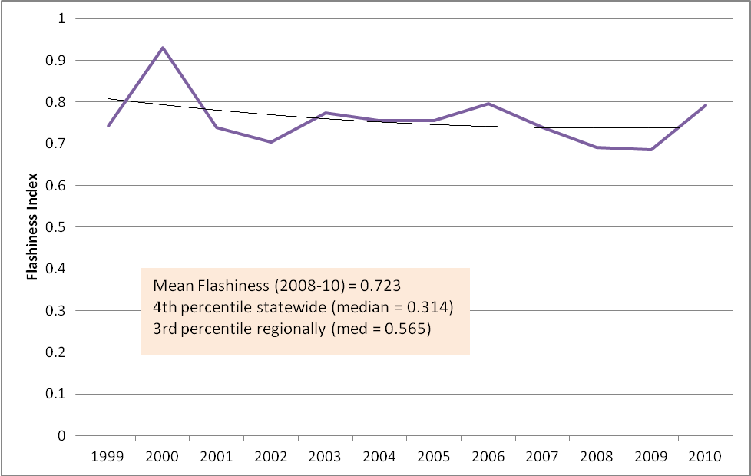
Figure 5. Observed stream discharge in Malletts Creek @ Chalmers Rd, from 1999-2010.

Erratic flows have been recognized as a key problem for Malletts Creek by others. Hydraulic and hydrologic modeling conducted for the Malletts Creek Restoration Project found that 22 percent of the land area in the watershed is impervious surface directly connected to the stormwater system and creek. In fact, half of the flow to the creek is contributed by runoff from just 20 percent of the watershed, known generally as the Burns Park neighborhood. This part of the watershed contains some of the oldest residential and commercial neighborhoods mostly built prior to the era of stormwater management.

At the writing of the TMDL, the stream flow conditions of Malletts Creek were described as unstable and flashy in response to storm events captured by the USGS records at Chalmers Road. “This condition results in excessive stream bank erosion, sedimentation, and erosivity of otherwise stable, inhabitable substrate suitable for macroinvertebrate colonization and fish community development,” notes the TMDL’s authors, “Therefore, the sources of sediment loadings to Malletts Creek are primarily attributable to periodic erosion and storm water runoff from impervious surfaces . . . in the watershed” . The TMDL allocates loading of TSS among WLAs and Las, yet does not attempt to set targets for stormwater volumes directly.

While the creek appears not to be meeting the TSS load limits despite a downward trend, and continues to exhibit measures of impaired biota and altered flow profiles, it is recommended that the DEQ consider revising the TMDL to include targets for stream flow.

Precedence for this approach has been established by states and their EPA Regional Offices, as mentioned earlier, that have employed stormwater flow reductions in TMDLs to meet aquatic life designated uses. While more study is warranted, recent scientific research has sought to quantify the impact of flows on the functions of river ecology. Researchers in the United Kingdom found in a study of 83 river basins in England and Wales that variables associated with the magnitude of the flow regime consistently produced the strongest relationships with macroinvertebrate community metrics.

E. Aquatic biota impairment in Swift Run
The following is excerpted from the Implementation Plan for the Swift Run Biota TMDL.

Water Quality Sampling Data Summary
The authors of the TMDL recognize that sufficient, site-specific data regarding the stream flow and TSS concentration relationship (i.e., TSS loading) associated with stormwater sources was insufficient at the writing of the TMDL to establish specific numeric targets. This TMDL, then, was established as a phased TMDL to allow for additional data collection that could result in additional TSS targets that are flow-related. In response to the lack of data, the watershed entities under the leadership of HRWC developed a monitoring program for Swift Run Creek in 2003 to capture these data.

Data collected since 2003 by HRWC and partners at the Swift Run Creek monitoring station at Shetland Drive (Figure 3) is the primary source information to gauge TSS levels. The HRWC Water Quality Monitoring Program collects water samples for analysis of TSS, among other variables. Since data collection began in 2003, the average TSS concentration is 18.4 mg/L. Including stream flow, this equates to an average daily load of 353 lbs/day or 128,933 lbs/yr (64 tons/yr) – well below the target load for the creek of 80 mg/L. However, these data are from routine sampling, rather than wet weather events. One wet weather event was sampled for TSS in Swift Run, and it resulted in a flow-weighted event concentration of 30 mg/l, still well below the target. Results from the 2011 monitoring season will be incorporated into this plan when available.

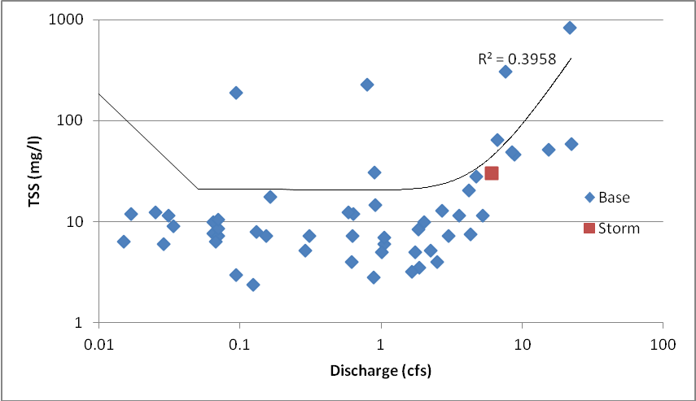
Figure 3. TSS samples showing the relationship to observed stream discharge in Swift Run Creek at Shetland Dr.

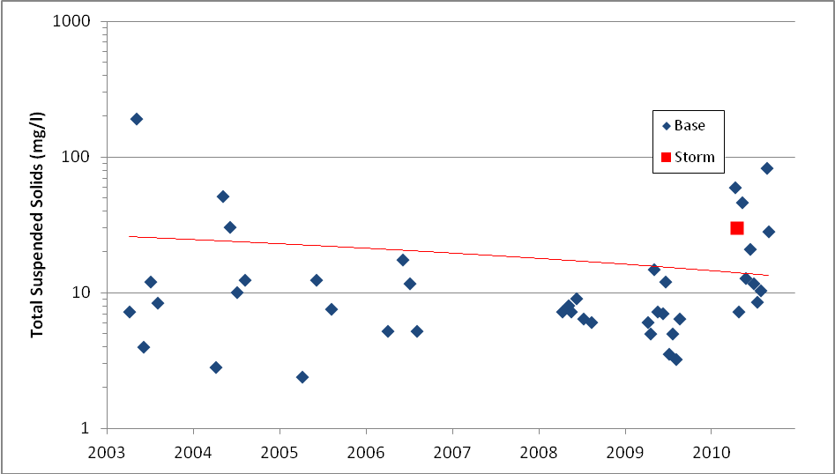
Figure 4. TSS samples by year from Swift Run Creek at Shetland Dr. The red line indicates a slight downward trend in concentration.

The original TMDL model was based entirely on land use projections, while the estimation from HRWC is based on sampling data, so the estimates are not directly comparable. Further, the sampling data was quite variable (Figure 4), so load estimates are not precise. The full 95 percent confidence interval of load estimates ranges from 31 to 119 tons/yr. Thus, based on monitoring data, Swift Run Creek is currently below TSS targets and is meeting the secondary TMDL target.

Macroinvertebrate Sampling Data Summary
Data collected since 1992 by HRWC and partners at a single monitoring station is the primary source of information on the benthic macroinvertebrate community in Swift Run Creek.
Insects living in the creek compose the benthic macroinvertebrate (no backbone) population, along with clams and other mollusks, crayfish, among other taxa. Typically, monitoring focuses on insects (in aquatic stages of development) as they are representative of a variety of trophic levels, are sensitive to local environmental conditions and are easy to collect. Since the benthic population depends on the physical conditions of the stream as well as water quality, its composition indicates the overall stream quality. Insect diversity indicates good stream quality, and is measured by the number of different insect families. Eighty-seven benthic insect families are found in the Huron River watershed.

Much of the benthic macroinvertebrate data in this plan is from HRWC’s Adopt-A-Stream Program, which relies on trained volunteers to monitor more than 70 sites in the watershed, including 30 in the Middle Huron watershed. Monitoring data has been gathered since as early as 1992 at some sites through annual spring and fall collection days, and a winter stonefly search each January. All sites have been monitored at least once per year since monitoring began at the site.

Insect families belonging to the orders of Ephemeroptera (mayflies), Plecoptera (stoneflies), and Trichoptera (caddisflies) are known as the EPT families, which are indicators of alterations in stream flow, temperature, oxygen and other changes that raise metabolic rates. Sensitive insect families, such as Perlidae (Perlid stonefly) and Brachycentridae (log-cabin caddisfly), are highly sensitive to organic pollution; 19 of the 87 benthic insect families living in the Huron River watershed are sensitive.

Winter stoneflies, which are active in January and require high levels of oxygen, are indicators of good stream quality. Absence of winter stoneflies suggests that toxic pollutants may be present. This is because organic pollutants, such as fertilizer and human or animal waste, are associated with stormwater runoff in warmer months. Because there is usually little or no stormwater runoff in January, there is a greater likelihood that any pollutants in the stream are persistent (long-lasting) inorganic toxic substances are present in the bottom of the streambed. Conversely, at a site where insect diversity is lower than expected but winter stoneflies are present, organic pollutants are more likely to be the problem.

The Adopt-A-Stream Program also rates the “ecological conditions” at each site, which are determined by both the biological and physical conditions of the site. Biological conditions include the diversity of insect families, EPT families, and sensitive families. Physical conditions are determined by conductivity results and “measuring and mapping” assessments of habitat. These assessments involve examining characteristics such as the stream banks, stream widths and depths, and bed material (such as sand, gravel, or muck). When interpreting the biological and physical conditions, more diversity is generally expected at larger sites or sites with cooler summer stream temperatures.
- Site summary for Swift Run Creek @ Shetland Drive through January 2011:
This monitoring site is located in the downstream reach of Swift Run Creek and drains five square miles. Approximately 50 percent of the watershed is developed or cultivated. Monitoring began here in 1992 and has been visited 30 times by the Adopt-A-Stream program. Insect diversity is poor, and neither sensitive families nor winter stoneflies are present. However, results in 2010 show a slight improvement in the insect community. Future monitoring will show if that trend continues or if the improved community stabilizes. The conditions of stream banks, streambed, and streamside vegetation were rated as average when the last assessment was made in August 2010. Recent anecdotal observations at the site during water quality sampling suggest that the stream banks are eroding. Water quality is poor, based on high conductivity readings.

The overall condition per the Adopt-A-Stream Integrated Model is POOR.

The health of the macroinvertebrate community is not very different than conditions reported in the TMDL that summarized habitat and macroinvertebrate surveys conducted in 1997 and 2003 in Swift Run Creek. In general, the macroinvertebrate community observed during the field survey was indicative of small, warmwater streams with high sediment loads and organic pollution. Based on calculation of the Procedure 51 summary metrics the quality of the macroinvertebrate community in Swift Run Creek was poor. The results of the habitat survey and rating metrics indicated the habitat structure in Swift Run Creek ranges from good to fair. The report’s authors concluded that extreme flashiness of Swift Run Creek controls channel morphology, limits bank vegetation and stability and, therefore, limits the aquatic community diversity and stability.

Based on the monitoring results for macroinvertebrates to date, one must conclude that the impairment of the indigenous aquatic life and wildlife persists in Swift Run Creek, and that the suitability of TSS as a secondary TMDL target may be a questionable loading measure to relate to stream biota.

The Role of Flashiness in Swift Run Creek
The documented poor habitat conditions and insect populations that persist in Swift Run Creek highlight the continued need to look beyond TSS to the stream flow regime if sustained restoration is going to happen, and to ameliorate the use of practices that can reduce extreme flows. One measure to assess the ecological function of a stream from a flow perspective is to evaluate the “flashiness,” or the rate and degree to which the stream increases and decreases in flow rate in response to a rain storm or event. The Richards-Baker Flashiness Index was developed for wadeable Michigan streams to provide a standard measure of flow dynamics. The index varies from 0 to over 1, where an index of 0 would represent a stream where flow never changes and 1 would indicate a highly variable and rapidly changing stream.
HRWC installed a flow gage in Swift Run Creek at Shetland Drive in 2010. Data was collected between May and November. A gage was also installed previously and slightly upstream at Salem Court in 2007. HRWC analyzed daily mean discharges at these stations. In 2010, the flashiness index value for Swift Run Creek was 1.02, which makes it one of the flashiest streams of all similarly sized streams in Michigan. It is also well above the median stream in a six-state Midwestern survey. That year, the stream exhibited a peak flow of 273.5 cfs in response to a 2.6” rain event. In 2007, the gage measured flow only from June through August. Over that time period, the flashiness index was 0.418, with a peak flow of only 22.3 cfs following a 1.4” rain event. It is likely that the mean flashiness index for Swift Run is somewhere between the two years, but much higher than the average for its stream size. The stream is also being gaged in 2011 at Shetland Drive.
Erratic flows have been recognized as a key problem for Swift Run Creek by others. At the writing of the TMDL, the stream flow conditions of the creek were described as unstable and flashy in response to storm events as captured by the flow extremes recorded during June, July and August 2003 surveys conducted by LTI for MDEQ. Excessive stormwater runoff to Swift Run Creek from the built areas of the watershed is considered the most probable cause of the creek’s impairment. The TMDL allocates loading of TSS among WLAs and LAs yet does not attempt to set targets for stormwater volumes directly.

As the creek appears to be meeting the TSS load limits, but continues to exhibit measures of impaired biota and altered flow profiles, it is recommended that the MDEQ consider revising the TMDL to include targets for stream flow.

Precedence for this approach has been established by states and their EPA Regional Offices, as mentioned earlier, that have employed stormwater flow reductions in TMDLs to meet aquatic life designated uses. While more study is warranted, recent scientific research has sought to quantify the impact of flows on the functions of river ecology. Researchers in the United Kingdom found in a study of 83 river basins in England and Wales that variables associated with the magnitude of the flow regime consistently produced the strongest relationships with macroinvertebrate community metrics.

IV. Future Monitoring Plan

The TMDL summaries provided above are based primarily on data collected through HRWC's Water Quality Monitoring Program, which has been funded in part by MS4s. Currently the MS4s and other watershed partners plan to continue to support this program to seasonally monitor Middle Huron River tributaries for TMDL pollutants. However, for the purposes of NPDES stormwater permit compliance, the MS4s commit to the following monitoring plan.

- MS4s will support the collection of water quality samples from sites that are located at or near major tributary mouths. A map of current monitoring sites is located at http://www.hrwc.org/our-work/programs/water-quality-monitoring/. Tributary mouth sites (labeled as "long-term" sites on the map) are those designated MH02 - MH10.

- Samples will be collected at least twice during the permit cycle, not including the data included from previous monitoring. Sampling years will be 2015 and 2018. At least one sampling event will take place at each of the nine sites.

- Samples will be collected following procedures identified in HRWC's Water Quality Monitoring Program QAPP. Samples will be analyzed by the Ann Arbor Water Treatment Plant Laboratory or other certified lab for the following concentrations: Total Phosphorus (TP), Total Suspended Sediments (TSS), and E. coli.

- Stream flow estimates will be obtained from existing stations during the dates and times water quality samples are collected.

- The pollutant concentrations and stream flow estimates will be used to update pollutant loading models and estimate pollutant load reductions. These results will be summarized in a brief report to be shared with the public via HRWC and/or MS4 websites.

For more information including site maps and data reports, visit the program website: http://www.hrwc.org/our-work/programs/water-quality-monitoring/
Lehman, John. “Mass Balance Study of the Middle Huron River 2003-2004: Highlights of Key Findings to Date Relevant to Middle Huron Partners.” http://www.umich.edu/~hrstudy/, April 25, 2005
Lehman, John. (2011). Nuisance cyanobacteria in an urbanized impoundment: interacting internal phosphorus loading , nitrogen metabolism, and polymixis. Hydrobiologia, 661, 277-287.
Michigan Department of Environmental Quality Surface Water Quality Division. 1996. A phosphorus loading analysis and proposed TMDL for Ford and Belleville Lakes, Washtenaw and Wayne counties December 1994-November 1995.
Data reports can be found at http://www.hrwc.org/our-work/programs/water-quality-monitoring
Archived data can be found at http://www.umich.edu/~hrstudy
Martin, J. and Dakin T. 2003b. The Quality of a Hidden Treasure: the Davis Creek Report. February 2003. Ann Arbor, MI: HRWC.
Dakin and Martin. 2003a.
Fongers, D., K. Manning, and J. Rathbun. 2007. Application of the Richards-Baker Flashiness Index to Gaged Michigan Rivers and Streams. Michigan Department of Environmental Quality.
Malletts Creek Restoration Team for the Washtenaw County Water Resources Commissioner. 2000. Malletts Creek Restoration Project.
Wuycheck, J. , 2004
Monk, W.A., P. J. Wood, D. M. Hannah, D. A. Wilson, C. A. Extence, and R. P. Chadd. Flow variability and macroinvertebrate community response within riverine systems. River Res. Applic. 22: 595-615 (2006).
Martin, J. and Dakin T. 2003b. The Quality of a Hidden Treasure: the Davis Creek Report. February 2003. Ann Arbor, MI: HRWC.
Dakin and Martin. 2003a.
Fongers, D., K. Manning, and J. Rathbun. 2007. Application of the Richards-Baker Flashiness Index to Gaged Michigan Rivers and Streams. Michigan Department of Environmental Quality.
Monk, W.A., P. J. Wood, D. M. Hannah, D. A. Wilson, C. A. Extence, and R. P. Chadd. Flow variability and macroinvertebrate community response within riverine systems. River Res. Applic. 22: 595-615 (2006).

